6. Fresh Ways Working Group 2012

Basic Information

Title | Fresh Ways Working Group 2012
Contact Name and Details | The Revd Stephen Lindridge, Connexional Missioner for Fresh Expressions,  stephen.lindridge@freshexpressions.org.uk
Status of Paper | Final
Resolution | 6/1. The Conference receives the Report.

Summary of Content

Subject and Aims | Annual report
Main Points | Good News Stories with Theological reflection  VentureFX progress  Fresh Expressions Team Update
Background Context and Relevant Documents (with function) | The 2007 Conference affirmed and encouraged the priority of developing fresh ways of being church and the many and various ways in which this priority is being taken forward in the life of the Connexion.  The Conference directed the Methodist Council to bring annual reports to the Conference from 2008 to 2013 detailing progress made in encouraging the priority of developing fresh ways of being church and with detailed guidance on how this can be further encouraged including any necessary changes to Standing Orders. This is the fifth of these reports.

Fresh Ways Working Group 2012

- Introduction

- The 2007 Conference affirmed and encouraged the priority of developing fresh ways of being church and the many and various ways in which this priority is being taken forward in the life of the Connexion. The 2009 Conference 2009 reaffirmed this for phase two of Fresh Expressions initiative.

- The Conference directed the Methodist Council to bring annual reports to the Conference from 2008 to 2013 detailing progress made in encouraging the priority of developing fresh ways of being church and with detailed guidance on how this can be further encouraged including any necessary changes to Standing Orders. This is the fifth of these reports.

- In October 2007 the Methodist Council approved the constitution of a Fresh Ways Working Group to oversee the development of the 2007 resolutions and to produce the annual reports to Conference. The members of the group are:

- The Revd Dr Andrew Wood (Chair), the Revd Stephen Lindridge (Convener), the Revd Ian Bell, the Revd Joanne Cox, Mr Jon Curtis, the Revd Jenny Ellis, Ms Daniella Fetuga-Joensuu, Mr Siôn Rhys Evans, the Revd Katei Kirby, the Revd Dr Peter Phillips, Deacon Ruth Poch, the Revd Andrew Roberts.

- This report has three sections;
Fresh Ways Working Group’s good news overview of fresh expressions in Methodist Church (7-27)
The Venture FX report (28-38)
The Fresh Expressions Team update (39-46)

- 2010 Statistics for Mission of the Methodist Church on Fresh Expressions
The report to the 2010 Conference took a deeper look at two fresh expressions and the theology in action around their narratives. This year’s report seeks to offer a macro approach from a connexional overview detailing progress made in encouraging the priority of developing fresh ways of being church, using the information gained in the Statistics for Mission gathered in 2010 on fresh expressions.

- Although the information gained can only be offered as a cautious positive indication and further research is ongoing, never the less when all the following factors are considered the macro picture from these statistics is an encouraging one.

- The other caveat before exploring the figures is to remind the reader that the term ‘fresh expression’ is an overarching phrase covering a wide variety of initiatives but the principal vision and purpose of the working definition is being explored, which is;

- A fresh expression is a form of church for a changing culture established primarily for the benefit of people who are not yet members of any church. It will come into being through principles of listening, service, incarnational mission and making disciples. It will have the potential to become a mature expression of church shaped by the gospel and the enduring marks of the church and for its cultural context.

- Therefore being mindful of this spectrum of kind and development, the following is offered in a tone of encouragement.

- First – Location

- The table below shows Methodism’s geographical categorisation from last year’s report (2011) on the Statistics for Mission.
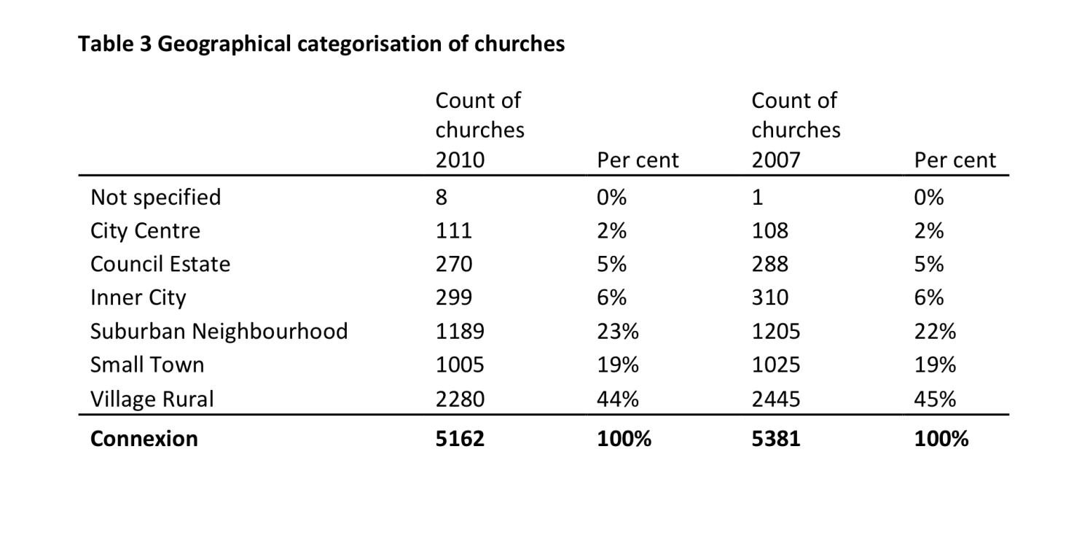
- The graph below records the categorisation for where fresh expressions were being delivered.

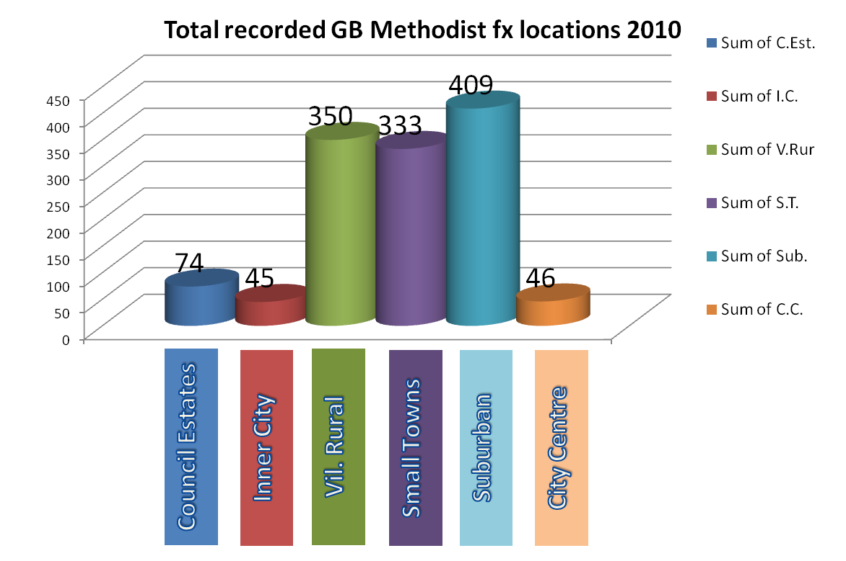
- Using the two tables and observing the comparative numbers of fresh expressions with the number of churches in the respective categories the following insights are noted.

- First, it is very encouraging to see that all categories show a significant engagement with fresh expressions, of 15% or greater but particularly noteworthy is the high percentage of city centre churches (41% of 111 churches) that are doing fresh expressions.

- Secondly, although the higher numbers of fresh expressions are obvious to see the true reflection is found in the percentages. One third of all suburban and small town churches host fresh expressions and the same is true for just over a quarter of Methodist Churches on council estates. Although it may be speculative and somewhat anecdotal, these higher values might be attributed to the churches in these contexts still having stronger links into the community coupled with the resources to begin something new.

- Thirdly, though it is very encouraging to see 350 fresh expressions in rural or village contexts that only amounts to 15% of the total number of churches in this category. Speculative generalisation suggests this is perhaps largely a reflection of village or rural church demographics. That is, of a high average age and coupled with insufficient resources or energy to affect change and begin something new. Therefore the probability to see increased growth in the percentage for this category may be unrealistic over the short term. Next year statistics will be a valuable reference point for this supposition.

- Lastly, the sum of Methodist churches with fresh expressions was 24% in 2010, equating to 67% of circuits. After seven years since the Fresh Expressions initiative began in 2004 this is a very exciting and forward-looking indication of the shape and potential of the Methodist Church in Britain.

- Secondly – observations

- First, to set the context it is important to be reminded of the 2011 Statistics for Mission report, which said (para 5.11): In 2010 there were 1,257 fresh expressions identified by Methodist churches and LEPs. Although all of these are stored and the data will be used, at the advice of fresh expressions specialists, those that meet on a regular basis (monthly or more often) are included in this more detailed analysis. This leaves a total of 941 (in 723 churches). There were between 1 and 13 fresh expressions identified in any one Circuit, with an average of 3 across the 315 circuits that identified a fresh expression. This means that around 67% of all Methodist Circuits had at least one fresh expression. Half of the fresh expressions identified were found in just under a third (32%) of Districts. Southampton was the District with the greatest number of fresh expressions, 6% of all fresh expressions. This compares to 893 fresh expressions identified in 2009 (this was the first year for asking this question). However, it must be noted that these figures are estimates only and it would be premature to read this as an increasing trend.

- That said, the observation of the significant rise across all the Districts in comparison to 2009 should not be overlooked. Although the count in 2009 did not ask for frequency of meeting and so in fairness the two years are not strictly comparable, there are several strong markers, which suggest an encouraging rise in the churches’ activity in fresh expressions. The first is the number of Circuits involved. In 2009 this was 56% (frequency not known) and noted above in 2010 was 67% (meeting more than monthly). The second is the recognisable rise in the number of Messy churches from 2009 to 2010 across the districts, seen in the graph below. Had this been unique to only a few Districts the inference might have been quite different. However the fact that nearly all Districts have portrayed a substantial increase points to a conclusion that this is not a one off nor is it subject to one particular set of demographics.
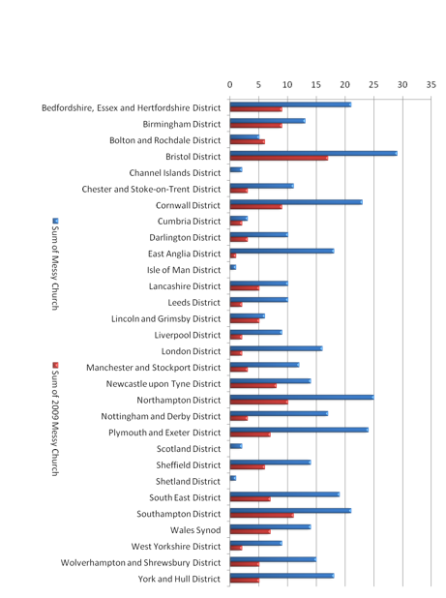
- Lastly, examining where fresh expressions gathered (table 10 in the 2011 Statistics for Mission report), offers the insight that 62% met on church premises, 14% met in homes and 23% met off church premises in a variety of places (eg cafes, pubs, gyms, libraries and locations defined only as ‘other’). Though the church percentage may seem higher than some would like, we must hold in mind that many beginning fresh expressions have only just started in the last year or two. Bearing this in mind we have to use what resources we have and that the most sensible place to start is from where you are. From there confidence can be built and great steps of faith emerge. So with this in mind it is a very encouraging sign of a rise in confidence to move outside of church premises and become more connected to the communities in which the Methodist people live, serve and communicate the gospel in ways which make sense to all involved. Thus intentionally seeking to offer relevant forms of church for those who are not yet members of any church.

- What paragraphs 21-23 may point to is the early indication of the widespread embedding of the vision and values of fresh expressions in every theology, location and practice which makes up the broad spectrum which is Methodism in Britain today. Recollecting this is intrinsic to the Methodist heritage of going to those who need you most. Fresh Expressions is facilitating the church in finding a renewed vigour for such work.

- Summary

- The learning is constantly being gathered and in partnership with the Connexional Team and Fresh Expressions ecumenical partners, every effort is being pooled to inform the churches’ overall development to encourage, equip and facilitate the people called Methodists to become more of a discipleship movement, shaped for mission.

- Statistics for Mission are invaluable in helping the Church understand what is developing at the grass roots and where there are clear areas to improve, so it is deeply appreciated the amount of time it takes to submit carefully gathered local information. The continuing research and evaluation will be substantial in helping a future Conference discern how to apportion resources appropriately to help Methodist disciples share in God’s mission.

- VentureFX

- Background. Pioneer mission is a focused approach to establishing fresh ways of being church among those who belong to the growing number of people in our society who do not engage to any meaningful extent with Christian faith and the life of the Church. VentureFX was a scheme adopted by the Conference in 2008 in order to address this urgent need, especially among people under 40 years old. Pioneers work in a Circuit or District, engaging in contextual mission. Their starting point is the community where they are based and, although they work closely with the wider church and value the ‘mixed economy’ environment, they seek to make disciples of Jesus and form new ecclesial communities in the places where people are.

- The projects. Currently there are thirteen VentureFX projects around the Connexion, six of which have been established during the past connexional year:
The Sherwood area of Nottingham, working closely with those exploring alternative spiritualities such as tarot, crystals, meditation, magic and New Age practices. The pioneer is helping people with undisguised spiritual openness to make connections with the Christian narrative in the hope that an appropriate new Christian community will emerge there in due course.
Bermondsey, South London, where a pioneer is working among young adults, mainly from the African and Caribbean communities, who are finding it difficult to engage with the church tradition of their culture. She is creating an environment in which people can become disciples of Jesus and discover an appropriate form of church for their context.
Colwyn Bay, on the North Wales coast, is the location for a pioneer who has a background in the creative arts and music. He is working with local people to create an arts cafe in the centre of the town where creative arts can be a means whereby people in that community can make connections with faith and the life of church.
Plymouth and Exeter, where a pioneer is working across the district, partnering with others who share a vision for establishing a network of ‘simple’ missional church communities among young adults who are not currently connecting with any church.
Milton Keynes is the location for a VentureFX pioneer who is engaging with the various networks of young adults who form a disproportionately large section of that new town community. The strongly ecumenical nature of Christian mission in Milton Keynes gives an added and very exciting dimension to this project.
‘Edinburgh Dreams’ is the working title for the project recently established in that city. The pioneer is gifted in various kinds of creative activity and is already establishing fruitful networks among young adults who have similar interests in what has been dubbed Britain’s loneliest city. She has a clear vision for a worshipping community which will reflect the cultural context of those young adults.

- The pioneer team. The current team of fourteen VentureFX pioneers represents an interesting diversity of background, theology, gender, ethnicity and approach to mission. Some are lay, others are ordained. Some have extensive formal theological training, others have little. Some are full time, others are part time. The projects are in very different areas of the Connexion, representing a real diversity of contexts.

- An important value of the scheme is the peer network of support and learning which the pioneers share as they explore pioneer mission within a connexional context. They are aware that they do not journey alone, but in the company of fellow VentureFX pioneers and others who are engaged in many different forms of pioneering. To help capture a sense of this shared journey the following Rhythm of Life has emerged:
We are a pioneer mission movement of the Methodist Church. VentureFX pioneers are committed to journey together and with others as part of an evolving community of pioneer mission. Our work is with those who don’t currently connect with Christian faith or the Church. We are called to be at the edges, where Christian faith can creatively engage with contemporary culture, building the church from the outside in. We seek to invite people to be disciples of Jesus and to live out that discipleship in radical and relevant community with others.
We are committed to a rhythm of life which flows from three core values:
Innovation - breaking new ground and planting for the future
Imagination - dreaming God’s vision for what church could become
Incarnation - immersed in our communities in the name of Christ
We seek to express those values by:
Daily - reflecting on our spiritual journey as disciples of Jesus
Weekly - observing a common day for the discipline of prayer and fasting
Monthly - gathering together for support, encouragement and learning
Annually - sharing in a retreat to renew our individual and common life with God
This rhythm helps to provide focus, coherence and accountability as pioneers work locally but also as part of the church’s wider mission.

- Review. The scheme was the subject of an independent review in the autumn, the beginning of its third year. This was a planned review, undertaken after two years so that learning could be gained in order that any necessary changes could be made as the scheme develops. It was also a requirement of the original scheme approval.

- The review tells the story of each project, and identifies common elements in the pioneers’ approaches, including their commitment to a Methodist identity, and their use of creative methodologies including art, music, sport, and community building, as well as up-to-date technology and social networking tools, to engage young adults in relationships that may lead to explicit faith-based conversation and shared worship.

- The review finds that the scheme is almost universally highly valued by review respondents, many of whom accept that the value of the scheme is its open-ended and exploratory nature, described as an exercise in ‘holy risk’. While none of the work of the pioneers is unique in and of itself, the distinctiveness of the scheme lies in the potential for shared learning about evangelism in contemporary cultures that is emerging from the current and future wider pioneer network. The reviewer recommends that this learning is best shared in the environment surrounding the work of the pioneers, their ‘communities of practice’.

- The pioneers are functioning effectively in their localities, beyond the edge of the Church’s normal reach; highly creative initiatives are being developed and implemented; there are the seeds of ecclesial communities being formed; healthy questions are being raised about emerging church and ministry. While there is no claim that pioneers are unique in their practice, the added value of the VentureFX scheme lies in the opportunity it offers for shared reflection - including theological reflection - among pioneers and on the pioneering process.

- The liminal place, the edge or boundary where creative reflection and learning is happening, the ‘zone of possibilities‘ is the community of practice being formed amongst the pioneers. VentureFX is also operating at the edge or threshold of the institutional Methodist Church, the Connexion.

- The reviewer recognises that that nature of forming new ecclesial communities means that it can take up to ten years for a fresh expression of church to reach a point of sustainability. For this reason it is recommended that the Methodist Church should proceed to implement the second phase, whereby each project is partly supported for a further five years, and that resources should be committed to this at an early date. In the light of budgetary constraints it is better to support fewer projects than the twenty originally envisaged, but to support them for ten years each.

- Fresh Expressions Team

- The Fresh Expressions team is ever grateful for the generous support it receives from the Methodist Church and is ever mindful of its role in supporting and enabling Methodism to realise its connexional priority of establishing fresh ways of being church. Major attention has been given in the past year to beginning to shape long-term vision and strategy that enables an initiative to evolve into a sustainable and continually growing movement. To ensure that, in the words of the General Secretary, the exotic and exceptional becomes normative and natural. Part of this involves participation in core Methodist work such as Fruitful Field and the development of training resources for local preachers and worship leaders to ensure that these and other parts of the church’s life are truly representative of a mixed economy church.

- The team has been working with denominational partners to produce robust data on the growth of the movement thus far. Using the same definition of a fresh expression of church the Methodist Church and the Church of England have established that at least 2,000 fresh expressions have been formed across the 2 denominations with 70,000 people involved, the majority of whom are either new to the Christian faith or rekindling faith. The age profile in fresh expression is also considerably younger than in inherited church. The United Reformed Church (URC) has embarked on a mapping exercise that in due time will lead to quantitative analysis of the number of people involved in URC fresh expressions.

- Ecumenical involvement continues to grow with the Church of Scotland due, at the time of writing, to become full partners. Meetings are being held at senior level with the Baptist Union and conversations are developing with some black majority and Pentecostal churches. Partnership opportunities with the Hope initiative are also being explored.

- In 2011/12 the team has continued to contribute to the theological exploration and development of fresh expressions by participating in the JAMWPEEC working group (whose report appears elsewhere in the Conference papers) and producing two significant books: Fresh!, which is a guide to the theology, history and practice of fresh expressions and pioneer ministry written by Andrew Roberts, David Goodhew and Michael Volland, and Church for every context a substantial treatise on the theology behind fresh expressions by Michael Moynagh.

- Two of the major Fresh Expressions training resources have been significantly developed. The widely used six-week course mission shaped intro has been fully revised and updated. Mission shaped ministry (msm) continues to grow in two ways. First geographically, with significant growth internationally. msm is now being used in Canada, the US, Australia, Barbados and Germany providing major opportunities for cross-cultural learning from the world church. Secondly work has begun on offering both post msm training in collaboration with other partners and adapted versions of msm for those working with particular groups, for example the growing number of children and family workers.

- A major study of the outcomes of msm has shown that for 90% of the respondents the course has produced at least one of the following six outcomes (please note the outcomes are not mutually exclusive and therefore the outcomes added together add up to over 100%):

1. Start a fresh expression of church 26 %
2. Develop an existing fresh expression of church 32 %
3. Apply the principles of msm to their present inherited church 58 %
4. Clarify a call to pioneer ministry, 20 %
5. Grow in support or oversight of fresh expressions of church 38 %
6. Grow in their discipleship/Christian ministry 66 %

- Finally the Fresh Expressions Communications Hub has expanded its work in exploring the use of new media, particularly web based media to share stories of good practice and lives transformed. More thought is also being given to communicating beyond the Christian Community and the diverse communities within the Connexion. The team has good and growing links with providers of secular media and is keen at the right time to say that church is changing so why not take a fresh look?

***RESOLUTION

6/1. The Conference received the report.

