22. Unified Statement of Connexional Finances

Basic Information

Title | Unified Statement of Connexional Finances
Contact Name and Details | Nick Moore, Head of Support Services  mooren@methodistchurch.org.uk  Maureen Sebanakitta, Director of Financial Operations  sebanakittam@methodistchurch.org.uk
Status of Paper | Final
Resolution | 22/1. The Conference receives the Report as the Unified Statement of Connexional Finances required by SO 360.

Summary of Content

Subject and Aims | Summary extracts of the full consolidated accounts of the Methodist Church in Great Britain for 2010/11 adopted by the Methodist Council and presented to the Conference as the unified statement of connexional finances required by Standing Order 360.
Main Points | - The Council adopted the accounts after they had been approved by Baker Tilly, the external auditors and scrutinised in detail by the Finance Sub-committee of the SRC.  - There is no cause for immediate acute concern in these accounts.  - These accounts consolidate figures for a wide variety of Methodist activities and entities; together they had income of £44m and expenditure of £43m.  - Basic charitable income was lower than in the previous year, mainly due to reduced investment income.  - Basic charitable expenditure, when adjusted for exceptional one-off items, was 3% higher than in the previous year, an increase below the rate of inflation.  - One entity, Westminster College Oxford Trust was incorporated into these consolidated accounts for the first time.
Background Context and Relevant Documents | When the Methodist Church in Great Britain was registered with the Charity Commission it was agreed that the accounts of the registered charity would be those of the Methodist Council. The full consolidated accounts were presented to the Council as MC/12/4 and adopted by the Council under SO 212 (1) on 24 January 2012. They are available for scrutiny on the Methodist Church website and in printed form from the contacts named at the head of this Report. Printed copies will also be available at the Conference.  Under Standing Order 360 the Council has to present to the Conference a “unified statement of connexional finances.... so as to give an overall view of those moneys and other assets for which the council is responsible”. This Report consists of extracts from the full consolidated accounts which provide a summary of them to meet that requirement. It is submitted to the Conference as the trustee body of the registered charity.  The full consolidated accounts adopted by the Methodist Council have been submitted to the Charity Commission.
Impact | Considerable. The provision of good information enables the Conference to exercise good stewardship of the Church’s resources and to make better strategic decisions about the use of those resources to further the worship and mission of the whole Connexion.
22. Unified Statement of Connexional Finances

- Financial Review

The activities covered in these consolidated accounts are those under the oversight of the Methodist Council. The Methodist Church in Great Britain is the registered charity and the Charity Commission have agreed that these accounts can properly serve as the accounts of the charity.

The funds covered in these consolidated accounts ended the year to 31 August 2011 with net incoming resources before transfers and revaluations of £1 million (2010: £13 million deficit). Total incoming resources for the year were £44 million, up 2% on the previous year. Like for like expenditure increased by 5% to £42m. In 2010, the costs included a one off write down of the net assets of Southlands College totalling £15 million for a grant of a lease of the College by the Methodist Council to Roehampton University.

Charitable income

The main sources of charitable income are donations (including legacies), and the district assessment, and together these accounted for 55% of all incoming resources.

Total income increased by 2% to £44 million (2010: £43 million) primarily due a growth in voluntary income. The increase in voluntary income includes the impact of the consolidation of a new entity, Westminster College Oxford Trust, for the first time. Levy income on property sales also increased by over 46% despite the national slump in the property market.

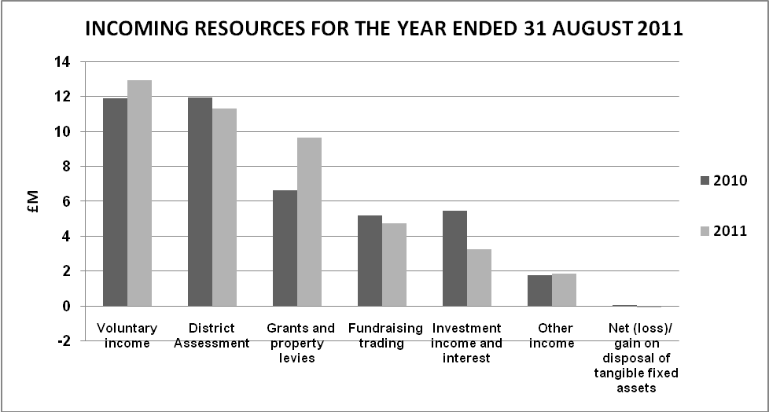

Charitable Expenditure

The underlying increase in total resources expended was 5% after stripping out the impact of the grant of the lease of Southlands College to Roehampton University. Charitable expenditure includes a planned draw-down on restricted and designated funds (including the Training Assessment and Connexional Priority Funds).

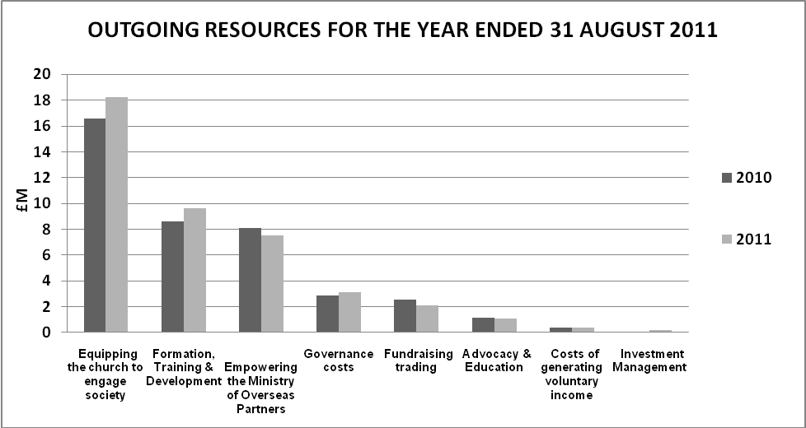

Strategic objectives, aims and purposes of the Methodist Church in Great Britain

The work covered in these accounts falls within the work of the Methodist Church. The strategic objectives of The Methodist Church in Great Britain (“The Methodist Church”) are directly linked to its aims. They are:
- Worship – to increase awareness of God’s presence and to celebrate God’s love;
- Learning and Caring – to help people to learn and grow as Christians, through mutual support and care;
- Service – supporting community development and action for justice, especially among the most deprived and poor - in Britain and worldwide; and
- Evangelism – developing confidence in evangelism and in the capacity to speak of God and faith in ways that make sense to all involved.

Public Benefit Requirement

The trustees of The Methodist Church had due regard to the public benefit guidance published by the Charity Commission in compliance with its duties under section 4 of the Charities Act 2006.

This guidance sets out two key principles:
- The organisation must have an identifiable benefit.
- The benefit must be to the public or a section of the public.

The Church exists, inter alia, to:
- increase awareness of God’s presence and to celebrate God’s love;
- help people to learn and grow as Christians, through mutual support and care; and
- be a good neighbour to people in need and challenge injustice.

The trustees consider that for these reasons the charity meets these public benefit requirements.

*** RESOLUTION

22/1. The Conference adopted the Report.
Consolidated Statement of Financial Activities for the year ended 31 August 2011
 |  | Unrestricted Funds |  | Restricted Funds |  | Endowment Funds |  | Total |  | Total
 |  |  |  |  |  |  |  | 2011 |  | 2010
 |  | £000 |  | £000 |  | £000 |  | £000 |  | £000
Incoming resources:
Incoming resources from generated funds
District Assessment |  | 11,223 |  | 93 |  | - |  | 11,316 |  | 11,934
Voluntary income |  | 571 |  | 12,353 |  | - |  | 12,924 |  | 11,894
Investment income and interest |  | 1,012 |  | 2,248 |  | - |  | 3,260 |  | 5,477
Activities for generating funds
Fundraising trading |  | 745 |  | 3,981 |  | - |  | 4,726 |  | 5,198
Incoming resources from charitable activities
Grants and capital levies |  | 8,943 |  | 685 |  | - |  | 9,628 |  | 6,605
Other income |  | 1,151 |  | 723 |  | - |  | 1,874 |  | 1,750
Other incoming resources
Net (loss)/ gain on disposal of tangible fixed assets |  | (97) |  | 5 |  | - |  | (92) |  | 42
Total incoming resources |  | 23,548 |  | 20,088 |  | - |  | 43,636 |  | 42,900
Resources expended
Cost of generating funds
Costs of generating voluntary income |  | 365 |  | - |  | - |  | 365 |  | 374
Fundraising trading |  | 326 |  | 1,798 |  | - |  | 2,124 |  | 2,528
Investment Management |  | 86 |  | 83 |  | - |  | 169 |  | 79
Charitable activities
Equipping the church to engage society |  | 12,807 |  | 5,417 |  | - |  | 18,224 |  | 16,609
Formation, Training Development &  Resourcing |  | 7,944 |  | 1,712 |  | - |  | 9,656 |  | 8,613
Transfer of Southlands College |  | - |  | - |  |  |  | - |  | 15,198
Empowering the Ministry of Overseas Partners |  | 829 |  | 6,685 |  | - |  | 7,514 |  | 8,073
Advocacy & Education |  | 1,058 |  | - |  | - |  | 1,058 |  | 1,135
Governance costs |  | 3,124 |  | 2 |  | - |  | 3,126 |  | 2,885
Total resources expended |  | 26,539 |  | 15,697 |  | - |  | 42,236 |  | 55,494
Net incoming/(outgoing) resources before transfers |  | (2,991) |  | 4,391 |  | - |  | 1,400 |  | (12,594)
Gross transfers between funds |  | 1,009 |  | 7,676 |  | (8,685) |  | - |  | -
Net incoming/(outgoing) resources after transfers and before other recognised gains |  | (1,982) |  | 12,067 |  | (8,685) |  | 1,400 |  | (12,594)
(Losses)/Gains on revaluations and disposal of investment assets |  | (147) |  | 2,340 |  | (581) |  | 1,612 |  | 5,648
Net movement in funds |  | (2,129) |  | 14,407 |  | (9,266) |  | 3,012 |  | (6,946)
Total funds brought forward
Total funds brought forward at 1 September |  | 42,915 |  | 71,273 |  | 21,898 |  | 136,086 |  | 143,032
Total funds carried forward at 31 August |  | 40,786 |  | 85,680 |  | 12,632 |  | 139,098 |  | 136,086

All activities are classed as continuing.

The Methodist Church in Great Britain
Consolidated balance sheet as at 31 August
 |  |  |  |  |  |  | 2011 |  |  | 2010
 |  |  |  |  |  |  | £000 |  |  | £000
Fixed Assets
Tangible assets |  |  |  |  |  |  | 22,871 |  |  | 23,738
Investments |  |  |  |  |  |  | 116,266 |  |  | 102,429
 |  |  |  |  |  |  | 139,137 |  |  | 126,167
Current Assets
Stock |  |  |  |  |  |  | 167 |  |  | 201
Debtors |  |  |  |  |  |  | 8,366 |  |  | 7,580
Short term deposits |  |  |  |  |  |  | 12,426 |  |  | 22,351
Cash at bank and in hand |  |  |  |  |  |  | 1,787 |  |  | 1,687
 |  |  |  |  |  |  | 22,746 |  |  | 31,819
Creditors
Amounts falling due within 1 year |  |  |  |  |  |  | (13,093) |  |  | (13,140)
Net current assets |  |  |  |  |  |  | 9,653 |  |  | 18,679
Total Assets less current liabilities |  |  |  |  |  |  | 148,790 |  |  | 144,846
Creditors
Amounts falling due after more than 1 year |  |  |  |  |  |  | (9,692) |  |  | (8,760)
Net Assets |  |  |  |  |  |  | 139,098 |  |  | 136,086
Endowment funds |  |  |  |  |  |  | 12,632 |  |  | 21,898
Restricted income funds |  |  |  |  |  |  | 85,680 |  |  | 71,273
Unrestricted income funds |  |  |  |  |  |  | 40,786 |  |  | 42,915
Total funds |  |  |  |  |  |  | 139,098 |  |  | 136,086

Accounting policies

- Basis of accounting
The consolidated accounts of The Methodist Church in Great Britain have been prepared under the historical cost convention, except for investments which are stated at market value (hotel properties are held at valuation), and are in accordance with applicable accounting standards and the Statement of Recommended Practice 2005 (SORP), Accounting and Reporting by Charities issued in March 2005 and the Charities Act 1993 and 2006.

b) Basis of preparation
The entities included in these accounts have been consolidated based on the view of the Council of the degree of control which it exercises over the entities concerned which is constantly under review.

- Basis of consolidation
The consolidation principles applied are based on Financial Reporting Standard (FRS 2) & SORP 2005 Para 381-385 which requires consolidation of all legally-controlled entities, where a majority of voting rights are held in order to show a true and fair view.
All of the entities listed in the table below are consolidated on the grounds that the Methodist Conference has the right to exercise dominant influence, and this influence is demonstrated in a number of ways, but mainly through the selection of the trustees on the boards of these entities.
Activities managed or administered by the Connexional Team (“the Connexional Funds”)
Cliff College | (a separately registered charity)
Cliff College Outreach Limited | (a separately registered company)
Cliff (Methodist) Developments Limited | (a separately registered company)
Methodist International Centre Limited | (a separately registered company)
Methodist Relief and Development Fund | (a separately registered charity)
Southlands College | (a separately registered charity)
Southlands College Enterprises Limited | (a separately registered company)
T Beckett (Saddler) Limited | (a separately registered company)
Trinity Hall Trust | (a separately registered charity)
Wesley Conference Centre Limited | (a separately registered company)

All the entities which are separately registered as charities, together with their wholly owned trading subsidiaries, have been consolidated as subsidiaries on a line by line basis in accordance with FRS2 and SORP 2005.

- The accounting / reporting structure

- Excluded entities - grounds for exclusion under paragraph 383 of SORP 2005
A number of entities have been excluded from the consolidation. These are:

Local Churches, Circuits and Districts
Methodist Independent Schools
Trustees for the Methodist Church Purposes (TMCP)
The Central Finance Board (CFB)
Methodist Ministers Housing Society

Whilst these entities might form part of the overall picture of the Methodist Church, the Methodist Council does not control their activities.

f) Definitions of Resources expended

Costs of generating funds
Costs of generating funds include the direct costs of fundraising trading, investment management, custody fees and a proportion of shared and indirect support costs.

Charitable activities
Charitable activities: These include the direct costs of the activities.

Support costs: These include the central functions and have been allocated to fundraising, charitable activities and governance in proportion to the directly attributable costs of these activities.
Governance costs: These are the costs associated with constitutional and statutory requirements and include external audit, legal advice on governance issues, district chairs, trustees’ expenses and a proportion of shared and indirect support costs.

g) Definitions of Funds
Unrestricted funds are funds which are available for use at the discretion of the trustees in furtherance of the general objectives of the Charity.

Designated funds comprise unrestricted funds that have been set aside by the trustees for particular purposes. The aim and use of each designated fund is set out in the notes to the financial statements.

Restricted funds are funds which are to be used in accordance with specific restrictions imposed by donors or which have been raised by the trustees’ particular purposes. The cost of raising and administering such funds are charged against the specific fund.

Endowment funds represent monies received from donors where there is some restriction on the use of the initial capital.

Investment income is allocated to the appropriate fund in the case of restricted funds and in accordance with the terms of the endowment in the case of endowment funds

h) Tangible fixed assets

In line with FRS 15 requirements, the managing trustees of the various entities have reassessed the market value of their existing land and buildings and are of the opinion that it significantly exceeds the book value of the assets.

Assets having an initial cost of £1,000 or less are written off on acquisition. Furniture & fittings, computer equipment, computer software and motor vehicles having an initial cost greater than £1,000 are stated at cost less depreciation which is charged on a straight line basis. Computer equipment and software are depreciated at the rate of 33 1/3% per annum.

Furniture & fittings and motor vehicles are depreciated at the rate of 20% per annum.

i) Heritage assets
Heritage assets are defined as assets which have historical, artistic, scientific, technological, geographical or environmental qualities that are held and maintained principally for their contribution to knowledge and culture.

Where the Church has information on the cost or value of a heritage asset then it will account for it at that cost or valuation. Where this information is not available and the historical cost information cannot be obtained the assets have been excluded from the balance sheet.

There are four Methodist Heritage sites in Great Britain which fit into this definition. These are: The Old Rectory, Epworth, Lincolnshire - the childhood home of John and Charles Wesley; The New Room (John Wesley's Chapel), Bristol - the first-ever Methodist building in the world; Wesley's Chapel & House, & The Museum of Methodism, London - John Wesley's London base, (from which he travelled 250,000 miles to preach, and the place of his death and burial) and Englesea Brook Chapel & Museum of Primitive Methodism, near Crewe - exhibitions and activities focusing on one strand of nineteenth century Methodism.

All these assets are under the trusteeship of a number of Districts and Circuits which are not included in the consolidated accounts of the Church.

Independent Auditor’s Report to the Trustees of The Methodist Church in Great Britain

We have audited the financial statements of The Methodist Church in Great Britain for the year ended 31 August 2011. The financial reporting framework that has been applied in their preparation is applicable law and United Kingdom Accounting Standards (United Kingdom Generally Accepted Accounting Practice).
This report is made solely to the charity’s trustees as a body, in accordance with the Charities Act 1993. Our audit work has been undertaken so that we might state to the charity’s trustees those matters we are required to state to them in an auditor’s report and for no other purpose. To the fullest extent permitted by law, we do not accept or assume responsibility to anyone other than the charity and the charity’s trustees as a body, for our audit work, for this report, or for the opinions we have formed.
Respective responsibilities of trustees and auditor
The trustees are responsible for the preparation of the financial statements and for being satisfied that they give a true and fair view.
We have been appointed as auditors under section 43 of the Charities Act 1993 and report in accordance with regulations made under section 44 of that Act. Our responsibility is to audit and express an opinion on the financial statements in accordance with applicable law and International Standards on Auditing (UK and Ireland). Those standards require us to comply with the Auditing Practices Board’s (APB’s) Ethical Standards for Auditors.
Opinion on financial statements
In our opinion the financial statements:
- give a true and fair view of the state of the group’s and charity’s affairs as at 31 August 2011 and of their incoming resources and application of resources for the year then ended;
- have been properly prepared in accordance with United Kingdom Generally Accepted Accounting Practice; and
- have been prepared in accordance with the requirements of the Charities Act 1993.

Matters on which we are required to report by exception
We have nothing to report in respect of the following matters where the Charities Act 1993 requires us to report to you if, in our opinion:
- the information given in the Trustees’ Report is not consistent with the financial statements; or
- the parent charity has not kept sufficient accounting records; or
- the parent charity financial statements are not in agreement with the accounting records and returns; or
- we have not received all the information and explanations we require for our audit.

BAKER TILLY UK AUDIT LLP
Statutory Auditor, Chartered Accountants
Hartwell House, 55 – 61 Victoria Street
Bristol, BS1 6AD

Date: 24 January 2012

