52. Statistics for Mission 2008-10
Title | Statistics for Mission 2008-10
Contact Name and Details | Christopher Stephens, Research Officer  Stephensc@methodistchurch.org.uk 020 7467 5247
Status of Paper | Final
Resolution/s | The Conference receives the Report

Summary of Content
Subject and Aims | The paper aims to:  - inform the Conference of developments in the annual Statistics for Mission process and reporting styles since 2008  - provide information on the full scope of statistical reporting that will be made available on the Methodist website by the time the Conference meets and in the following months  - set out collection and reporting priorities for the future  - provide a connexional-level report on membership, attendance and other statistical data gathered during 2008/2010 (but to encourage representatives to use this only as a starting point for exploring the data to be made available online)
Main Points | - Context  - Why count?  - Improving the process  - Improved reporting  - The connexional Statistics for Mission analysis report  - Additional Information: “STATS4MISSION” pilot  - Additional Information: data analysis and Methodist Schools  - Appendix 1: 2010 summary data tables  - Appendix 2: definitions and methodological notes
Background Context and Relevant Documents | SO 358; 644 (8); 054 (12-13)  Reporting of 2009 data at www.methodist.org.uk/statisticsformission (to which will be added some additional detailed 2010 reporting by the time the Conference meets)  Statistics for Mission (2008 Conference Report, Agenda 2 pp.578-591)
Consultations | Methodist Council; regular feedback from church members; focused consultation with District Chairs, Superintendent Ministers, District Development Enablers and District Membership Secretaries; Working Party of district representatives.

Summary of Impact
Impact | The information provided in this report and, in particular, the more detailed reporting available to all members of the Church online should impact on decision making and mission planning throughout the Church.
Risk | Statistics do not provide a complete narrative about the health of the Church. Headline figures must be treated with caution and understood as only limited measures of Church activity. The use of figures in isolation from wider contextual information can lead to unfair or inaccurate assumptions.

Statistics for Mission 2008-10

Good research helps the Church to understand more of what it is, what it has been and what it can or might become. Only by learning about itself can the Church make informed decisions about how best to focus its resources and energies to serve its God-given mission. This is the principle which underlies the Statistics for Mission process.

1. Context

1.1 The Methodist Church has a long tradition of intentionally and purposefully counting. Although the data collected and type of reporting has varied, Conference Agendas stretching back to the nineteenth century show a concern for the collection of statistics for the purposes of transparency and accountability and to ensure the better functioning and oversight of the Connexion.

1.2 Standing Order 358 requires that the Connexional Team brings a report on the annual membership returns to the Conference every three years. 2011 marks the latest in this series of triennial reports. In turn, the same Standing Orders require Chairs and Superintendents, with support from circuit office holders, to make available to the Team such statistical figures as are necessary for this reporting, as well as other types of data necessary for the business of the Team in providing “a coherent and effective service in behalf of the Conference “ [SO 302(1)] and enabling the Methodist Church “better to fulfil its calling of responding to God’s love in Christ and working out is discipleship in worship and mission” [SO 303(1)].

1.3 The membership returns are therefore just one aspects of a much broader piece of work, now called Statistics for Mission, the results of which are made available on the Methodist Church website www.methodist.org.uk/statisticsformission. A large amount of effort has, during the last triennium, been put into expanding both the type of data collected in the regular October returns and also the intended audience of the resulting reports, with the sole purpose of focusing on and releasing the mission potential of this research activity for the whole Methodist Church and, indeed, the whole people of God. The first step in this was to increase the administrative and technical support for the process from October 2009 and to transfer responsibility for managing the work to the Research team within the Projects, Research and Development Cluster of the Connexional Team, for whom it has become a dominating focus. That team made efforts to ensure that everyone in the Church who had been, who is, or could be involved in the Statistics for Mission process on a regular basis was contacted and given the open and continuing invitation to make comments, give feedback and suggestions, and help plan the future direction of this work. That offer remains open.

2. Why Count?

2.1 The reporting of connexional and local statistical information lets the Church, the Conference, the Connexional Team, district officers, circuit ministers, Methodist members and worshippers, ecumenical and international Partner Churches find out something about what we are, who we are, where we are, how we have changed and are changing and, to a certain extent, what we are doing. The Conference has consistently affirmed the importance of this for a mission-focused Church.

2.2 At one level, the Statistics for Mission reporting allows us to know interesting and useful facts about the Church, to provide us with a sense and measure of what is sometimes, probably unhelpfully, called the ‘health’ of the Church. The connexional analysis report in Section 5 below does just this. This year, therefore, the report tells us that in 2010 the Connexion was made up of 5,162 church communities in 467 Circuits; we had a membership of 238,000 people; a wider community roll of up to 587,000 people; and an estimated average weekly attendance at churches of 248,000 people. The analysis report demonstrates how this has changed over the past three years.

2.3 On a more practical level, the data captured in the Statistics for Mission process feeds directly into connexional programmes and projects, strategic decisions and policy recommendations. Some recent examples where this has happened include work relating to fresh expressions, the Belonging Together partnership, equalities and diversity, children and youth, carbon reduction initiatives, and the missing generation project. 2009 Statistics for Mission reporting, available online, gathered together a number of comments from Church officers to demonstrate the critical place this data has had in decision making in a number of areas like these.

2.4 Most importantly, the data available to every church member via the Methodist website can provide a planning tool for anyone with an active interest in church life and mission work. In 2009/2010, some basic guidance was written and placed alongside the online statistical reporting. This began to demonstrate how local congregations could begin to use the data available to them in raw, summarised and map forms to assist in planning new ventures, boosting local support networks, and setting up new initiatives. As our reporting evolves, so it is the intention of the Research team to focus more and more efforts on supporting local communities to use the information available to them.

2.6 As the Research team develops the type of data collected and the way it is reported, a particular concern is to ensure this process really does emphasise the fact it is ‘for mission’ and that its results are used in that way. We are often easily led into believing the statistics the Church collects represent a picture of decline. However, by looking also at measures of church life other than Sunday attendance and formal membership, the hope of the Research team is to show a more rounded picture of church life, and offer a voice of hope. There is, indeed, a great deal in this year’s report about which to be hopeful. In 2010, 133,000 children and young people were involved in Methodist, church-led activities outside of regular worship; 67% of Methodist Circuits reported a regular activity which they considered to be a fresh expression of church; Methodist churches offered worship or fellowship in 41 languages.

3. Improving the process

3.1 The major data collection exercise for Statistics for Mission takes place in October of each year, during which every local church is asked to fill out a web-based form with the data required. Data collection happens on a church-by-church basis (a church being defined as a gathered community of worshippers) rather than at the level of worship building or Circuit. This limits the process in some respects, but remains the most efficient level at which to count, given the resources available. To take account of this, forms are now designed to allow some types of data capture which enable the analytical process to extract circuit-level information. The response rate has increased significantly over this triennium and in 2010 reached 96% of churches. This is the result of work on the part of district, circuit and church staff, ministers and volunteers and their efforts are greatly appreciated.

3.2 October has been chosen deliberately as part of an ecumenical agreement amongst the major Christian denominations in Britain to count data at the same time. Although there is nothing like a ‘typical’ month in the life of the Church, October is a safe choice for giving a stable picture of church life, avoiding high festivals and lengthy summer vacations. It also avoids times of major transition in most Methodist Circuits. Counting at the same time allows denominations to make more accurate comparisons and plan together more fruitfully.

3.3 Over this triennium, the annual Statistics for Mission cycle has been developed to be as collaborative, responsive and flexible as possible. Additional efforts to do this can mean significant rewards for the Church. By 2011 the Research team has not achieved all that is possible already, and it fully intends to keep working on this. As changes and developments in technological possibilities arise, these, too, will allow Statistics for Mission to adapt to make the process easier and the reporting better. At this time, for example, the Research team is working with a new web development company to produce a more advanced and more user-friendly data entry site. Many of the new features will result from suggestions made by circuit ministers and administrators, who submit the October data.

3.4 The most significant change in the last triennium has been the inclusion of ‘annual questions’ in the 2009 and 2010 forms. These are questions which appear for one or two years to provide specific one-off data sets relating to a particular area of Church life. In 2009 and 2010 these additional questions have provided information on fresh expressions of church, ethnically distinct congregations, diversity in worship language, the roles and numbers of local chaplains, local church links with World Church partners, and a range of data on volunteer and employed children and youth workers across the Connexion. In 2011, annual questions will begin to provide valuable information on age and gender demographics across the Church, on the amount and scope of community outreach work engaged in by Methodist churches in local contexts, and on local carbon reduction activities.

3.5 Questions that are added in this way are the result of proposals made by anyone in the Church who wishes to put them forward, with invitations being sent to all District Chairs, District Development Enablers, Training Officers, District Membership Secretaries and Superintendent Ministers on a number of occasions throughout the year. The questions used are chosen on the basis of several factors, including the likely importance of the proposed data for the mission needs of the Church, the ease of collection for local churches, the frequency of the request, and the correlation of the question with other strategic priorities emerging in the Church. Questions are debated, designed and tested to ensure the least possible work is required of local churches to produce the most useful results. The results are then collated and reported by the Research team as simply and usefully as possible and made available on the Methodist website. The Research team is assisted in this work by a partnership agreement with the Church of England Research and Statistics department, who perform important analytical work on our behalf, and by the vital assistance of database, administrative and IT staff in the Connexional Team.

3.6 Shortly after the beginning of the connexional year 2010/11, the complete set of 2009/2010 data, analysis and reporting was published on the Methodist website and links to this sent to every District Chair, Superintendent Minister and District Membership Secretary (where these still exist). This was accompanied by the offer of personal time spent with connexional and district staff to assist in the interpretation and use of the data. As new sets of data become available, this offer remains open, as does the invitation to anyone involved in the collection process, or local mission generally, to contact the Research team at Methodist Church House and discuss the emerging numbers, the process, or the questions.

4. Improved reporting

4.1 This year, the Research team has attempted to do more with the triennial reporting than has previously been offered, with a particular focus on providing data and analysis which is accessible, visually appealing and focused particularly at district level. The purpose of this is to assist in key mission planning at that level, as well as providing for local churches and Circuits reports into which their own local contexts fit less anonymously than in a solely connexional-level analysis.

4.2 A key message which has been voiced around the Church is that, while detailed numerical charts and spreadsheets should be made available to church members, developing a more approachable style of reporting will allow far more people to engage with the data and, in turn, instigate more fruitful, mission-focused conversations. As such, the 2009 Statistics for Mission reports featured, in addition to the raw data and numerical analysis, both written summaries of district ‘headline stories’ and also a number of analytical maps. These have been warmly received. The intention of the Research team is therefore to focus increasing efforts on alternative styles of reporting, particularly creative visual methods of representing data, and to produce these throughout this and every year.

4.3 In order to accommodate this focus, to build on the extensive reporting offered for the October 2009 data, and to allow for more advanced methods of reporting, particularly maps, the majority of the statistical reporting available to the Church in 2011 is not contained in the main Conference Agenda. The Conference is offered in Section 5 of this Report a connexional-level analysis in the traditional style of past years, with some enhancements. However, this is just one small part of what will be available for Methodist members from July 2011 and throughout this and future connexional years. The Conference will be given a unique demonstration during its Representative Session of what else has been done by that point and is, or will be, available online at www.methodist.org.uk/statisticsformission. In addition, district representatives at the Conference will be issued during the Representative Session with separate printed copies of some of the new, additional material relating specifically to their Districts. Work is also underway to produce a popular booklet summarising the triennial findings, for distribution across the Church. Districts will be invited to order copies of this for their synods when they become available in the autumn.

5. The Connexional Statistics for Mission Analysis Report

5.1 Foreword from Lynda Barley, Head of the Research and Statistics Department of the Archbishops Council

Methodist churches are a lively Connexion and the 2010 collection of mission statistics provides a fuller statistical picture than has been previously possible. The positive development of web based data collection has significantly improved the efficiency of this annual exercise and its ability to adapt to changing contexts on the ground.

Children and young people are both the Church of the future and part of the Church today. These mission statistics are evidence that many churches are seeing the rewards of bringing this vibrancy into their church life. In 2010 the participation of children and young people in worship and other activities attached to church life has grown mainly from activities outside Sunday observance. Commitment to the future of church life is demonstrated further by the large number of churches which employ adults to work with children and young people.

Looking further beyond our church walls, 2010 saw significant numbers of fresh expressions of church and of expressions of community chaplaincy reported by churches. Methodist churches are finding a positive response as they rise to the challenge of spreading the good news of the Gospel beyond their doors into the wider community and the next generation. It is a joy that in this report the 2010 statistical collection reveals churches getting into good shape to grasp the Apostle Paul's Olympic spirit of straining towards what lies ahead, pressing towards the heavenly prize to which God has called us.

The Revd Lynda Barley May 2011
5.2 Summary

Table 1 Key membership and attendance statistics, 2007 to 2010
Thousands | 2007 | 2008 | 2009 | 2010 | Change 2007 to 2010 | Change 2009 to 2010
Membership | 263 | 252 | 243 | 238 | -10% | -2%
Community Roll | 644 | 601 | 575 | 565 | -12% | -2%
Baptisms and Thanksgivings | 12 | 11 | 11 | 11 | -7% | 4%
Confirmations | 3 | 3 | 3 | 3 | 0% | 15%
Couples Married or Blessed | 4 | 4 | 4 | 4 | -12% | 0%
Funerals | 24 | 24 | 23 | 23 | -3% | 2%
Average Adult Sunday Attendance | 194 | 189 | 188 | 181 | -7% | -4%
Average Adult Midweek Attendance | 22 | 22 | 21 | 20 | -11% | -7%
Average Adult Attendance All Week | 215 | 211 | 209 | 200 | -7% | -4%
Average Under 13 Sunday Attendance | 22 | 22 | 21 | 20 | -9% | -5%
Average Under 13 Midweek Attendance | 14 | 16 | 14 | 17 | 20% | 17%
Average Under 13 Attendance All Week | 36 | 37 | 35 | 37 | 2% | 4%
Average 13 to 19 Sunday Attendance | 7 | 7 | 6 | 6 | -6% | 0%
Average 13 to 19 Midweek Attendance | 4 | 4 | 3 | 5 | 18% | 35%
Average 13 to 19 Attendance All Week | 11 | 11 | 10 | 11 | 1% | 10%
Average Sunday Attendance | 223 | 217 | 215 | 207 | -7% | -4%
Average Midweek Attendance | 40 | 42 | 39 | 41 | 3% | 6%
Average Attendance All Week | 262 | 259 | 254 | 248 | -5% | -2%

- In 2010 the Methodist Connexion was made up of 31 Districts, 467 Circuits and 5,162 church communities (defined as a worshipping community with a Church Council). These figures compare to a Connexion in 2008 which contained 5,484 church communities in 546 Circuits, representing a reduction of 322 (6%) and 79 (14%).

- The total number of children and young people reported to attend children and youth groups attached to the 2,067 churches who reported such activities in 2010, was 133,000. This compares to 98,000 children and young people in groups attached to 1,700 churches in 2009, and 108,000 in 1,733 churches in 2008.

- Churches were asked in 2010 how many people are employed (in a paid capacity) in their church specifically to work with children and young people, and with which age ranges they were engaged. In 2010, 646 posts were identified by 495 churches. However, half of those posts were shared, either across Circuits, the District, or with other partners.

- In 2010 there were 1,257 fresh expressions identified, 941 (in 723 churches) of which meet on a regular basis (monthly or more often).

- 1,055 churches reported expressions of community chaplaincy performed by between 1 and 21 people (excluding larger groups of volunteer lay people) in each church. Across the Connexion, this added up to 2,947 people involved in chaplaincy roles (including those volunteer lay people).

- Respondents were asked for the first time in 2010 whether their church has a formal link with an overseas church, 327 of whom reported that they did.

- In 2009 and 2010 125 churches reported that their church runs or hosts Methodist worship or fellowship in a language other than English or Welsh and 165 that their church runs or hosts Methodist worship or fellowship using English or Welsh for ethnically distinct congregations or groups.

5.3 Introduction
This report marks the end of the 2008–2010 triennium and explores how, in terms of the statistics our churches collect, the Methodist Church has changed and developed over the past three years. Information in this report focuses on top level figures for the whole Methodist Connexion, including links with overseas congregations, worship in schools and fresh expressions. This triennium, additional local level information and analysis can also be found in district profile reports, which will be made available by the time the Methodist Conference meets via the Methodist website at www.methodist.org.uk/statisticsformission. Whilst the majority of analysis explores the last triennium, in some places it is possible to look back further and compare with previous triennia.

5.4 Method and response rate
The data used in this report was collected via an online or paper survey form, made available in 2010 to 5162 churches from the start of September, with a closing date in December. The response rates for the three years 2008, 2009 and 2010 are listed in Table 2 below, and include those who gave partial responses. Where appropriate, missing data has been imputed to enable estimated totals to be given for the whole Methodist Connexion.

Table 2 Response rate 2008 to 2010
2008 | 85 %
2009 | 91 %
2010 | 96 %

5.5 The Methodist Connexion
In 2010 the Methodist Connexion was made up of 31 Districts, 467 Circuits and 5,162 church communities (defined as a worshipping community with a Church Council). These figures compare to a Connexion in 2008 which contained 5,484 church communities in 546 Circuits, representing a reduction of 322 (6%) and 79 (14%).
Figure 1
Churches are invited to classify themselves in terms of the makeup of their local area ranging from rural village to city centre. Of the 5,162 church communities, nearly a half are considered to be village rural (Table 3). Comparing the number of churches to those in the previous triennium indicates that the geographical spread of churches has remained broadly stable.

Table 3 Geographical categorisation of churches
 | Count of churches 2010 | Per cent | Count of churches 2007 | Per cent
Not specified | 8 | 0% | 1 | 0%
City Centre | 111 | 2% | 108 | 2%
Council Estate | 270 | 5% | 288 | 5%
Inner City | 299 | 6% | 310 | 6%
Suburban Neighbourhood | 1189 | 23% | 1205 | 22%
Small Town | 1005 | 19% | 1025 | 19%
Village Rural | 2280 | 44% | 2445 | 45%
Connexion | 5162 | 100% | 5381 | 100%

5.6 Membership

5.6.1 Wholly Methodist churches (non-LEP churches)
Membership of the 4,622 wholly Methodist churches in 2010 ranged from under 10 in the smallest churches to 549 in the largest churches. Accounting for missing data, it is estimated that there are 219,000 members in total across the Methodist Connexion in wholly Methodist churches. This has declined through the triennium by 6 per cent from an estimated 234,000 members in 2008.
The estimated total number of “Pastoral Others”, that is those linked with local churches but not formally members, across wholly Methodist churches in the Methodist Connexion was 289,000, a drop of around 8 % over the triennium.

5.6.2 LEP Membership
Membership of the 540 Local Ecumenical Partnership (LEP) churches in 2010 ranged from under 10 across all denominations in the partnerships in the smallest churches to 450 in the largest churches. Again, accounting for missing data, an estimated total number of members (Methodist, URC, Baptist, CofE, other denominations and joint members) in LEP churches is 42,000. The estimated total of the Methodist membership (including those joint members apportioned according to local LEP agreements as Methodist) within LEPs, across the Methodist Connexion is 19,000. This has grown through the triennium by 2 per cent from an estimated 18,000 members in 2008, when there were 554 LEPs.
In 2010, LEPs were most frequently partnerships between Methodists and United Reformed Church denominations (Figure 2). Methodist membership within LEPs on average accounted for around 46 % of the total LEP membership.

Figure 2 LEP denominational membership makeup 2010

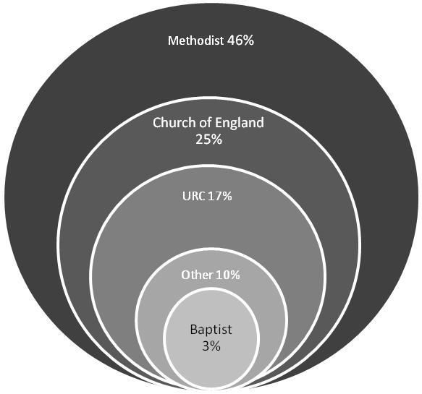

The estimated total number of “Pastoral Others”, that is those linked with local churches but not formally members, across LEP churches in the Methodist Connexion was 38,000 in 2010, compared to 37,000 in 2008.

5.6.3 Total Methodist Membership
Combining the estimated total membership of wholly Methodist churches and the Methodist membership of LEPs, the total Methodist membership of the Methodist Connexion in 2010 was 238,000. Adding pastoral others (327,000) gives an estimated total community roll of 565,000 in 2010, compared 601,000 in 2008 (Table 4).

Table 4 Methodist membership and pastoral others 2007 to 2010
 | 2007 | 2008 | 2009 | 2010 | Change 2007 to 2010 | Change 2009 to 2010
Members of wholly Methodist Churches |  | 234,000 | 224,000 | 219,000 |  | -2%
LEP Methodist members |  | 18,000 | 19,000 | 19,000 |  | 0%
Total Methodist members | 263,000 | 252,000 | 243,000 | 238,000 | -10% | -2%
Pastoral Others | 380,000 | 349,000 | 332,000 | 327,000 |  | -2%
Community roll | 644,000 | 601,000 | 575,000 | 565,000 | -12% | -2%

Half of the Methodist members in the Connexion are found in just over a third (35 %) of the Districts. The District with the largest number of members is London, with 8 % of members. The pattern is echoed with Pastoral Others, again with half of Pastoral Others found in just under a third (32 %) of Districts.

5.6.4 Wider community roll
The Church’s community roll can be interpreted and calculated in different ways. If we include not just those counted in table 4, but add together all people linked with Methodist churches across the Connexion (Methodist members, other denominational members of LEP churches and all Pastoral Others associated with Methodist or Methodist LEP churches) there were in 2010 587,000 people in regular contact with Methodist churches across Britain (Figure 3). This represents a 5 per cent drop over the triennium from 2008.

Figure 3 Community roll 2008 to 2010

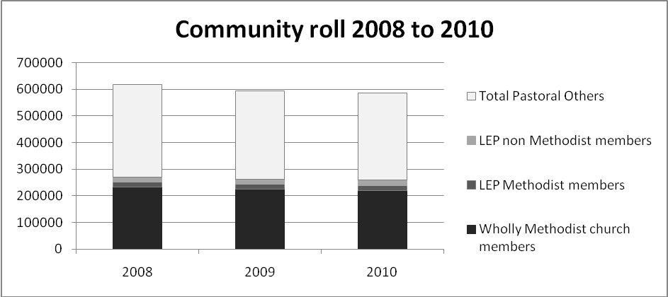

5.7 Confirmations, gains and losses
The trend over the triennium of gains and losses has remained broadly stable with a net loss in 2010 of 5,800 people across wholly Methodist and LEP churches (Figure 4). This compares to a net loss of 5,600 in 2008.
Figure 4 Total gains and losses across the Methodist Connexion, 2010
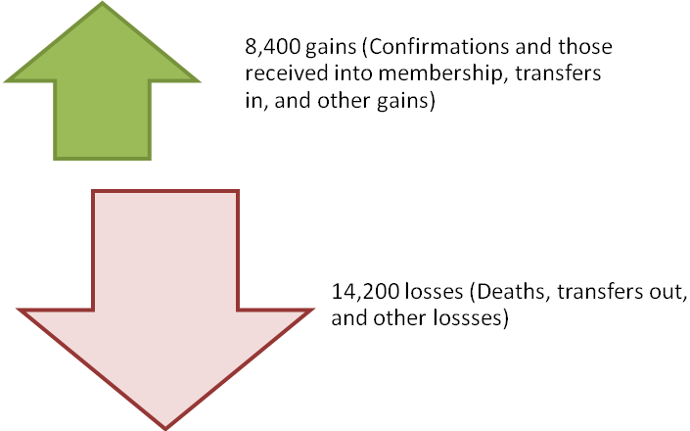

Figure 5 illustrates how the number of confirmations or those received into membership and other gains has remained stable across the triennium, but there appears to be a steady decline in additional members categorised as “transfers in” from other Methodist churches. The losses have again remained broadly stable through the triennium, but with fewer transfers out and deaths reported in 2009 and 2010, compared to those in 2008.

Figure 5 Gains and losses across the triennium
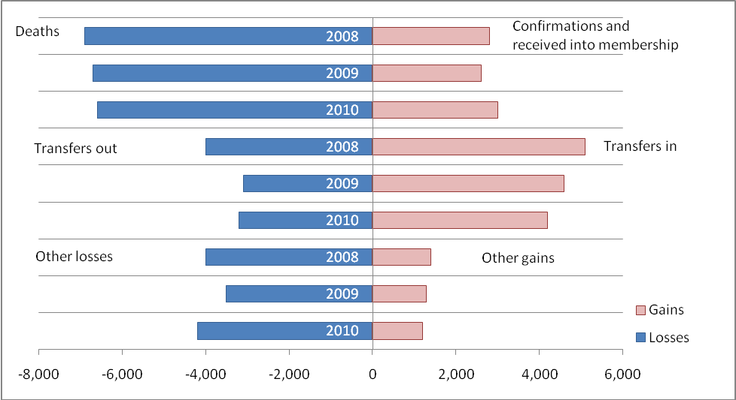
Table 5 shows the break-down of the losses and gains, looking first at wholly Methodist churches, and then LEPs. Gains in LEP churches show a very stable picture, but there appears to have been some increase in losses across the triennium.

Table 5 Gains and losses across the Methodist Connexion 2008 to 2010
Wholly Methodist Churches | 2008 | 2009 | 2010
Gains
Confirmations and those received into membership | 2,400 | 2,200 | 2,700
Transfers in | 4,600 | 4,000 | 3,700
Other Gains | 1,200 | 1,100 | 1,000
Total | 8,200 | 7,300 | 7,400
Losses
Deaths | 6,300 | 6,000 | 6,000
Transfers out | 3,700 | 2,800 | 2,700
Other losses | 3,500 | 3,100 | 3,600
Total | 13,500 | 11,900 | 12,300
Net loss | -5,300 | -4,600 | -4,900

LEP Churches | 2008 | 2009 | 2010
Gains
Confirmations and those received into membership | 300 | 400 | 400
Transfers in | 400 | 600 | 400
Other Gains | 200 | 200 | 200
Total | 900 | 1,200 | 1,000
Losses
Deaths | 600 | 700 | 700
Transfers out | 300 | 300 | 600
Other losses | 500 | 400 | 600
Total | 1,400 | 1,400 | 1,900
Net loss | -500 | -200 | -900

The gains and losses reported by churches often do not add up to reflect the total change in membership from 2009 to 2010. This can result from historic errors in the data, from differing response rates in each of the years, or from churches reporting membership without reporting gains and losses. These are problems which cannot be easily remedied. These figures for gains and losses in membership are therefore being considered separately to the net membership figures.

5.8 Wider influence of the Church
Churches were asked to report the baptisms, thanksgivings, marriages, blessings and funerals conducted in or in the name of their churches (Table 6).
Baptisms and thanksgivings in the each of the years 2008-2010 were slightly fewer in number than in 2007, but have remained fairly static in recent years. However, there appear to be early indications of changing patterns in the rates of baptisms of infants under 1 and those aged 1-12, possibly indicating parents may be waiting slightly longer to put children forward for baptism. This trend would, however, need to be investigated further and monitored in coming years before firm conclusions can be drawn.
The number of marriages and blessings of couples have remained stable in the years 2008-2010, but again appear to be slightly fewer in number than in 2007.
Funerals in total have fluctuated over the triennium, but have been similar in number to those reported in 2007.
Table 6 Baptisms, thanksgivings, marriages, blessings and funerals 2007 to 2010
 | 2007 | 2008 | 2009 | 2010 | Change 2007 to 2010 | Change 2009 to 2010
Baptisms aged <1 |  | 7,200 | 6,300 | 6,600
Baptisms ages 1 to 12 |  | 2,700 | 3,400 | 3,300
Baptisms aged >13 |  | 1,100 | 700 | 900
Thanksgivings for births |  | 500 | 500 | 500
Total baptisms and thanksgivings | 11,900 | 11,400 | 10,900 | 11,200 | -6% | 3%
Couples married |  | 3,600 | 3,300 | 3,300
Couples blessed |  | 400 | 400 | 500
Total marriages and blessings | 4,300 | 4,000 | 3,700 | 3,800 | -12% | 3%
Funerals in churches |  | 12,100 | 11,100 | 11,800
Funerals elsewhere in the name of the church |  | 12,200 | 11,800 | 11,600
Total funerals | 24,000 | 24,300 | 22,900 | 23,400 | -3% | 2%

5.9 October Attendance
The total number of people attending Sunday and midweek services has declined across the triennium in wholly Methodist churches, although there has been some growth in the number of people attending LEP churches. Combining the attendance of Methodists in wholly Methodist churches with all those who attend LEPs that involve a Methodist partnership gives a total weekly average attendance of 248,000 in 2010, compared to 259,000 in 2008. Attendance figures have seen some decline over the triennium, however these statistics also show a shifting pattern with attendance of midweek services remaining more stable over the triennium than Sunday attendance. This is a different trend to the previous triennium (2004 to 2007) which saw decline in both Sunday and midweek attendance. Tables 7 a, b and c provide attendance figures for wholly Methodist churches and LEPs separately.

Table 7a October attendance, 2008 to 2010
Wholly Methodist Churches | 2008 | 2009 | 2010 | Change 2008 to 2010
Average Adult Sunday Attendance | 164,100 | 160,700 | 155,200 | -5%
Average Adult Midweek Attendance | 19,700 | 18,400 | 16,500 | -16%
Average Adult Attendance All Week | 183,800 | 179,200 | 171,700 | -7%
Average Under 13 Sunday Attendance | 18,400 | 17,600 | 16,700 | -9%
Average Under 13 Midweek Attendance | 13,700 | 12,000 | 14,500 | 6%
Average Under 13 Attendance All Week | 32,100 | 29,600 | 31,100 | -3%
Average 13 to 19 Sunday Attendance | 5,800 | 5,500 | 5,600 | -3%
Average 13 to 19 Midweek Attendance | 3,700 | 3,000 | 4,100 | 11%
Average 13 to 19 Attendance All Week | 9,600 | 8,500 | 9,500 | -1%
Total Attendance All Week | 225,500 | 217,300 | 212,300 | -6%

Table 7b October attendance, 2008 to 2010
Attendance at LEPs (whole congregations) | 2008 | 2009 | 2010 | Change 2008 to 2010
Average Adult Sunday Attendance | 24,500 | 26,700 | 25,500 | 4%
Average Adult Midweek Attendance | 2,700 | 2,700 | 3,100 | 15%
Average Adult Attendance All Week | 27,200 | 29,500 | 28,600 | 5%
Average Under 13 Sunday Attendance | 3,300 | 3,500 | 3,300 | 0%
Average Under 13 Midweek Attendance | 1,900 | 2,400 | 2,300 | 21%
Average Under 13 Attendance All Week | 5,200 | 5,900 | 5,600 | 8%
Average 13 to 19 Sunday Attendance | 900 | 900 | 800 | -11%
Average 13 to 19 Midweek Attendance | 300 | 400 | 500 | 67%
Average 13 to 19 Attendance All Week | 1,200 | 1,300 | 1,300 | 8%
Total Attendance All Week | 33,600 | 36,700 | 35,500 | 6%

To reflect what might be called the ‘Methodist portion’ of attendees at LEPs, the attendance figures can be scaled down appropriately based on the proportion of the LEP membership that is Methodist, as established locally in each church’s LEP agreement. This is, of course, an inexact science since it is not possible to know whether those attending an LEP are Methodist members or from other denominations, but it does give a helpful indication.

Table 7c October attendance, 2008 to 2010
Methodist portion of LEP congregations | 2008 | 2009 | 2010 | Change 2008 to 2010
Average Adult Sunday Attendance | 14,600 | 15,100 | 12,300 | -16%
Average Adult Midweek Attendance | 1,600 | 1,600 | 1,600 | 0%
Average Adult Attendance All Week | 16,200 | 16,600 | 13,900 | -14%
Average Under 13 Sunday Attendance | 1,900 | 1,900 | 1,500 | -21%
Average Under 13 Midweek Attendance | 1,100 | 1,100 | 1,100 | 0%
Average Under 13 Attendance All Week | 3,000 | 2,900 | 2,600 | -13%
Average 13 to 19 Sunday Attendance | 500 | 500 | 400 | -20%
Average 13 to 19 Midweek Attendance | 200 | 200 | 200 | 0%
Average 13 to 19 Attendance All Week | 700 | 700 | 500 | -29%
Total Attendance All Week | 19,900 | 20,200 | 17,000 | -15%

Comparing this to the previous triennium, the trend of decline is broadly stable (Figure 6). The sharper rate of decline between 2004 and 2006 may simply result from differing response rates. The change in total attendance all week between 2004 and 2010 is a drop of 22 %.
Figure 6 Average All Week attendance, 2004 to 2010
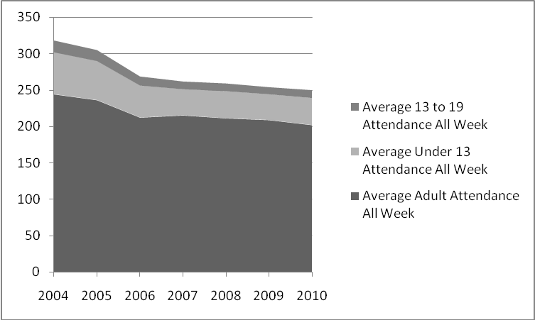

5.10 Children, youth and young adult groups
The total number of children and young people reported to attend children and youth groups attached to the 2,067 churches who reported such activities in 2010, was 133,000. This compares to 98,000 children and young people in groups attached to 1,700 churches in 2009, and 108,000 in 1,733 churches in 2008 (Figure 7). In 2010 there was a large increase (20 %) in churches responding to this question compared to 2008 and 2009. This means that, whilst the total number of children reported as attending has increased, the primary reason for this is because the number of groups we know about has increased. That said, this increase is good news, and should not be passed over.
The average number of children and young people attending groups attached to each church which reported these activities has remained stable across the triennium at 60 children or young people per church. The average number of groups per Methodist church across the whole Connexion has also remained stable across the triennium, at around three. The 5 to 13 age group remains the largest in terms of attendance, as does the larger number of females over males, particularly in that age category.

Figure 7 Attendance at children, youth and young adult groups, 2008 to 2010

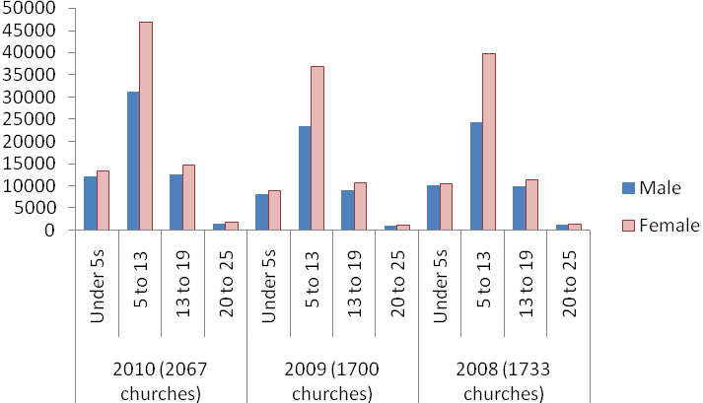
Respondents were asked from a drop down list to indicate the type of group each of these activities represented. The groups most frequently listed were Brownies, children’s midweek groups, other youth groups and Sunday morning groups. This has remained broadly consistent over the triennium (Table 8).

Table 8 Children and youth group activities, 2008 to 2010
 | 2010 | 2009 | 2008
Beavers | 3% | 3% | 3%
Boys’ Brigade | 5% | 6%
Brownies | 10% | 10% | 10%
Children's Midweek Groups | 9% | 15%
Cubs | 4% | 4% | 4%
Girls’ Brigade | 4% | 4% | 4%
Godly Play | <1%
Guides | 7% | 7% | 7%
JMA | 1% | <1%
Messy Church | 1%
Miscellaneous | 7% | 7%
Other Youth Group | 10% | 11% | 8%
Rainbows | 6% | 6% | 5%
Scouts | 4% | 4% | 4%
Sunday Morning Group | 13% | 14% | 1%
Under 5s | 8%
Uniformed Group Miscellaneous | 1% | 1% | <1%
Venturers | <1% | <1%
Youth Club | 7% | 8% | 9%
Unknown |  |  | 45%
Total | 100% | 100% | 100%

Churches were asked in 2010 how many people were employed (in a paid capacity) in their church specifically to work with children and young people, and with which age ranges they were engaged. In 2010, 646 posts were identified by 495 churches. However, half of those posts were shared, either across Circuits, the District, or with other partners. The following breakdown considers all posts as opposed to people (this is both due to methodological difficulties in identifying individuals from the posts, but also because this reflects the local experience of each church).

On average each post was active for 20 hours per week, but this represents reported working hours ranging from 1 hour a week to over 50 hours per week. The age group most frequently worked with was 5 to 13 years olds, where 59 % of posts did some kind of work with this group. 20-25 year olds were least frequently cited as being a target group of the work of these posts (Table 9).

Table 9 People employed to work with children and young people, 2010
 | Per cent of posts working with each group
Under 5 | 50%
5-13 years | 59%
13-19 years | 51%
20-25 years | 15%
Families | 30%

In 2009, churches were asked simply to identify the number of adults they employed to work with children and young people. In addition, they were asked to provide the number of adults in the church community who volunteered regularly to work with children and young people. 454 churches reported a very notable 19,099 volunteers and 466 paid staff appointed exclusively to single churches and a further 350 posts shared within the Circuit or in other arrangements.

5.11 Fresh Expressions
Respondents were asked to identify any fresh expressions attached to their church. A fresh expression is defined formally as “a form of church for our changing culture established primarily for the benefit of people who are not yet members of any church”. Understanding of what fresh expressions could look like is developing across all denominations. As such, the way that this data is collected has changed over the triennium and how we use or rely on the data must be considered with some caution. The Fresh Expressions agency and specialists in the Connexional Team have looked closely at this data in the last two years, and are working with the Research team to identify increasingly better ways to identify new, missional work from which the Church more widely can learn.

In 2010 there were 1,257 fresh expressions identified by Methodist churches and LEPs. Although all of these are stored and the data will be used, at the advice of fresh expressions specialists, those which meet on a regular basis (monthly or more often) are included in this more detailed analysis. This leaves a total of 941 (in 723 churches).

There were between 1 and 13 fresh expressions identified in any one Circuit, with an average of 3 across the 315 circuits which identified a fresh expression. This means that around 67 % of all Methodist Circuits had at least one fresh expression. Half of the fresh expressions identified were found in just under a third (32 %) of Districts. Southampton was the District with the greatest number of fresh expressions, 6 % of all fresh expressions. This compares to 893 fresh expressions identified in 2009 (this was the first year for asking this question). However, it must be noted that these figures are estimates only and it would be premature to read this as an increasing trend. The numbers are likely to change as people gain a better understanding of what should be recognised as a fresh expression of church and what activities might better be defined as fresh expressions of worship or other types of missional outreach work.

In 2010, four predefined categories were given for respondents to use when describing what type of fresh expression they ran: Messy Church, Café Church, Cell, 3rd Place. There was a spread of fresh expression types, with “Messy Church” being the most frequently cited and attended. Average attendance ranged from 31 people at Messy Church to 13 people at 3rd Place. 3rd Place fresh expressions are those where the worshipping community meets away from the church premises, for example in a pub or the gym, and which are types of fresh expression that do not fit one of the other predefined categories.

The pie chart below (Figure 8) illustrates the breakdown of reported Methodist fresh expressions that fit the pre-defined categories of fresh expression available on the October Count form.
Figure 8 Types of fresh expressions, 2010
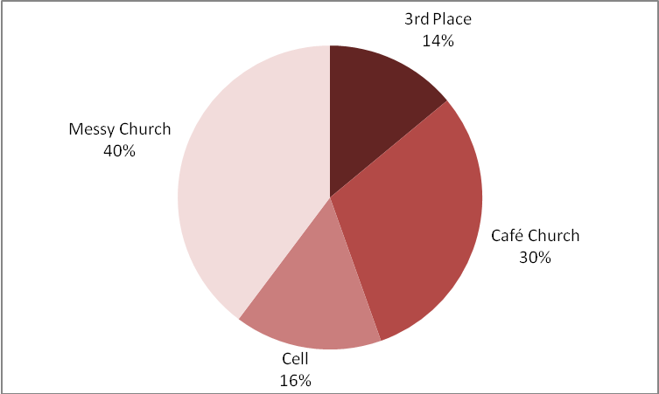

Fresh expressions most often took place in church buildings (62 % of those cited), followed by homes (14 %) and cafes (11 %). Nearly three quarters (73 per cent) met once or twice per month, and just over a quarter (26 %) met weekly or more frequently (Table 10).

Table 10 Types and locations of fresh expressions, 2010

 | Café | Church | Home | Library | Other | Pub | Total
3rd Place | 37% | 9% | 13% | 0% | 28% | 13% | 100%
Café Church | 15% | 74% | 1% | 1% | 9% | 0% | 100%
Cell | 0% | 16% | 79% | 0% | 2% | 3% | 100%
Messy Church | 3% | 89% | 0% | 0% | 8% | 0% | 100%
Total | 11% | 62% | 14% | 0% | 10% | 2% | 100%

Looking at the 297 fresh expressions meeting regularly which did not fit into the standard predefined categories revealed a variety of activities that will need consideration, discussion and engagement to work out which are in fact new and exciting fresh expressions of church, from which the Church more widely can learn and with which it must engage. They are found in the following locations, covering a wide range of ventures and initiatives (Figure 9):
Figure 9 Location of "other" fresh expressions, 2010
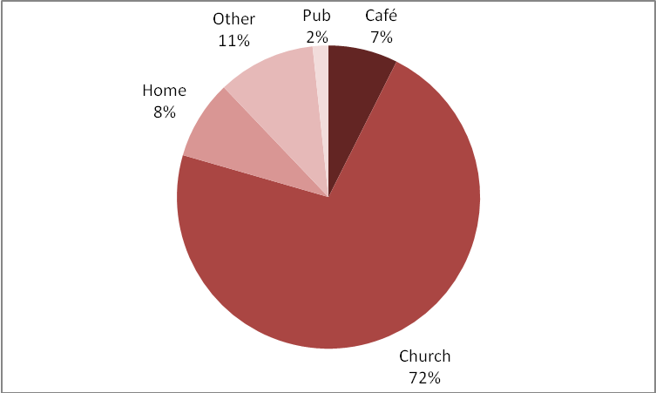

5.12 Expressions of community chaplaincy
For the first time in 2010, churches were asked to identify all expressions of chaplaincy they perform in their communities. 1,055 churches reported 1,829 expressions of chaplaincy with responses ranging between 1 and 21 expressions in each church. Across the Connexion, this added up to 2,947 people involved in these chaplaincy roles. Chaplaincy here includes the normal accepted ministries together with other forms of community ministry where churches engage with the community outside of their own life (eg Street Pastors, town centre chaplaincy, ministry to care homes for the elderly).

Of these chaplaincy roles, respondents were asked to report how many were performed by presbyters, deacons, paid lay people, or volunteer lay people (Table 11). Volunteer lay people accounted for half of the expressions of chaplaincy reported, followed by presbyters (39 %). Deacons and paid lay people accounted for the fewest reported expressions of chaplaincy, at 11 % combined.

Table 11 Expressions of community chaplaincy, 2010
Volunteer lay people | 50%
Presbyters | 39%
Paid lay people | 8%
Deacons | 3%

5.13 World Church links, language and ethnicity

5.13.1 Overseas link
Respondents were asked for the first time in 2010 whether their church has a formal link with an overseas church. It should be noted that these responses represent active engagement at church level with these kinds of activities, and they do not by any means represent a picture of other initiatives at district or connexional level.
327 churches reported that they did have a link, over 10 % of which were from the Chester and Stoke on Trent District. Of those overseas links cited, the majority were with Kenya (19 %), followed by Zambia (9 %) and Zimbabwe (7 %). In total, Methodist churches had links with 60 different countries. The nature of those links was fairly evenly spread between overseas mission projects (28 %), church-to-church links (25 %), involvement in a district link (22 %), and other links, including working with children and schools, (17 %) and hosting an overseas minister (1 %) (Figure 10).
Figure 10 Formal links with an overseas church, 2010

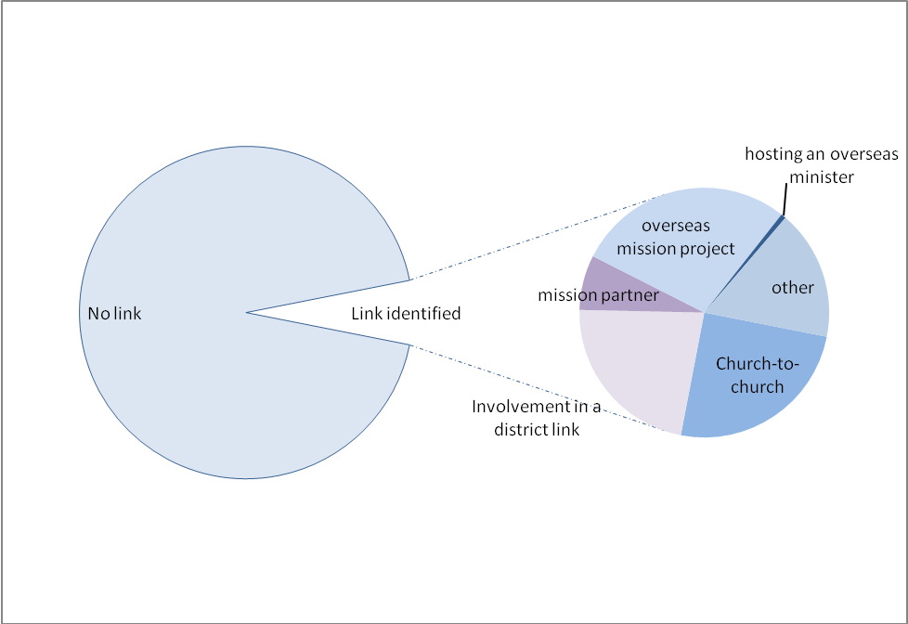

5.13.2 Language
Respondents were asked in 2009 and 2010 whether their church runs or hosts Methodist worship or fellowship in a language other than English or Welsh. 125 churches of the 4,167 to respond indicated that they did, over a quarter of which were in the London District.

The most frequently stated language was Zimbabwean/Shona, followed by French, Korean and Punjabi. One interesting result of this question was to identify six churches across the Connexion with worship or fellowship conducted in British Sign Language. The full list of languages reported were as follows (Figure 11):

Figure 11 Languages of Methodist worship or fellowship, 2010
Amharic, British Sign Language, Cantonese, Chinese, Congolese, Cornish, Creole, Eritrean, Ethiopian, Fante, Farsi, Fijian, Filipino, French, Gah, German, Ghanaian/Twi, Gujarati, Hindi, Kerala, Kiswahili, Korean, Lingala, Malayalam, Mandarin, Nepalese, Punjabi, Romanian, Russian, Shona/Zimbabwean, Swahili, Syriac, Tagalog, Tamil, Tongan, Urdu, Vietnamese, Yoruba, Zambian.

5.13.3 Worship or fellowship for ethnically distinct congregations
Respondents were also asked whether their church runs or hosts Methodist worship or fellowship using English or Welsh for ethnically distinct congregations or groups.
Over the years for which this question was asked (2009 and 2010) 165 churches indicated that they did, again with the London District reporting the highest number, nearly a third of all reported. Just under a half of those churches to report such worship or fellowship were in only three Districts: London, Birmingham and Manchester and Stockport. Of the three main groups reported by churches, the one reported most frequently was Ghanaian (33 %), followed by Zimbabwean (27 %) and then Nigerian (22 %). Other groups specified included: Caribbean (16 %), Sierra Leonian, Chinese, Congolese and Korean.

5.14 Variation across the Connexion
Each church is classified according to the type of area within which it sits, for example whether it is in a city centre or a rural village. It is interesting to see how statistical patterns vary across the Connexion. Churches running or hosing Methodist worship or fellowship in languages other than English or Welsh are most likely to be found in more urban areas. It is important to compare the spread of activity with the spread of churches across the Connexion. In the graph below, the top bar shows the make-up of the Connexion, which can be compared to the spread of various measures, including membership (Figure 12).

Figure 12 Urban and rural variation of responses, 2010
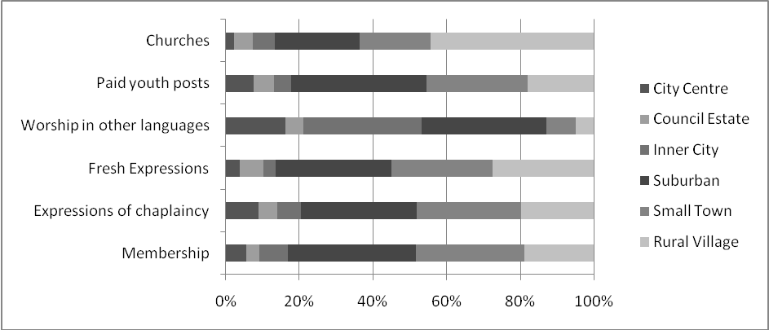
Categories illustrated
Left to right
The graph below illustrates this in a different way by comparing the proportion of each category of church to report a number of measures compared to the connexional average, with a longer bar representing above average and a shorter bar representing below average. If churches in all of the rural/urban categories were to have on average the same numbers of members, fresh expressions, paid youth posts, and other measures as those in the other categories, then the bars would be of equal length, like the top bar titled “churches”. Where churches across one category have a higher or lower number of each measure than the connexional average across all categories, the bars are longer or shorter accordingly.

The graph therefore illustrates that city centre churches had on average more paid youth posts, were more likely to host or run Methodist worship in languages other than English or Welsh, more likely to report fresh expressions, more likely to report expressions of chaplaincy, and have on average more members, than rural village churches (Figure 13).

Figure 13 Response by church category, comparing to the average, 2010
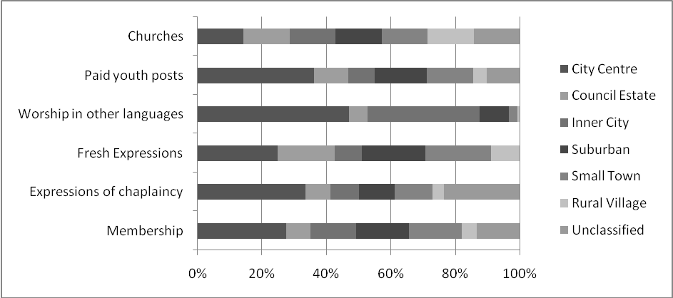
Categories illustrated
Left to right
6. Additional Information: “STATS4MISSION” Pilot

6.1 During October 2009, the Manchester and Stockport District designed a new method of data collection for the District’s Statistics for Mission process. The aim was to see whether the process could be developed to create a fuller report about the life of any given church, Circuit or District. In 2010, Manchester and Stockport was joined in this exercise by Bolton & Rochdale, Cornwall, Sheffield, Cumbria, Bedfordshire, Essex, and Hertfordshire, Liverpool and Lancashire: a total of 1,237 churches in 122 Circuits. This work came to form a pilot exercise to test the viability of collecting data in different ways across the Church, of collecting much larger amounts of specific details relating to church activities during October and throughout the year, and of reporting findings using a more tailored and responsive website.

6.2 The two years of this pilot exercise proved a significant learning curve for all concerned. It was a successful enterprise and, although some teething problems occurred, a great deal was gained and many participants found it be a positive step forward:

“These Statistics show us our mission purpose – they give us the ammunition for change” (Steve Wild, Chair of the Cornwall District)

“We can now see our Church Life in 360 degrees – a fuller view of our worship life, the Christian fellowship and our community groups, including WHO we are doing WHAT for and WITH WHOM” (Helen Boardman, District Development Enabler, Manchester and Stockport District)

Amongst the benefits of the pilot process was an improved ability to identify additional outreach and mission work being done by churches in their community contexts throughout the year, as well as to identify more non-worship events in churches (7,461 groups were identified in the 8 Districts, with the total number of people involved being greater than the whole of the Methodist membership count in 2010). This presents substantial opportunities for mission conversations and developing relationships.

The online portal, ‘A Window for Every Church’, has also been developed to enable each church to see its ‘story within its community’. This places church statistics alongside details of the church’s context (linked to census and neighbourhood reports) and can even provide indications of where funding opportunities are available to churches engaging in particular activities or located in particular contexts.

6.3 As a result of this pilot, significant changes to the questions that will be asked and the style of website used for data capture have been made in preparation for October 2011, when the whole Church will once again use one, standard data entry website. We have learned significant lessons from the pilot exercise, which demonstrates the value of connexional and district officers working in partnership to test and challenge one another’s work.

6.4 Fuller reports on the pilot exercise and its findings can be accessed via: www.methodist.org.uk/statisticsformission and at www.stats4mission.org.uk. ‘A Window for Every Church’ is provided in partnership with Commitment in Communities (www.c-i-c.org.uk).

7. Additional Information: Data Analysis and Methodist Schools

7.1 In addition to data captured in October, the statistical reporting section of the Methodist website is growing as a space for holding reports on additional types of numerical information collected across the Church. Currently, this includes a summary analysis of the equality and diversity demographics of Methodist Conference delegates in 2010 and opinion surveys performed during Youth Assembly. The intention of the Research team is to develop an archive of interesting and useful data relating to the Methodist Church, available for anyone to use as they wish. All Conference delegates and members of the Church are invited to make use of this and to recommend additional reports that might be included.

7.2 A particular concern expressed by the Conference in past years has been to include within statistical reporting indications of the mission potential represented by Methodist schools across Britain. Information on Methodist Maintained Schools can be obtained from the Education Development and Improvement Officer at Methodist Church House or at www.childrenandyouth.org.uk/schools. Information on Methodist Independent Schools can be obtained by request from the Secretary to the Board of Management for Methodist Independent Schools at Methodist Church House, or at www.methodisteducation.co.uk and in the publication, A Closer Look at Methodist Schools. For the purposes of this Statistics for Mission report, it will suffice to summarise the following data:

7.3 There are 79 Methodist Schools in Britain, of which 65 are Voluntary Aided, Voluntary Controlled, or Foundation schools in the Maintained sector. The remaining 14 are Methodist independent schools.

In September 2010, this represented a pupil roll of:

- Maintained schools: 4, 197
- Independent schools: 9,391
Total: 13,588

These numbers show that Methodist schools represent a key point of contact for the Church with children and young people, their friends and relatives. The Methodist Church is engaged in education as part of its Christian mission in the world. Recognising this, these figures demonstrate the extent to which Methodist schools embody a context of and opportunity for mission.

*** RESOLUTION (Daily Record 8/5)

52/1 The Conference received the report.

Report from the Parallel Session
An energetic and hugely affirming debate took place, responding to further information arising from the Statistics for Mission, and introduced by Connexional Team Members.
“You’ve made the October count come alive!”
“I used to think collecting data was pointless, but I now see how it is crucial to our strategies for mission”.
The Conference in parallel session explicitly thanked the research officers, and urged the continuing work needed, particularly rolling out the data throughout the Connexion.
The Conference adopted the Report of the Parallel Session.

Appendix 1: 2010 District Summary Data Tables

Membership 2010
 | District name | Methodist membership | Pastoral others | Confirmations | Transfers in | Other gains | Deaths | Transfers out | Other losses
1 | Synod Cymru | 1,860 | 430 | 20 | 0 | 20 | 30 | 10 | 70
2 | Wales Synod | 8,530 | 11,460 | 100 | 130 | 40 | 280 | 90 | 100
5 | Birmingham District | 9,890 | 16,580 | 150 | 160 | 40 | 280 | 120 | 150
6 | Bolton and Rochdale District | 6,110 | 10,170 | 80 | 70 | 10 | 150 | 80 | 90
7 | Bristol District | 9,300 | 12,540 | 150 | 190 | 40 | 260 | 190 | 120
9 | Cumbria District | 4,010 | 4,940 | 50 | 60 | 0 | 120 | 70 | 30
10 | Channel Islands District | 1,390 | 1,610 | 10 | 20 | 10 | 40 | 10 | 10
11 | Chester and Stoke-on-Trent District | 8,870 | 11,900 | 70 | 140 | 40 | 230 | 130 | 110
12 | Cornwall District | 6,420 | 7,800 | 60 | 130 | 10 | 210 | 130 | 100
13 | Darlington District | 6,840 | 8,990 | 110 | 140 | 50 | 200 | 70 | 100
14 | East Anglia District | 7,680 | 8,210 | 90 | 140 | 20 | 220 | 130 | 120
15 | Isle of Man District | 1,100 | 870 | 20 | 20 | 10 | 40 | 10 | 20
16 | Leeds District | 7,680 | 11,290 | 90 | 90 | 20 | 240 | 100 | 100
17 | Lincoln and Grimsby District | 5,840 | 8,280 | 50 | 110 | 20 | 190 | 70 | 50
18 | Liverpool District | 6,440 | 9,600 | 60 | 190 | 110 | 220 | 50 | 190
19 | Manchester and Stockport District | 9,270 | 14,070 | 130 | 150 | 30 | 260 | 100 | 250
20 | Newcastle upon Tyne District | 8,890 | 13,310 | 120 | 130 | 20 | 260 | 80 | 70
21 | Lancashire District | 8,310 | 9,880 | 140 | 170 | 20 | 230 | 70 | 240
22 | Nottingham and Derby District | 9,670 | 17,810 | 100 | 160 | 30 | 270 | 120 | 160
23 | Northampton District | 11,960 | 14,180 | 120 | 190 | 40 | 280 | 110 | 130
24 | Plymouth and Exeter District | 8,860 | 11,240 | 100 | 190 | 20 | 280 | 130 | 180
25 | Sheffield District | 8,240 | 18,830 | 100 | 140 | 20 | 210 | 120 | 200
26 | Southampton District | 10,410 | 10,760 | 90 | 260 | 20 | 320 | 140 | 150
27 | West Yorkshire District | 7,360 | 11,570 | 40 | 90 | 30 | 260 | 80 | 110
28 | Wolverhampton and Shrewsbury District | 9,410 | 11,680 | 120 | 130 | 30 | 310 | 90 | 110
29 | York and Hull District | 9,740 | 11,120 | 120 | 170 | 30 | 250 | 120 | 80
31 | Scotland District | 2,590 | 2,930 | 20 | 40 | 10 | 90 | 20 | 50
32 | Shetland District | 220 | 300 | 0 | 0 | 0 | 10 | 0 | 0
34 | Bedfordshire, Essex and Hertfordshire District | 8,950 | 15,080 | 120 | 170 | 20 | 230 | 420 | 460
35 | London District | 19,570 | 21,370 | 400 | 350 | 360 | 340 | 240 | 460
36 | South East District | 12,370 | 18,440 | 200 | 280 | 70 | 340 | 180 | 210
 | Connexion | 238,000 | 327,000 | 3,100 | 4,200 | 1,200 | 6,600 | 3,300 | 4,200

Wider influence of the church 2010
 | District name | Baptisms and thanksgivings | Marriages and blessings | Funerals
1 | Synod Cymru | 20 | 10 | 50
2 | Wales Synod | 320 | 130 | 1,110
5 | Birmingham District | 470 | 170 | 1,170
6 | Bolton and Rochdale District | 260 | 50 | 430
7 | Bristol District | 380 | 160 | 840
9 | Cumbria District | 150 | 50 | 310
10 | Channel Islands District | 40 | 20 | 90
11 | Chester and Stoke-on-Trent District | 520 | 150 | 1,020
12 | Cornwall District | 190 | 100 | 730
13 | Darlington District | 600 | 140 | 960
14 | East Anglia District | 360 | 180 | 830
15 | Isle of Man District | 50 | 20 | 120
16 | Leeds District | 300 | 100 | 790
17 | Lincoln and Grimsby District | 240 | 90 | 560
18 | Liverpool District | 260 | 60 | 630
19 | Manchester and Stockport District | 420 | 130 | 750
20 | Newcastle upon Tyne District | 890 | 210 | 1,220
21 | Lancashire District | 270 | 100 | 730
22 | Nottingham and Derby District | 520 | 130 | 1,230
23 | Northampton District | 600 | 280 | 1,140
24 | Plymouth and Exeter District | 270 | 130 | 750
25 | Sheffield District | 680 | 190 | 1,130
26 | Southampton District | 350 | 130 | 700
27 | West Yorkshire District | 280 | 90 | 730
28 | Wolverhampton and Shrewsbury District | 570 | 160 | 1,130
29 | York and Hull District | 550 | 150 | 950
31 | Scotland District | 50 | 20 | 170
32 | Shetland District | 10 | 10 | 20
34 | Bedfordshire, Essex and Hertfordshire District | 430 | 130 | 1,050
35 | London District | 680 | 220 | 890
36 | South East District | 500 | 260 | 1,170
 | Connexion | 11,220 | 3,750 | 23,370

Expressions of Chaplaincy 2010
 | District name | Expressions of chaplaincy | Presbyters | Deacons | Paid lay chaplains | Volunteer lay people
1 | Synod Cymru | 1 | 1 | 0 | 0 | 0
2 | Wales Synod | 98 | 69 | 6 | 2 | 44
5 | Birmingham District | 44 | 24 | 5 | 12 | 32
6 | Bolton and Rochdale District | 29 | 21 | 0 | 15 | 38
7 | Bristol District | 126 | 69 | 2 | 21 | 288
9 | Cumbria District | 30 | 23 | 0 | 0 | 8
10 | Channel Islands District | 9 | 6 | 0 | 1 | 11
11 | Chester and Stoke-on-Trent District | 46 | 26 | 2 | 5 | 65
12 | Cornwall District | 43 | 34 | 2 | 14 | 33
13 | Darlington District | 44 | 31 | 3 | 9 | 18
14 | East Anglia District | 141 | 74 | 3 | 3 | 83
15 | Isle of Man District | 17 | 14 | 0 | 1 | 2
16 | Leeds District | 46 | 27 | 4 | 5 | 13
17 | Lincoln and Grimsby District | 50 | 18 | 4 | 1 | 30
18 | Liverpool District | 49 | 32 | 0 | 3 | 22
19 | Manchester and Stockport District | 49 | 31 | 4 | 4 | 14
20 | Newcastle upon Tyne District | 42 | 26 | 2 | 4 | 39
21 | Lancashire District | 47 | 29 | 1 | 10 | 13
22 | Nottingham and Derby District | 94 | 47 | 6 | 6 | 68
23 | Northampton District | 117 | 61 | 7 | 7 | 99
24 | Plymouth and Exeter District | 53 | 33 | 1 | 3 | 69
25 | Sheffield District | 36 | 20 | 2 | 20 | 104
26 | Southampton District | 112 | 59 | 7 | 13 | 60
27 | West Yorkshire District | 28 | 18 | 4 | 1 | 29
28 | Wolverhampton and Shrewsbury District | 79 | 40 | 0 | 11 | 80
29 | York and Hull District | 76 | 55 | 0 | 11 | 16
31 | Scotland District | 25 | 34 | 0 | 2 | 4
32 | Shetland District | 7 | 4 | 0 | 0 | 5
34 | Bedfordshire, Essex and Hertfordshire District | 66 | 35 | 4 | 4 | 37
35 | London District | 133 | 76 | 5 | 26 | 99
36 | South East District | 92 | 65 | 2 | 5 | 62
 | Connexion | 1,829 | 1,102 | 76 | 219 | 1,485

October attendance 2010
 |  | Wholly Methodist churches |  |  |  | LEP churches
 | District name | AWA Adults | AWA Under 13 | AWA 13-19 |  | AWA Adults | AWA Under 13 | AWA 13-19
1 | Synod Cymru | 860 | 50 | 10 |  | 130 | 0 | 0
2 | Wales Synod | 5,920 | 1,230 | 310 |  | 830 | 280 | 70
5 | Birmingham District | 7,120 | 1,340 | 490 |  | 980 | 230 | 40
6 | Bolton and Rochdale District | 4,020 | 1,340 | 330 |  | 440 | 150 | 10
7 | Bristol District | 6,090 | 830 | 230 |  | 3,140 | 540 | 100
9 | Cumbria District | 2,890 | 420 | 180 |  | 380 | 40 | 0
10 | Channel Islands District | 1,070 | 280 | 60 |  | 0 | 0 | 0
11 | Chester and Stoke-on-Trent District | 7,100 | 1,230 | 340 |  | 450 | 80 | 10
12 | Cornwall District | 5,690 | 870 | 250 |  | 160 | 20 | 0
13 | Darlington District | 5,040 | 710 | 160 |  | 330 | 90 | 10
14 | East Anglia District | 6,680 | 750 | 170 |  | 1,220 | 200 | 70
15 | Isle of Man District | 870 | 160 | 30 |  | 10 | 0 | 0
16 | Leeds District | 5,240 | 1,060 | 270 |  | 390 | 40 | 10
17 | Lincoln and Grimsby District | 4,780 | 460 | 150 |  | 350 | 40 | 0
18 | Liverpool District | 4,100 | 670 | 220 |  | 910 | 460 | 80
19 | Manchester and Stockport District | 6,590 | 1,120 | 320 |  | 590 | 100 | 40
20 | Newcastle upon Tyne District | 6,750 | 1,310 | 400 |  | 1,060 | 180 | 40
21 | Lancashire District | 5,530 | 1,340 | 480 |  | 580 | 80 | 20
22 | Nottingham and Derby District | 7,560 | 1,310 | 400 |  | 860 | 140 | 30
23 | Northampton District | 8,320 | 1,530 | 550 |  | 2,680 | 540 | 80
24 | Plymouth and Exeter District | 7,000 | 1,020 | 410 |  | 1,030 | 140 | 20
25 | Sheffield District | 7,220 | 1,510 | 440 |  | 940 | 200 | 60
26 | Southampton District | 7,630 | 1,370 | 520 |  | 1,510 | 220 | 60
27 | West Yorkshire District | 4,790 | 970 | 190 |  | 990 | 130 | 30
28 | Wolverhampton and Shrewsbury District | 7,550 | 1,470 | 400 |  | 860 | 170 | 40
29 | York and Hull District | 6,940 | 1,390 | 370 |  | 700 | 120 | 40
31 | Scotland District | 1,570 | 360 | 90 |  | 240 | 30 | 10
32 | Shetland District | 230 | 30 | 10 |  | 0 | 0 | 0
34 | Bedfordshire, Essex and Hertfordshire District | 6,170 | 1,290 | 370 |  | 2,010 | 510 | 150
35 | London District | 12,180 | 2,260 | 980 |  | 2,100 | 470 | 160
36 | South East District | 8,240 | 1,430 | 420 |  | 2,710 | 430 | 90
 | Connexion | 171,700 | 31,100 | 9,500 |  | 28,600 | 5,600 | 1,300

Children, youth and young adult groups 2010
 | District name | Paid Youth posts | Youth groups | Under 5s attendance | 5-13s attendance | 13-19s attendance | 20-25 attendance
1 | Synod Cymru
2 | Wales Synod | 10 | 180 | 1,160 | 1,700 | 670 | 130
5 | Birmingham District | 30 | 290 | 1,280 | 3,890 | 1,120 | 120
6 | Bolton and Rochdale District | 10 | 190 | 500 | 1,970 | 770 | 60
7 | Bristol District | 40 | 230 | 860 | 2,560 | 900 | 150
9 | Cumbria District | 0 | 130 | 320 | 1,220 | 790 | 30
10 | Channel Islands District | 10 | 30 | 210 | 330 | 80 | 0
11 | Chester and Stoke-on-Trent District | 20 | 190 | 990 | 2,170 | 740 | 70
12 | Cornwall District | 10 | 130 | 400 | 1,130 | 610 | 10
13 | Darlington District | 20 | 140 | 560 | 1,750 | 530 | 30
14 | East Anglia District | 20 | 140 | 810 | 1,130 | 360 | 30
15 | Isle of Man District | 0 | 30 | 20 | 160 | 40 | 0
16 | Leeds District | 10 | 210 | 470 | 3,110 | 700 | 40
17 | Lincoln and Grimsby District | 10 | 140 | 300 | 1,500 | 500 | 90
18 | Liverpool District | 20 | 210 | 760 | 2,550 | 1,090 | 70
19 | Manchester and Stockport District | 30 | 260 | 2,110 | 5,350 | 2,390 | 670
20 | Newcastle upon Tyne District | 20 | 200 | 670 | 2,900 | 750 | 180
21 | Lancashire District | 30 | 260 | 840 | 2,820 | 1,370 | 90
22 | Nottingham and Derby District | 30 | 250 | 1,000 | 3,440 | 1,340 | 110
23 | Northampton District | 30 | 280 | 1,520 | 4,240 | 1,240 | 90
24 | Plymouth and Exeter District | 40 | 180 | 960 | 2,170 | 780 | 120
25 | Sheffield District | 40 | 300 | 700 | 3,560 | 1,450 | 80
26 | Southampton District | 60 | 280 | 1,250 | 3,160 | 1,290 | 120
27 | West Yorkshire District | 20 | 240 | 1,160 | 2,810 | 860 | 80
28 | Wolverhampton and Shrewsbury District | 20 | 250 | 730 | 3,290 | 970 | 100
29 | York and Hull District | 30 | 270 | 1,020 | 3,590 | 900 | 90
31 | Scotland District | 10 | 20 | 70 | 340 | 110 | 20
32 | Shetland District | 0 | 10 | 50 | 60 | 20 | 10
34 | Bedfordshire, Essex and Hertfordshire District | 30 | 400 | 1,180 | 5,000 | 1,610 | 110
35 | London District | 50 | 390 | 1,780 | 6,160 | 1,990 | 260
36 | South East District | 30 | 340 | 1,660 | 3,980 | 1,140 | 110
 | Connexion | 650 | 6,160 | 25,320 | 78,040 | 27,080 | 3,050

Regular fresh expressions 2010
 | District name | Total FX | Messy church | Cafe church | Cell church | 3rd place | Other FX
1 | Synod Cymru | 0 | 0 | 0 | 0 | 0 | 0
2 | Wales Synod | 30 | 8 | 5 | 5 | 4 | 8
5 | Birmingham District | 28 | 8 | 3 | 6 | 2 | 9
6 | Bolton and Rochdale District | 12 | 5 | 2 | 2 | 0 | 3
7 | Bristol District | 40 | 17 | 9 | 2 | 5 | 7
9 | Cumbria District | 11 | 2 | 5 | 0 | 0 | 4
10 | Channel Islands District | 3 | 2 | 0 | 0 | 1 | 0
11 | Chester and Stoke-on-Trent District | 28 | 8 | 6 | 1 | 1 | 12
12 | Cornwall District | 28 | 8 | 8 | 1 | 0 | 11
13 | Darlington District | 39 | 7 | 6 | 9 | 3 | 14
14 | East Anglia District | 47 | 12 | 14 | 3 | 1 | 17
15 | Isle of Man District | 2 | 0 | 0 | 1 | 1 | 0
16 | Leeds District | 21 | 7 | 2 | 1 | 8 | 3
17 | Lincoln and Grimsby District | 27 | 4 | 10 | 2 | 3 | 8
18 | Liverpool District | 26 | 7 | 5 | 0 | 4 | 10
19 | Manchester and Stockport District | 35 | 6 | 3 | 3 | 2 | 21
20 | Newcastle upon Tyne District | 33 | 8 | 7 | 6 | 5 | 7
21 | Lancashire District | 29 | 4 | 8 | 2 | 3 | 12
22 | Nottingham and Derby District | 47 | 15 | 8 | 5 | 5 | 14
23 | Northampton District | 53 | 19 | 9 | 6 | 4 | 15
24 | Plymouth and Exeter District | 51 | 16 | 8 | 7 | 7 | 13
25 | Sheffield District | 37 | 8 | 12 | 2 | 0 | 15
26 | Southampton District | 57 | 15 | 10 | 5 | 4 | 23
27 | West Yorkshire District | 28 | 6 | 3 | 12 | 1 | 6
28 | Wolverhampton and Shrewsbury District | 49 | 12 | 8 | 6 | 9 | 14
29 | York and Hull District | 48 | 11 | 12 | 8 | 2 | 15
31 | Scotland District | 5 | 2 | 0 | 0 | 0 | 3
32 | Shetland District | 5 | 1 | 1 | 0 | 3 | 0
34 | Bedfordshire, Essex and Hertfordshire District | 39 | 14 | 13 | 2 | 2 | 8
35 | London District | 37 | 12 | 9 | 1 | 4 | 11
36 | South East District | 46 | 12 | 11 | 3 | 6 | 14
 | Connexion | 941 | 256 | 197 | 101 | 90 | 297

World church links, language and ethnicity 2010
 | District name | Overseas link | Worship in other language | Worship for distinct ethnic groups
1 | Synod Cymru | 0 | 0 | 0
2 | Wales Synod | 10 | 4 | 3
5 | Birmingham District | 15 | 6 | 11
6 | Bolton and Rochdale District | 13 | 2 | 2
7 | Bristol District | 17 | 4 | 4
9 | Cumbria District | 18 | 0 | 0
10 | Channel Islands District | 2 | 1 | 1
11 | Chester and Stoke-on-Trent District | 14 | 1 | 3
12 | Cornwall District | 8 | 1 | 0
13 | Darlington District | 37 | 2 | 3
14 | East Anglia District | 18 | 5 | 2
15 | Isle of Man District | 0 | 0 | 0
16 | Leeds District | 5 | 3 | 0
17 | Lincoln and Grimsby District | 6 | 0 | 0
18 | Liverpool District | 8 | 0 | 1
19 | Manchester and Stockport District | 4 | 4 | 9
20 | Newcastle upon Tyne District | 8 | 2 | 3
21 | Lancashire District | 9 | 0 | 0
22 | Nottingham and Derby District | 12 | 4 | 4
23 | Northampton District | 9 | 10 | 8
24 | Plymouth and Exeter District | 11 | 4 | 0
25 | Sheffield District | 9 | 6 | 5
26 | Southampton District | 15 | 4 | 1
27 | West Yorkshire District | 9 | 3 | 0
28 | Wolverhampton and Shrewsbury District | 12 | 2 | 1
29 | York and Hull District | 10 | 3 | 3
31 | Scotland District | 1 | 2 | 3
32 | Shetland District | 1 | 0 | 0
34 | Bedfordshire, Essex and Hertfordshire District | 17 | 10 | 6
35 | London District | 16 | 35 | 35
36 | South East District | 12 | 6 | 5
 | Connexion | 326 | 124 | 113

Appendix 2: Definitions and methodological notes

Missing data: where churches have not given data it is necessary to impute figures before calculating connexional totals. This is done by looking at returns for previous years and making adjustments. Where there are no previous returns, figures are imputed based on the geographical context of the church. Varying responses rates will impact on the level of imputation necessary and therefore the accuracy of the data.
Rounding: Annual questions (see below) have not been rounded. In the remaining cases, all figures are rounded appropriately to the question and available data. This will vary from question to question according to the statistical accuracy of the collected data sets (particularly on the amount of data which needs to be imputed across the Church to take account of missing responses) and according to the size of the numbers in a particular question. Because of this, figures may not always sum.
Annual questions: responses for annual questions on fresh expressions, expressions of chaplaincy, children, youth and young adult groups, world church links, language and ethnicity have not been grossed up to account for missing data. It is possible that the responses here indicate only a proportion of those churches where such work is happening and should be considered as indicative only.
Data cleaning: where responses have been incongruous, returns have been edited.
October attendance: attendance figures are collected for 4 weeks in October and an average attendance figure calculated. Where a church does not have a service every week the average attendance figure will be lower than in any one of the reported weeks. This method has been used to give an indication across the Connexion of the number of people attending on any given Sunday, thereby taking into account to some degree any churches that may “share” attendees with rotating services.

