31. The Fruitful Field Project

Basic Information

Title | The Fruitful Field project
Contact Name and Details | Doug Swanney | Head of Discipleship & Ministriesswanneyd@methodistchurch.org.uk | 020 7467 3791
Status of Paper | Interim report
Resolution/s | 31/1. The Conference receives the Report.

Summary of Content

Subject and Aims | This report offers an update to the Conference on work undertaken under the auspices of the Fruitful Field project – a project which concerns the development of the Church’s existing connexional activities in the field of learning, formation, training, theological education, scholarship, research and development.
Main Points | The report outlines the context for the project, which includes the Church’s learning institutions, dispersed expert learning and development staff, and the financial resources expended in this area. The report also outlines the infrastructural challenges and opportunities which the Church faces, which include pressure on resources from the Central Services Budget, institutional viability, and changes in the Higher Education sector. The report also highlights the central importance of learning programmes which address the wide and dispersed learning needs of a discipleship movement shaped for mission. The report finally addresses the timelines and accountability structures for future work in this area.
Background Context and Relevant Documents (with function) | The Fruitful Field project was introduced in the “Ministries, Learning and Development” report received by the 2010 Conference.

Impact | Work to be undertaken during the next connexional year will identify significant educational, financial and constitutional matters to be brought to the 2012 Conference.
Risk | Educational, financial and oversight functions may be weakened if the outlined timelines are not commended. The outlined timelines are tightly drawn and do not include a significant margin for overrunning deadlines.

The Fruitful Field Project

(I) Introduction
1 The Fruitful Field project takes its name from a reference in the “Liverpool Minutes”, a series of resolutions on pastoral work adopted by the Wesleyan Methodist Conference of 1820. The resolutions outline the pragmatic, practical and efficient actions and structures discerned by the Conference as necessary to “spread Scriptural holiness through the land”. Yet, throughout, it is emphasised that, in order to secure the “revival and extension of the Work of God, the great thing to be desired is an abundant effusion of the Holy Spirit on ourselves and our families, our Societies and our Congregations”. Accordingly, the resolutions conclude with the affirmation that “we desire to ‘continue with one accord in prayer and supplication’... ‘until the Spirit be poured upon us from on high, and the wilderness becomes a fruitful field, and the fruitful field be counted for a forest’”.

2 This concluding image is taken from the thirty-second chapter of the book of Isaiah, where the prophet foresees the Spirit’s gifts creating, for a chastened people, a land of fruitfulness, righteousness, quietness and trust. It is a vision of organic development – a vision of ploughing, reaping, pruning, nurture and growth – and, as such, is an appropriate foundational image for a project which concerns the development of the Church’s existing connexional activities in the field of learning, formation, training, theological education, scholarship, research and development.

3 The primary aims of the Fruitful Field project were outlined in the “Ministries, Learning and Development” report received by the 2010 Conference:
to support the governance bodies of the Methodist Church as they exercise their oversight of the Church’s learning and development infrastructure and programmes, by providing an overview of the Church’s connexional commitments and activities;
to ensure that modifications and developments across the Church’s learning and development infrastructure and programmes are coherent, and that the work undertaken across the Church’s connexional commitments and activities is consistently reflective, collaborative, ambitious and prophetic.

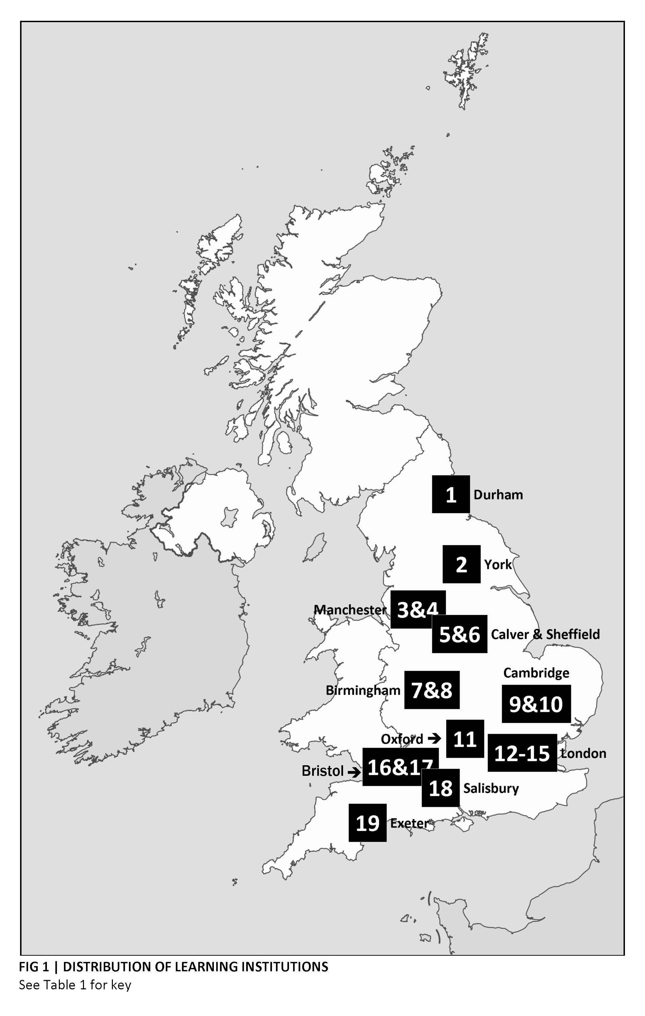

Table 1 | Connexionally-sponsored learning institutions
The figures in square brackets provide a key to Figure 1.
(A) Learning institutions receiving full-time ministerial students
- The Queen’s Foundation, Birmingham (also the core institution of the Midlands Regional Training Network – see Figure 2) [7]
- Wesley House, Cambridge (also the core institution of the South-East Regional Training Network – see Figure 2) [9]
- The Wesley Study Centre, Durham (also the core institution of the Yorkshire & North-East Regional Training Network – see Figure 2) [1]
(B) Learning institutions receiving part-time ministerial students
- ERMC (the Eastern Region Ministry Course) [10]
- Hartley Victoria College, Manchester (also the core institution of the North-West Regional Training Network – see Figure 2) [3]
- SEITE (the South-East Institute for Theological Education) [12]
- STETS (the Southern Theological Education & Training Scheme) [18]
- SWMTC (the South-West Ministry Training Course) [19]
- UTU (the Urban Theology Unit), Sheffield [6]
- Wesley College, Bristol (also the core institution of the South & South-West Regional Training Network – see Figure 2) [17]
- The York Institute for Community Theology [2]
(C) Lay learning institutions
- Cliff College [5]
- The Guy Chester Centre [13]
(D) Archival and heritage-focused institutions or resources
- The Methodist Archives and Research Centre, deposited with the John Rylands University Library [4]
- The Methodist Missionary Society Library, deposited with SOAS (the School of Oriental and African Studies) [14]
- The New Room, Bristol [16]
(E) World church-related learning institutions
- SOCMS (the Selly Oak Centre for Mission Studies) [8]
(F) Institutionally-associated trusts providing (a) Higher Education sector support and (b) scholarship and research provision
- The Westminster College Oxford Trust (associated with the Westminster Institute of Education and the Oxford Centre for Methodism and Church History) [11]
- Southlands Methodist Trust (associated with Southlands College) [15]
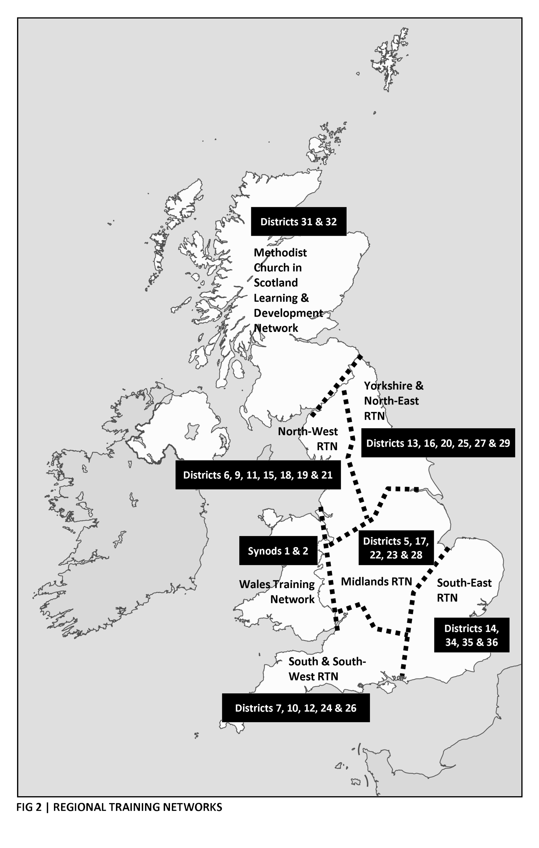

(II) Context
4 One necessary starting point for the Fruitful Field project is the existing use and distribution of the connexional learning infrastructure and resources.

Infrastructure | Learning institutions
5 The location of nineteen connexionally-sponsored learning institutions is shown in Figure 1. A key to the figure and a categorisation of the institutions is provided in Table 1.
6 In addition to these institutions, the connexional learning activities relate to a number of partner-institutions and partner-agencies. Furthermore, other connexional institutions, not included within the “Ministries, Learning and Development” report received by the 2010 Conference, represent significant connexional investment in the facilitation of learning, formation and training. Both types of institution are included in Table 2.
7 Significant Connexional Team staff time has been dedicated over recent months to establishing an understanding of the institutions included in Table 1 in terms of their (a) learning activities, (b) learning environments, (c) premises, (d) partnerships, (e) governance arrangements, (f) financial activities, and (g) assets, funds and liabilities. A Connexional Team member now attends the governing body or management committee meetings of the majority of the institutions included in Table 1, including all of the institutions receiving connexional grants of over £35,000 per annum. An appropriate connexional presence is being secured on the governing bodies of all of the other institutions included in Table 1 where this is not already the case.
Table 2 | Other institutions
(A) Partner-institutions and partner-agencies
- The Centre for Youth Ministry
- The Fresh Expressions agency
- Several Regional Training Partnerships in England (primarily in partnership with the Church of England and the United Reformed Church)
- Ecumenical learning partnerships in Scotland and Wales
(B) Other connexional institutions associated with learning, formation and training
- The Methodist Diaconal Centre, Birmingham
- Methodist International Centre, London

Infrastructure | Dispersed expert staff
8 In addition to the learning institutions discussed above, the connexional learning infrastructure includes a number of dispersed expert staff posts. These staff posts are outlined in Table 3. The distribution of some expert staff posts is related to the Church’s Regional Training Networks – regional networks of district officers and learning practitioners – and these networks are outlined in Figure 2.
9 A recent change within the staff team of the Discipleship & Ministries Cluster has enabled a significant proportion of a Connexional Team post to be dedicated to liaising with and supporting Training Officers and District Development Enablers. Support from Connexional Team members was already in place for PPMs, DEEs and DMEs.

Table 3 | Dispersed expert staff
(A) Training Officers
- Two full-time Training Officer posts within each Regional Training Network in England
- Alternative arrangements in Scotland, Wales and the Island districts
(B) District Development Enablers
- Half-time District Development Enabler (DDE) post within each District in England
- Alternative arrangements in Scotland, Wales and the Island Districts
(C) Other dispersed expert staff
- One PPM (Participation Project Manager) post located within each Regional Training Network in England, as part of the Youth Participation Strategy (YPS)
- District Evangelism Enabler (DEE) and District Mission Enabler (DME) posts – appointed by Districts

Financial resources
10 The Central Services Budget includes operational expenditure of £3.4m per annum to the maintenance of the institutional infrastructure and the dispersed expert staff posts included in Tables 1-3. Another £2.3m is allocated within the Central Services Budget towards the delivery of programmes, as (a) fees for Initial Ministerial Learning programmes, (b) bursaries and expenses payments to Initial Ministerial Learning students and (c) grants to Districts and individual ministers towards the costs of Continuing Ministerial Learning programmes. The distribution of the combined operational expenditure of £5.7m per annum is shown in Figure 3.

(III) Infrastructural challenges and opportunities
11 Much of the institutional and staffing infrastructure described above emerged from the work of the “Future Use and Configuration of Training Institutions” process, which reported to the 2006 Conference and, as the “Training Institutions Review Group”, to the 2007 Conference. In setting out its framework to the 2006 Conference, the “Future Use and Configuration of Training Institutions” report noted that:
[b]ecause the whole education and training field is changing so rapidly any proposals should allow modification and development to take place as flexibly as possible and be robust enough to respond to future changes and opportunities.

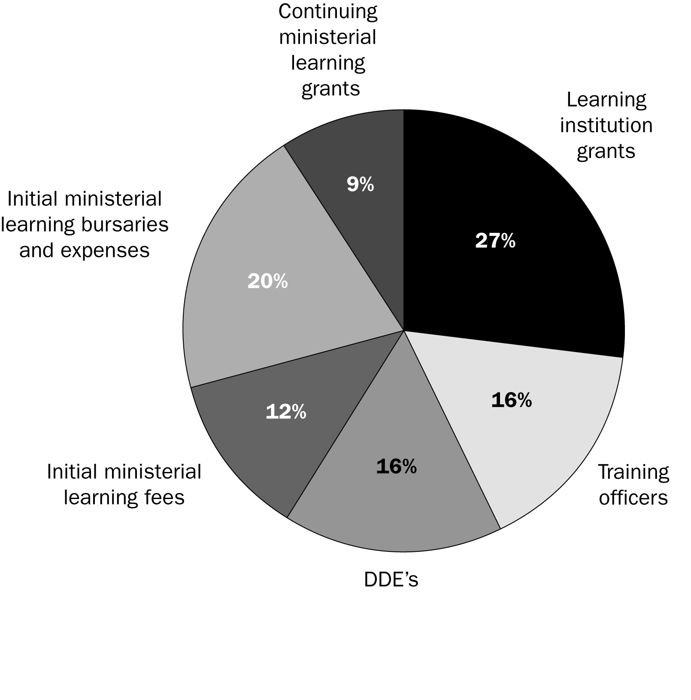
Figure 3 | Distribution of the commitment from the Central Services Budget to learning, formation, training, theological education, scholarship, research and development

12 The 2007 Conference agreed arrangements for institutional grants, Initial Ministerial Learning costs and District Development Enabler posts which were to last for a period of five years from the beginning of the 2008/2009 connexional year; these arrangements consequently come to an end at the end of the 2012/2013 connexional year. Some arrangements, such as the Methodist Church’s partnership agreement with SOCMS (the Selly Oak Centre for Mission Studies), expire at the end of the 2011/2012 connexional year. These timelines, of themselves, establish the need for an assessment of the Church’s infrastructural commitments in this area.

13 However, the emerging challenges and opportunities predicted in the 2006 Conference report have already become a present reality, and the need for the Methodist Church to be able to respond to such challenges and opportunities establishes a yet greater need for a radical assessment of the connexional infrastructural commitments in the field of learning, formation, training, theological education, scholarship, research and development. These challenges and opportunities consequently provide a second starting point for the work of the Fruitful Field project, and are outlined in this section of the report.

Expenditure on learning from the Central Services Budget
14 A total operational expenditure of £5.7m on connexional learning activities represents a significant portion of the total Central Services Budget expenditure. Given the magnitude of this expenditure, and the importance of the activities which it supports, it is clearly necessary to ensure that the Methodist Church exercises good stewardship of such funds and that the relevant bodies can demonstrate that these connexional resources have been wisely spent. To this ongoing responsibility to be good stewards of connexional resources are added three further challenges.

15 First, a significant contribution has been made to the Church’s Central Services Budget in recent years from the Training Assessment Fund (TAF). Use of the TAF has made it possible to sustain a high level of connexional expenditure on learning activities, including the fees and bursaries required to sustain a higher than expected number of ministerial students following full-time, bursaried learning pathways. However, given that donations towards the TAF are no longer solicited, the balance of the fund is diminishing, and the TAF will not be able to support existing levels of expenditure beyond the 2012/2013 connexional year.

16 Secondly, it is likely that the Methodist Church will need to decide on the future use of the Fund for Training. For a number of years, the Fund for Training (which should not be confused with the Training Assessment Fund) has been a largely dormant fund – given (a) that learning costs have been met from other funds and revenue streams within the Central Services Budget, (b) that donations towards the fund are no longer solicited, and (c) that the fund has contained negligible realisable assets. However, the reduction of the balance of the TAF, combined with the decision of the Conference to close Wesley College, Bristol, may make it necessary to reassess the use made of the Fund for Training. In particular, should the Conference decide to dispose of the Wesley College site, the proceeds of sale or the income released will revert to the Fund for Training. It is therefore likely that a revised formal policy for the stewardship of the fund’s resources will be required.

17 Thirdly, it is necessary to set the expenditure of resources on connexional learning activities within the wider context of our conviction that God desires a healthy, more vibrant Methodism. The General Secretary’s report to the Conference encourages the Methodist Church at every “level” deliberately to use our giving, budgeting and spending processes to facilitate what we feel God is calling us to become, rather than adopting a default position of sustaining what we have. This necessarily demands a deep understanding of the use currently made of resources expended on connexional learning activities. It also demands a deep understanding of the potential impact of changes made to the level or direction of funding in response to newly discerned needs and sharper priorities. In short, this wider context demands of us a proactive and knowledgeable stewardship of the resources expended on connexional learning activities, so as to enable us to bring greater focus to our use of limited but still considerable resources.

Institutional viability
18 Other challenges and opportunities are posed by the desire of learning institutions to be healthy, more vibrant learning environments – and by their consequent willingness to make difficult choices if such a vibrant future is not viable within existing parameters.

19 The clarity of connexional funding arrangements achieved in the wake of the “Future Use and Configuration of Training Institutions” process in 2006 and 2007 has enabled some institutions to address with greater clarity than was previously possible the underlying issues of capital maintenance and investment, business planning and strategic development. This, in turn, has enabled institutions to face issues of viability with renewed determination and openness. For some institutions, this means making use of accumulated reserves to undertake new and exciting capital projects. For other institutions, it means contemplating difficult decisions about the viability of existing premises. For some institutions, it means contemplating still more difficult decisions about wholesale reconfiguration or dissolution.

20 In some cases, the institutions concerned are institutions ultimately governed by the Conference – and the funds expended and the liabilities incurred are consequently also those of the Conference itself. This demands of the Conference the ability to assess such opportunities and risks on a comparative basis. In other cases the institutions are self-governing entities, towards which the Conference’s responsibilities are properly limited. However, such self-governing institutions are invariably (a) institutions which have been sponsored by the Methodist Church for several years, (b) institutions in which the Methodist Church has consequently made a considerable investment over that period of time, (c) institutions in whose activities the Methodist Church has a significant educational interest, and (d) institutions towards which many within the life of the Connexion feel the Methodist Church has a moral and pastoral (if not always a direct and statutory) duty of care.

21 The Methodist Church consequently needs to be able to respond in a holistic and responsible way to the challenges and opportunities posed by the contrasting viabilities of its sponsored learning institutions.

22 The Methodist Church will undoubtedly need to develop the capacity to be able to respond responsibly and reactively to institutions who find themselves no longer to be viable, due to a range of developing factors, some of which are noted in the next sub-section of this report.

23 However, the Methodist Church will also need to develop the capacity to respond holistically and proactively to the challenge of securing viability across its sponsored institutions. Such a proactive attitude will enable the Methodist Church to ensure that its sponsored institutions are able to place at the service of the whole connexion an institutional infrastructure (a) which offers excellent learning environments for students, learners, tutors and visitors, (b) which is financially sustainable, with regard to operational and capital expenditure, (c) which can support the broad range of learning, formation, training, theological education, scholarship, research and development activities which the Methodsit Church requires, (d) which is responsive to the requests of the Conference and to the needs of Districts and Circuits, and (e) which elicits the trust, pride and investment of the Methodist people. The challenges and opportunities currently faced by institutions invites the Conference to respond in such a holistic and proactive manner to support and enable the viability of its sponsored institutions.

Changes in the Higher Education sector
24 Arguably some of the greatest challenges and opportunities faced by the Methodist Church in this area flow from the changes heralded by Lord Browne’s “Independent Review of Higher Education Funding and Student Finance”.

25 Much of the media coverage of the report and its legislative aftermath has focussed on the issue of student fee levels. For a minority of Methodist ministerial students, this is likely to present challenges which will require a response from the Methodist Church before the beginning of the 2012/2013 connexional year.

26 A more pressing and worrying consequence of changes to Higher Education (HE) funding concerns the withdrawal of teaching grants from the Government to HE institutions for the teaching of a range of subjects, including theology. Such a change in Government funding raises serious questions about the viability of the provision of theological study within many HE institutions. It also raises immediate questions about the viability of existing and prospective relationships between HE institutions and Church-sponsored learning institutions – relationships which have hitherto been directly and indirectly subsidised by Government teaching grants, in a manner beneficial to the Church-sponsored learning institutions concerned.

27 The long-term consequence of the Higher Education (HE) sector changes currently being implemented are likely to be more far-reaching still. Lord Browne’s report is based on a model of the HE sector where competition and purchaser-power are important elements for the sector’s holistic success. The report notes that:
In our proposals, institutions will face increased competition. They will compete for students and they will set different charges... In our proposals, we are relying on student choice to drive up quality. Students will control a much larger proportion of the investment in higher education. They will decide where the funding should go; and institutions will compete to get it... This is in our view a surer way to drive up quality than any attempt at central planning.

28 The report is honest in its assessment of some of the consequences of such a policy:
In a more competitive environment, some institutions will be more successful at attracting students than others; this means that some institutions may be at risk of failing... If institutional failure cannot be prevented... then the HE Council will explore options such as mergers or takeovers led by other providers so that the institution in a new form becomes a going concern.

29 For the Methodist Church, two lessons are immediately evident. First, a period of instability in the HE sector is likely to follow as the consequences of such a change of culture are absorbed. Secondly, it is likely that the Methodist Church will be forced to engage with the HE sector in a manner which moves away from established assumptions, and which maximises the Methodist Church’s impact and effectiveness in a changed environment. In many cases, this will require the Methodist Church, however regrettably, to place a monetary value on relationships and links which have previously been based on good will and shared priorities. In some cases, this will enable the Methodist Church to develop new, innovative partnerships in response to emerging opportunities and needs. In short, the Methodist Church will be challenged over the coming connexional year (a) to reassess its presence and impact in a rapidly developing sector, and (b) to search out those emerging opportunities which make the best use of connexional resources – and, if necessary, to reconfigure its resources accordingly.

(IV) The wide and dispersed learning needs of a discipleship movement shaped for mission
30 Not all of the opportunities and challenges which face the Methodist Church in this area are driven by the stewardship of resources or by infrastructural factors beyond the Methodist Church’s control – important as those considerations undoubtedly are. Many of the most interesting and forceful challenges and opportunities are those which arise from the Methodist Church’s own discernment of the learning needs of a discipleship movement shaped for mission.

31 Patterns of resourcing and ministry throughout the connexion are changing, and the support offered to emerging expressions of ministry by the Methodist Church’s learning programmes must be effective and apposite. As the General Secretary notes in his report to the Conference, key emerging themes include the ministry of the whole people of God, the importance of circuit ministry teams, the importance of small group leadership in the Methodist Church, the role of Superintendent Ministers, and the developing nature of the ministry of Local Preachers and of modes of local pastoral ministry. Other reports prepared for the 2011 Conference indicate the greater demands made on those exercising leadership within the lives of Local Churches, Circuits and Districts by statutory obligations and developing best practice.

32 All of this points towards the need for the Methodist Church’s learning activities to reach a wider and more dispersed group of people than has been possible in the past. A discipleship movement shaped for mission invites the widest range of people to receive and share in the ministry of God, and invites the Church in turn to prioritise the wherewithal to equip and resource this vibrant activity.

33 Such a vision for a wider and more dispersed group of learners chimes with the desires expressed both by ministerial students and also by learning institutions for a greater proportion of formal learning activity to take place in local contexts. There will always be a place for learning institutions configured as stable communities of learning, formation and scholarship. However, qualitative evidence also suggests a growing desire within the Methodist Church for the development of distributive learning programmes, where learning for lay and ordained people has, as its primary locus, the context in which ministry in being exercised and in which disciples are being formed. The role of the learning institution, within this model of learning, is (a) to shape and guide the local learning environment, and (b) to provide a complementary base for the delivery of occasional, concentrated programmes in an environment free from the pressures and expectations of circuit life.

34 This vision of wide and dispersed learning, located in the heart of Circuits and equipped by connexional resources and institutions, takes us close to a third starting point of the Fruitful Field project – a commitment to meeting the wide and dispersed learning needs of a discipleship movement shaped for mission. Such a commitment to the importance of integrated and incarnational learning is a core and historic component of Methodism’s identity as a missional, discipleship movement. It may be seen at work in the emphasis placed on Social Holiness – on studying Scripture together and on encouraging one another in the faith, or in the central place given to the teaching ministry of Local Preachers, or in the work of the SALT programme for emerging leaders from the World Church, or in the provision of robust and high-quality published material from the Epworth Press and beyond, or in the collation and analysis of detailed mapping and statistical information to support the work of Regrouping for Mission. Shared learning about our faith, about our mission context, and about one another is a cornerstone of our Methodist calling – and a healthy Methodist Connexion is consequently a community of learning where every disciple is learning about their faith and telling the story of the faith, where every minister is an educator and a reflective learner, and where every Circuit is a learning Circuit.

35 The challenges of such an approach should not be underestimated. A thoroughgoing response requires the encouragement of prayerful, intentional strategising about the use and deployment of gifts, graces and resources within Circuits and Districts. It also requires the careful identification of appropriate learning and formational outcomes – which relate not only to the demands of changing patterns of ministry, but to the role of the Circuit as a community of learning, to the understanding and practice of continuous learning, and to the Faith and Order of the Church. However the benefits of such an approach include the manifestation and development of the essential principle that communities of faith, devotion and shared learning are the normal context of formation for discipleship and ministries alike.

36 Much of the emphasis within this report necessarily falls on infrastructure and resources, and future judgements will need to attend closely to the development of these areas. However, these organisational components are the servants of the wide and dispersed learning needs of contemporary Methodism, and a commitment to meeting such needs lies at the heart of the Fruitful Field project.

(V) Timelines and accountability
Table 4 | The Fruitful Field project timeline for the 2011/2012 connexional year
August 2011 – mid-September 2011
Final pre-consultation discussions with members of the Strategy & Resources Committee and the Ministries Committee
Late September 2011 – end of November 2011
- Consultation period for all partners, practitioners and stakeholders, based on a consultation document; the document will prefigure deliberations and proposals to be brought to the 2012 Conference
- Proposed major discussion at the autumn meeting of the Methodist Council
December 2011 – early January 2012
Analysis of consultation responses
Mid-January 2012 – mid-February 2012
Discussion of consultation outcomes by the Strategy & Resources Committee and the Ministries Committee
Late February 2012 – late March 2012
- Feedback of consultation outcomes to partners, practitioners and stakeholders
- Discussion of consultation outcomes by the Methodist Council
April 2012
Preparation and publication of final report to the 2012 Conference
37 This report has outlined the character and nature (a) of the considerations which have driven the Fruitful Field project, (b) of the direction of travel which has been explored during the current connexional year, and (c) of the judgements which will be faced by a future Conference. The considerations have been developed through informal discussions with a range of partners, practitioners and stakeholders. The direction of travel has been explored at meetings of the Shadow Ministries Committee and the Connexional Leaders’ Forum, and through informal discussions with a number of learning institution principals and tutors, Training Officers, Local Preachers’ meetings and Superintendents’ meetings. Further informal consultations, including discussions with ecumenical partners, will follow over coming weeks. It is anticipated that a report to the 2012 Conference will consolidate the project’s deliberations and proposals.

38 Explorations during the current connexional year have been reflective and collaborative, and several partners have welcomed this way of working, and expressed their confidence in the character of the judgements likely to emerge from such a reflective and collaborative undertaking. The importance of the Methodist Church’s learning, formation, training, theological education, scholarship, research and development activities is such that a positive and inclusive way of working, fostered by reflection and collaboration, is crucial if misunderstandings and apprehensions are to be minimised. However, reflection and collaboration cannot and should not preclude the consideration of prophetic and ambitious proposals.

39 Deliberations and proposals brought to the 2012 Conference will need to be the subject of wide and open consultation. The ongoing work of the Fruitful Field project has consequently been structured to enable such consultation to take place during the early part of the 2011/2012 connexional year. The timeline proposed for the 2011/2012 connexional year is consequently as outlined in table 4.

40 The “Ministries, Learning and Development” report to the 2010 Conference noted that the nascent Ministries Committee would be the natural locus for oversight of the Fruitful Field project. It is consequently proposed that the existing Shadow Ministries Committee and the proposed Ministries Committee exercise oversight of the consultation process described above, working collaboratively with the Strategy & Resources Committee and its sub-committees as required.

***RESOLUTION (Daily Record 7/10/1-2)

31/1. The Conference received the Report.
31/2. The Conference directed the bodies named in Section (V) of the report to carry out further work in compliance with the provisions for timelines and accountability stated.

The “Liverpool Minutes 1820”, CPD, Vol 1, Book V, Part 3
“Ministries, Learning and Development”, Agenda 2010, ¶2.4
As well as its lay learning programmes, the Guy Chester Centre supports Higher Education sector students. As such, the centre could also have been included under the category: “Institutions providing Higher Education sector support and scholarship provision”.
These dispersed expert staff posts are included in Table 3 to demonstrate the link between their capacity-building work within Districts and Regional Training Networks and the work of other components of the Church’s learning infrastructure. However, these staff posts are funded either from district funds (occasionally with support from Connexional Grants Committee funds) or from within discrete connexional projects; consequently costs associated with these posts are not included in Figure 3.
The amounts in this section relate to the proposed Central Services Budget for the 2011-2012 connexional year. With the exception of the termination of the fixed-term project funding to support the work of the Extending Discipleship, Exploring Vocation (EDEV) initiative in Districts and regions, no material changes to the total amounts and the distribution approved as part of the 2010-2011 budget are proposed in the 2011-2012 budget.
“Future Use and Configuration of Training Institutions”, Agenda 2006, ¶3.7.5
“Securing a Sustainable Future for Higher Education: An Independent Review of Higher Education Funding and Student Finance” (October 2010), www.independent.gov.uk/browne-report
“An Independent Review of Higher Education Funding and Student Finance”, ¶6.9, ¶4.1 and Conclusion
“An Independent Review of Higher Education Funding and Student Finance”, ¶6.5

