30. The Ministries Committee

Basic Information

Title | The Ministries Committee
Contact Name and Details | Doug Swanney | Head of Discipleship & Ministries  swanneyd@methodistchurch.org.uk | 020 7467 3791
Status of Paper | Final report
Resolution/s | 30/1. The Conference receives the Report.

Summary of Content

Subject and Aims | This report outlines the work undertaken since the 2010 Conference to establish a Ministries Committee.
Main Points | The report outlines the proposed status, functions and membership of the Ministries Committee, as well as the implications of its creation for existing committees.
Background Context and Relevant Documents (with function) | The concept of a Ministries Committee was introduced in the “Ministries, Learning and Development” report received by the 2010 Conference.

Impact | Constitutional revisions are required to establish the Ministries Committee and to codify the implications of its creation for existing committees.
Risk | Oversight and accountability functions may be weakened if the proposed revised structures are not commended.

The Ministries Committee

- Background

1. The 2010 Conference received the “Ministries, Learning and Development” report, which contained outline proposals for the establishment of a Ministries Committee.

2. The genesis of proposals for a Ministries Committee is to be found in a review undertaken during the 2008/2009 and 2009/2010 connexional years of the connexional committees which have responsibility for developing and maintaining a strategic vision for the Church’s ordained, accredited, commissioned and informal connexional ministries. Among the committees with responsibilities in this area are the Connexional Allowances Committee, the Connexional Local Preachers Committee, the Diaconal Candidates & Probationers Oversight Committee (DCPOC), the Ministerial Candidates & Probationers Oversight Committee (MCPOC), the Ordained Ministries Committee, the Stationing Advisory Committee, the Stationing Committee and the Training Strategy & Resources Executive (TSRE).

3. The review identified as problematic the disparate nature of the strategic oversight exercised by this range of committees. A collaborative exploration of alternative models was undertaken by the chairs of the Connexional Allowances Committee, the Connexional Local Preachers Committee, DCPOC, MCPOC, the Ordained Ministries Committee, the Stationing Advisory Committee, the Stationing Committee and TSRE; the members of the committees themselves were kept informed of development on a regular basis.

4. The “Ministries, Learning and Development” report to the 2010 Conference outlined a preferred model based on three elements:
a. First, a grouping of committees, working to established protocols, which undertake tasks of immediate oversight on behalf of the Conference. These are existing committees, and include DCPOC and MCPOC (and their sub-committees), the Stationing Committee (working through its sub-committees), and the Stationing Advisory Committee (working through its panels).
b. Secondly, a Ministries Committee, working to enable the Methodist Church to develop and maintain a strategic vision for its ordained, accredited, commissioned and informal connexional ministries (including the ministry of deacons, local preachers, presbyters, those pioneering ’fresh ways of being church‘, superintendents, worship leaders and the corporate ministry of circuit leadership teams). It was suggested that the Ministries Committee would have general oversight of the protocols for the grouping of committees which undertake tasks of immediate oversight on behalf of the Conference, and a duty to work closely with that grouping of committees, responding to their experience and expertise.
c. Thirdly, a number of practitioners’ forums, stakeholders’ forums and resource groups to support the work of the Ministries Committee by discerning emerging issues and by undertaking clearly defined, time-limited pieces of work on its behalf.

5. The report also proposed the establishment of a Shadow Ministries Committee, to operate during the 2010/2011 connexional year. A primary task for this committee was to be to oversee the creation of terms of reference and membership guidelines for the Ministries Committee for presentation to the 2011 Conference. The Conference report also recognised the possibility that the shadow body could usefully provide an interim and immediate forum for ’cross-border‘ discussions between existing committees; consequently, in receiving the report, the Conference also encouraged connexional committees, where appropriate, to delegate their strategic and resource-based functions to the Shadow Ministries Committee.

6. The Shadow Ministries Committee has met five times since the 2010 Conference. The committee’s membership has included the chairs (or, if the chair has not been available, another representative of) the Connexional Allowances Committee, the Connexional Local Preachers Committee, DCPOC, MCPOC, the Ordained Ministries Committee, the Stationing Advisory Committee, the Stationing Committee and TSRE. The committee has been chaired by Ken Jackson, the Chair of the Stationing Committee.

7. This report outlines the conclusions of the Shadow Ministries Committee’s deliberations on that part of its remit which pertains to the establishment of a Ministries Committee, and does so under three headings: the proposed status of the Ministries Committee, the proposed functions of the Ministries Committee, and the proposed membership of the Ministries Committee. Section V offers a visual representation of the relationship of the Ministries Committee to other committees. Section VI outlines the implications of the establishment of a Ministries Committee along these lines for the work of other committees. Section VII outlines further work regarding the Ministries Committee which will be reported to the 2011 Conference elsewhere in its Agenda or Order Papers.

(II) The proposed status of the Ministries Committee
8. The deliberations of the Shadow Ministries Committee have identified the following descriptors of the status of the Ministries Committee:
a. The Ministries Committee shall be convened by the General Secretary & Secretary of the Conference.
b. The Ministries Committee shall report annually to the Methodist Conference in its Representative Session and, as appropriate, to the Ministerial Session of the Conference or the Conference Diaconal Committee. As part of its annual report to the Conference, the Ministries Committee shall present a consolidated report of the matters of policy or process requiring the attention of the Conference identified by the Connexional Allowances Committee, the Diaconal Candidates & Probationers Oversight Committee (DCPOC), the Ministerial Candidates & Probationers Oversight Committee (MCPOC), the Stationing Advisory Committee and the Stationing Committee. Matters of immediate oversight, authorisations and stationing recommendations about individuals shall continue to be reported directly to the Conference by the Candidates Selection Committees, DCPOC, MCPOC, the Stationing Advisory Committee and the Stationing Committee as appropriate under Standing Orders.
c. The Ministries Committee shall communicate to the Methodist Council or the Strategy & Resources Committee, as appropriate, such details of its business, procedures and activities as it deems appropriate or as the Methodist Council and the Strategy & Resources Committee may from time to time request.
d. The Ministries Committee may convene resource groups as appropriate and may recommend to the Connexional Team and the Methodist Council the establishment of relevant stakeholders’ forums and practitioners’ forums.
e. The Ministries Committee shall nominate its Chair or Deputy Chair to be a member of the Methodist Council, the Strategy & Resources Committee and the Connexional Leaders’ Forum.

(III) The proposed functions of the Ministries Committee
9. The deliberations of the Shadow Ministries Committee have identified the following functions of the Ministries Committee:
a. The Ministries Committee shall work reflectively, collaboratively, ambitiously and prophetically to enable the Methodist Church to develop and maintain a strategic vision for its ordained, accredited, commissioned and informal connexional ministries.
b. The Ministries Committee shall, on behalf of the Conference, develop and support the Conference’s oversight, accountability and professional development mechanisms for the ministries of the Methodist Church.
c. The Ministries Committee shall, on behalf of the Conference, develop and support programmes for nourishing, equipping and resourcing the ministries of the Methodist Church.
d. The Ministries Committee shall, on behalf of the Conference, develop and support the Methodist Church’s learning, training, scholarship, research and development infrastructure.
e. The Ministries Committee shall, in collaboration with other bodies, support the development of structures that support mission and the use of resources for mission within Circuits and Districts.
f. The Ministries Committee shall, on behalf of the Conference, oversee the Church’s connexional policy and processes for the oversight of its ordained ministers, including the processes of Candidating, Student and Probationer Oversight, Stationing and the granting of Ministerial Allowances (but not the decision-making about individual cases).
g. The Ministries Committee shall work collaboratively with the Methodist Council and the Strategy & Resources Committee at all times.

(IV) The proposed membership of the Ministries Committee
10. The deliberations of the Shadow Ministries Committee have identified the following specification and procedures regarding the membership of the Ministries Committee:
a. The Ministries Committee shall include no fewer than 12 and no more than 14 members.
b. The membership of the Ministries Committee shall include the General Secretary & Secretary of the Conference, a Chair of the Ministries Committee and a Deputy Chair of the Ministries Committee.
c. The members of the Ministries Committee shall be appointed by the Conference for a term of four years.
d. Nominations for the Chair and Deputy Chair of the Ministries Committee shall be brought to the Conference by a Nominations Group consisting of the General Secretary & Secretary of the Conference, the Chair of the Methodist Council and a representative of the District Chairs.
e. Nominations for the other members of the Ministries Committee shall be brought to the Conference by a Nominations Group consisting of the General Secretary & Secretary of the Conference, the Chair of the Ministries Committee and a representative of the District Chairs.
f. In making its nominations, the Nominations Group shall seek to achieve a membership which:
(i) includes appropriate representation of the Church’s ordained and lay ministries and offices;
(ii) includes appropriate representation from the committees with responsibility for Candidating, Student and Probationer Oversight, Stationing and the granting of Ministerial Allowances;
(iii) is representative of the diversity of the Church, with regard to age, disability, gender and race;
(iv) is representative of nations, regions and islands of the Connexion;
(v) is able to devote time and effort to the committee’s work;
(vi) is able to work effectively as a team;
(vii) is able to work reflectively, collaboratively, ambitiously and prophetically to enable the Methodist Church to develop and maintain a strategic vision for its ordained, accredited, commissioned and informal connexional ministries.
g. The Ministries Committee may invite such other observers or consultants, from within and beyond the Connexional Team, as appropriate.

(V) A visual representation of the relationship of the Ministries Committee to other committees
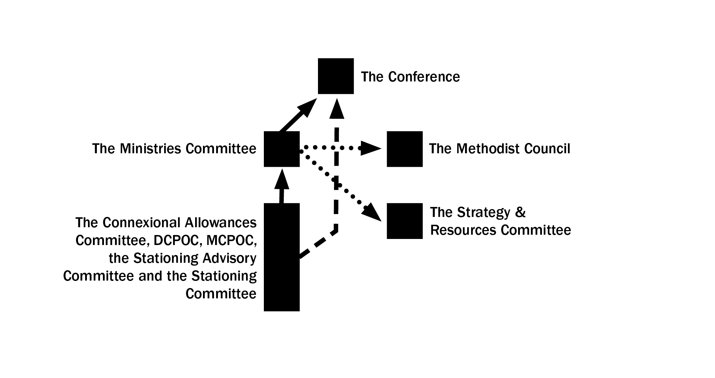
Key | Solid line Reporting line to the Conference
Dotted line Communication line
Dashed line Reporting line for matters of immediate oversight, authorisations and stationing recommendations

(VI) Implications of the creation of the Ministries Committee for existing committees
11. Ten committees are affected by the creation of the Ministries Committee.

12. The functions of the Connexional Local Preachers Committee, the Ordained Ministries Committee and the Training Strategy & Resources Executive are incorporated in their entirety into the functions of the Ministries Committee.
13. The functions of the Connexional Allowances Committee, the Diaconal Candidates Selection Committee, the Ministerial Candidates Selection Committee, the Diaconal Candidates & Probationers Oversight Committee (DCPOC), the Ministerial Candidates & Probationers Oversight Committee (MCPOC), the Stationing Advisory Committee and the Stationing Committee shall continue to be exercised by those committees under existing Standing Orders, with the exception of: (a) the changes required to give effect to the proposals regarding reporting in 8.b above, and (b) the changes required to give effect to the proposals regarding the oversight exercised by the Ministries Committee in 9.a and 9.f above.

(VII) Further preparations for the establishment of the Ministries Committee
14. The work of the Shadow Ministries Committee was reported to the April 2011 meeting of the Methodist Council, and was warmly received.

15. Further preparations are underway to enable the establishment of the Ministries Committee from September 2011.
- First, the Standing Orders to give effect to the status, functions and membership of the Ministries Committee (as outlined in paragraphs 8-10 above) have been drafted and may be found elsewhere in the Conference Agenda.
b. Secondly, the Nominations Groups referred to in paragraph 10 has been convened by the General Secretary & Secretary of the Conference, and nominations for the membership of the proposed Ministries Committee may be found elsewhere in the Conference Agenda.

***RESOLUTIONS (Daily Record 7/27)

30/1. The Conference received the Report.

30/2. The Conference appointed the Ministries Committee as follows:

The Revd Dr Martyn Atkins [ex officio]
General Secretary and Secretary of Conference.

Deacon Eunice Attwood
Diaconal member of a team of lay and ordained ministers in a city centre church in Newcastle upon Tyne. Instrumental in establishing the Newcastle Street Pastors Project, a Local Preacher and part-time diaconal tutor at the Wesley Study Centre in Durham. Ex Vice-President of the Conference.

Mr John Bell
Chair of the Connexional Allowances Committee. Former Vice-President of the Conference and convenor of the Stationing Review Group (2006-08). Local Preacher and Circuit Steward.

Ms Ruby Beech
Director of Corporate Services for a London based charity. A Local Preacher, a former Vice-President of the Conference, and a member of the World Methodist Council.

The Revd Anne Brown
Chair of the Beds, Essex & Herts District. Former Chair of the Ordained Ministries Committee and currently chair of the Stationing Action Group. Anne will serve as the Deputy Chair of the Ministries Committee.

Deacon Sue Culver
Warden of the Diaconal Order.

The Revd Mark Hammond
Presbyter with experience in leadership teams at local, circuit and district levels of the Methodist Church.

The Revd Liz Hunter
Presbyter in the Jersey Circuit. Circuit Local Preachers Tutor, former member of the Methodist Council and District representative to South & South West Regional Training Forum.

The Revd Jenny Impey
Co-Chair of the London District and Chair of the Diaconal Probationers and Candidates Oversight Committee.

Ms Jenny Jackson
Former Church and Circuit Steward. Lay Stationing Representative for the South East District since 2006 and regional representative on the Stationing Committee since 2009.

Mr Ken Jackson
Local Preacher and Circuit Steward. Previously a member of a number of Oversight Committees and a member of the Diaconal Candidates Selection Committee. Former Lay Stationing Representative for the Chester and Stoke-on-Trent District. Chair of Stationing Committee for the last six years and Chair of Shadow Ministries Committee for the last year. Ken is willing to serve for one year as the Chair of the Ministries Committee to aid the transition process. A new Chair will be appointed to succeed him in 2012.

The Revd Vernon Marsh
Chair of the Sheffield District and Chair of the Stationing Advisory Committee.

The Revd Marcus Torchon
A Minister of the Methodist Church in the Caribbean and the Americas (MCCA) currently stationed in the Wirral Circuit. Considerable awareness of and sensitivity to cross-cultural aspects of ministry.

The Revd Dr Andrew Wood
Chair of the Southampton District and Chair of the Ministerial Candidates and Probationers Oversight Committee.

The Conference noted that the following consultants had been invited to attend the Committee:

Mr Luke Curran (Director of the Wales Training Network)
Ms Helen Wareing (National Learning and Development Officer, Scotland and Shetland Training Forum)
The Revd Philip Jackson (Methodist Student Council representative to MCPOC; Ordinand in 2011)
The Revd Helen Cameron (Convenor of the Faith & Order Committee Ministries Resource Group)
The Revd Stephen Lindridge (Fresh Expressions Missioner)

