23. Methodist Homes for the Aged (MHA)

Basic Information

Title | Methodist Homes for the Aged (MHA)
Contact Name and Details | Keith Albans  Group Director - Chaplaincy & Spirituality  keith.albans@mha.org.uk
Status of Paper | Final Report
Resolution/s | 23/1. The Conference receives the General Report of Methodist Homes for the Aged.  23/2. The Conference amends Standing Orders as set out in the report.  23/3. The Conference expresses its thanks to Mr Brian Coldwell for his distinguished service to MHA.  23/4. The Conference appoints Keith Salsbury to the Board of MHA under Standing Order 241.

Summary of Content

Subject and Aims | Annual Report
Main Points | - General Report  - Report on Changes in MHA’s Governance  - Retirement of Mr Brian Coldwell as Chair of MHA Care Group Board  - Church Appointment to the Boards of MHA

Methodist Homes for the Aged (MHA)
- General Report
The past year has seen a change in the UK Government, a comprehensive review of public spending and a recession, all of which has cast a considerable shadow of uncertainty and challenge upon us all. The uncertainty was increased by the decision of the new coalition government to put the Labour Government’s White Paper on hold, abandon the plans for a National Care Service and set up the Commission on the Funding of Care and Support, tasked with reporting on options by July 2011.

Another source of uncertainty over the past year has been the major change in the system by which care homes in England are regulated. (Separate procedures cover other parts of the UK.) Since October 2010 the Health and Social Care Act 2008 has replaced the Care Standards Act 2000, and the previous National Minimum Standards which specifically covered Care Homes have been replaced by a more generic set of ‘essential standards of quality and safety’ which apply across the entirety of the health and social care sector. Moreover, the Care Quality Commission (CQC) decided to abandon the system of care home star ratings in June 2010 pending the creation of a new common rating system for both social care and health care services which are not expected before May 2011 at the earliest. Nevertheless it is pleasing to report that when the system was abandoned MHA was at the top of the ‘league’ of national providers, with 97% of our English care homes being rated as “Good” or “Excellent”.

For all that is uncertain, there are many certainties which affect the housing and care sectors for older people within which MHA operates. For a start, the number of older people as a whole and the proportion they make up in the population will both show a considerable increase when the results of the 2011 census are published, compared to 2001. Added to this the effects of the austerity measures adopted by the UK Government are being keenly felt. In care homes there are fewer people being referred to residential care, block contracts are being broken and the concept of negative fee increases is widespread. In Housing, changes in the way ‘Supporting People’ funding operates is hitting many people, and in community services many ‘Live at Home’ schemes are facing up to the sudden withdrawal of Local Authority grants. This is the challenging environment where MHA continues to operate successfully as the second largest not-for-profit providers of care homes in the UK.

We are pleased to be working for the first time this year with colleagues from Action for Children to provide a workshop for Conference representatives on the Saturday morning of the Conference. The workshop arises from our joint desire to share in an interactive way with Conference representatives something of our insights and distinctive perspectives on contemporary British society, and we hope we can develop such engagement creatively in future years.

Developing MHA’s Services

We have continued to extend the range of services available to older people, through development and acquisition, as well as working to ensure that existing MHA services are appropriate to the needs of today’s older people. Demand for our services remains high and in 2010-11 almost 96% of care home places were occupied and 99% of retirement housing apartments for rent occupied. The past year has seen the following achievements:

- The development of a new 76 place care home in Bristol and a new 60 place care home in Derby. We have also completed the acquisition of a 32 place care home in Nottingham.
- The development of 146 new apartments offering ‘Housing with Care’ in Harrogate, Newport Pagnell, Bedford and Leeds. In Harrogate and Newport Pagnell these have been through redeveloping existing sites and in Bedford the apartments are situated adjacent to an MHA care home.
- We have completed the upgrade of Richmond, our care home in Bexhill and the reprovision of Alexandra House, our care home in Dovercourt.
- Work has commenced a major upgrade of Langholme in Falmouth and Kenbrook in Wembley, and we have also begun to build a new care home at Leicester in the grounds of Aigburth, our existing care home.
- We have begun to build ‘Housing with Care’ schemes in Liverpool and Ben Rhydding, Ilkley, which together will provide an additional 85 apartments.
- At Auchlochan Garden Village in Scotland, work is progressing on completing the next phase of the Retreat, adding a further 24 apartments. Plans are also progressing for the creation of a new Village Centre, linking together Auchlochan House and the Courtyard.
- Following consultation with residents and relatives we have continued with a programme of adding care and other services to some of our existing housing schemes. All our retirement housing schemes now offer additional services including cleaning and shopping, while the full conversion of ‘Housing with Care’ has recently taken place at Norah Bellot Court, Barnstaple, The Paddock, Muswell Hill and Lawnfield Court, Wembley.
- ‘Live at Home’ has been our model for offering community services for almost 25 years, and two new schemes have launched in Great Horton, Bradford and North Douglas on the Isle of Man. Services have been expanded in 14 existing ‘Live at Home’ schemes. We recognise that our residential facilities can also become the base for new forms of community outreach, and projects have begun in 4 care homes and 14 housing schemes.
- MHA continues to offer management services to a number of external organisations. Two additional agreements have begun during the past year. One is with The British Home in Streatham and the other with Age Ventures India to support the development of retirement villages – the first projects are planned for New Delhi and Bangalore.
- We continue to develop our staff, and the number of care staff in homes having achieved level 2 or 3 in NVQ or SVQ in Care is now over 71%.
- Supporting the spiritual needs of older people remains at the heart of MHA’s work, and the role of our chaplains continues to grow and develop. The contribution of chaplains is valued by residents and staff alike, and is also acknowledged by external inspectors as making a significant impact on the life of MHA’s communities.
- MHA continues to explore ways of offering meaningful end of life care to our residents and to support their families. “The Final Lap” training programme for care staff remains at the heart of this, and is part of induction training for all staff in our care homes and housing with care schemes.
- MHA’s approach to spirituality is broader than a purely religious view. Our staff get to know each person, their story and family, life experiences and interests. We believe that spiritual well-being is achieved by nurturing the human spirit: through relationships and positive experiences – be they with God, family and friends, animals, nature, music, art or other creative activities.
- There is a constant challenge to enable residents to experience stimulation and enjoyment from personal care and daily routines in care homes. We are training more social care facilitators through NAPA, (The National Association for Providers of Activities for Older People), we have 54 qualified reflexologists with 16 more in the pipeline, and we have now employed 7 music therapists.

MHA and the Churches

MHA once again expresses thanks through the Methodist Conference for the support that we receive from the Church in so many ways.
- MHA is fortunate to benefit from the dedication of over 5,000 volunteers who give their precious time to older people, helping MHA to offer an extra special, person-centred service.
- Many of our volunteers serve as MHA reps in the churches, circuits and districts of Methodism, and we ask that their role is supported and recognised at Circuit Meetings and Synods.
- Charitable income is vital to the continuation of our work and every gift helps us to improve the quality of life for older people. Legacy donations make up the majority of our charitable income but we have also continued to benefit from an increase in regular, monthly giving by many of our supporters. Capital appeals seek to support our new developments and grant giving Trusts and numerous community events all play an invaluable role in enabling MHA to reach out to more older people.
- Methodist Homes Sunday in 2010 raised in excess of £210,000, for which we offer grateful thanks. The date of MHA Sunday 2012 has been fixed for Sunday 10June, although as always it can be moved to suit local circumstances. Worship materials will once again be produced and distributed with the winter edition of Heart and Soul and through Circuit Local Preachers’ Secretaries.

The latest audited accounts are available on request from Head Office. The indications from the unaudited accounts for the financial year ended 31 March 2011 indicate that MHA’s finances are in a most satisfactory position, which has enabled us to plan for the future with confidence.

***RESOLUTION (Daily Record 8/32)

23/1. The Conference received the General Report of Methodist Homes for the Aged.

- Report on Changes in MHA’s Governance
The structure under which MHA has been operating was established in 2000 in order to clarify the governance relationship between Methodist Homes for the Aged and Methodist Homes Housing Association, and to provide a structure for growth, facilitating additions to the Group. This structure has served us well, enabling the addition of MHA Auchlochan in 2009 and presiding over a period of unprecedented growth and development in MHA services.

However, the Boards have decided to take advantage of a change in the regulatory framework to change and simplify MHA’s Group Structure with effect from 1April 2011.
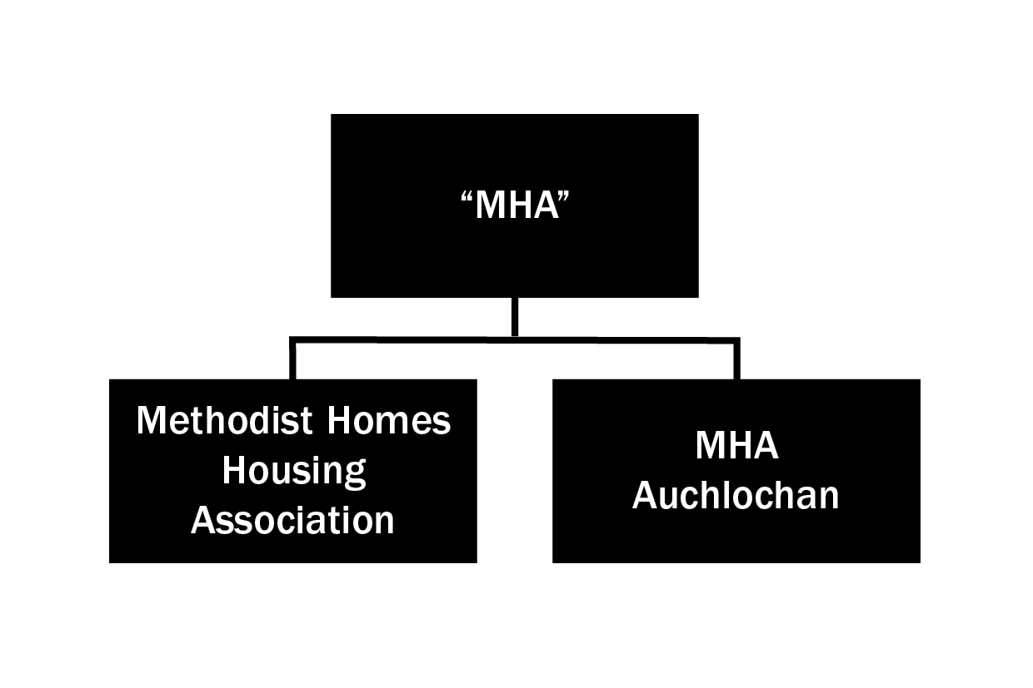

The new structure has Methodist Homes for the Aged as the principal charity, with two subsidiaries, MHA Auchlochan and Methodist Homes Housing Association. MHA Care Group has been wound up and its activities absorbed into the new structure. For some time the charity has been informally known as either MHA or Methodist Homes, and we have taken the opportunity to make the latter the official name – the words ‘for the Aged’ having been dropped as this is a term no longer in general use.

We have explored the possibility of absorbing the Housing Association into the main charity, but while this is technically and legally possible, it may involve the repayment of considerable amounts of Government grants. The main purpose in retaining MHA Auchlochan as a separate entity is to keep the registration with the Office of the Scottish Charity Regulator (OSCR) which is potentially significant to the Scottish commissioners.

In 2000, when MHA became a Company Limited by Guarantee rather than a Trust, we built in safeguards to ensure the charity’s objects could not be altered without the approval of the Church. This was achieved by having between one third and two thirds of MHA’s Board members as appointees of the Conference. Under the newly constituted Methodist Homes Board membership, we have continued to safeguard the charitable objects by having one Church nominee on the Board and included in the new Articles of Association a requirement that the Board give one year’s notice of any material changes, which could therefore be brought to the Conference’s attention for debate. We have had the benefit of consultation with representatives of the Law and Polity Committee in dealing with this matter. The amendments to Standing Orders reflecting the new constitution are proposed below.

***RESOLUTION (Daily Record 5/15)
23/2. The Conference amended Standing Orders as follows:

(i) Delete SO 007, items (iiiA), (iiiB), (iiiC). These items simply defined the constituent parts of the previous MHA group, and are now no longer required.

(ii) Delete the whole of SO 241 as set out below, and replace by the following:

241 Methodist Homes. The Conference shall exercise its powers of nominating any member of the board of Methodist Homes in accordance with the constitution of that body as amended from time to time. The provisions of Standing Order 206 shall apply to the proposal of any such name as if it were a Conference appointment.

[Existing wording: 241 MHA Care Group. (1) The Conference shall exercise its powers of appointing and removing members of the boards of MHA Care Group, Methodist Homes for the Aged and Methodist Homes Housing Association in accordance with the constitutions of those bodies as amended from time to time. Clauses (2), (4) and (5) of Standing Order 203 and Standing Order 206 shall apply to nominations for those appointments.
(2) In exercising the power of appointment in relation to the board of MHA Care Group the Conference shall include amongst the persons appointed the Connexional Team Secretary with responsibility for the care of older people or his or her nominee.]

- Retirement of Mr Brian Coldwell as Chair of MHA Care Group Board
Brian was appointed as Chair of the Board of MHA Care Group in 2002, having previously served on the Board of Methodist Homes for the Aged. Under his leadership MHA has expanded greatly the number and range of services available; care homes for those with dementia and nursing needs, community services, apartments for sale or rent with care / support and a retirement village. At the same time, Brian has always emphasised the need to focus on the quality, not the quantity, of services, something which is reflected in the high level of resident satisfaction recorded and the fact that the regulator of care services lists MHA as the national provider with the highest proportion of good and excellent care homes.

In his previous career Brian was Personnel and Services Manager with ICI, and he has brought this experience to bear within MHA, by keeping the focus on people. His interest in the thousands of members of staff around the country and their personal development, performance and satisfaction has been outstanding and his personal commitment to supporting and encouraging staff development has been appreciated by many in MHA – Board Members, CMT, managers and staff.

As Chair, Brian has been unwavering in his commitment to the long-term wellbeing of MHA; taking due account of the environment of the moment but sticking fast to our values, intent on doing the right thing the MHA way. Under his leadership MHA has developed into a successful charity, recognised in the sector, the Methodist Church and in the wider community, as a Christian-based charity providing care, accommodation and support services for older people which are both well-managed and professional, as well as underpinned by our values.

Brian’s has made a magnificent contribution to MHA and we wish him well for the future.

The Conference adopted Resolution23/2 (Daily Record 5/15)

***RESOLUTION (Daily Record 5/15)

23/3. The Conference expressed its thanks to Mr Brian Coldwell for his distinguished service to MHA.

- Church appointment to the Boards of MHA

Mr David Hobbs is the only other member of an MHA Board, serving in 2101/11, who has served his maximum term and is therefore stepping down. We thank him for his contribution to the work of MHA and wish his every blessing for the future. All other Board members continue to serve on the Board either of the principal charity or one of the subsidiaries.

The members of the Board of MHA for 2011/12 are as follows:

Mr Mike Bamford
The Revd Wes Blakey
The Revd Anne Gibson
Dr David Hall
Professor Malcolm Johnson
Ms Chris Paley
Ms Joan Rippingale
Mr Andrew Robinson
Mr Keith Salsbury (Chair)
Ms Moira Simpson
Mr Graham Smith

In 2008 the Conference appointed Mr Keith Salsbury as Chair of Methodist Homes for the Aged and, following an open recruitment process, he was chosen to succeed Brian Coldwell as Chair of MHA Care Group.

Under SO 241 Brian Coldwell has served on the Board as the nominee of the Connexional Team Secretary with responsibility for older people. In the new dispensation, we bring the name of Keith Salsbury to serve as the Church appointed Board member.

Reasoned Statement

Keith Salsbury retired from the National Health Service in 2002 having served in a number of senior management positions including 11 years as Chief Executive of Wakefield Health Authority. Keith holds an MBA in Health and Social Care Management and has worked at all levels of the NHS, acquiring a vast experience of health care. He has also served as a Trustee of a hospice and Chair of a local cancer charity. Keith has been a member of the Methodist Church for over 40 years where he has served as Church Secretary, Treasurer and Steward at different times.

***RESOLUTION (Daily Record 8/32)

23/4. The Conference appointed Keith Salsbury to the Board of MHA under Standing Order 241.

