21. Youth Participation Strategy Steering Group Report
Executive Summary
  - The Steering Group presented its full report to the Methodist Council (April 2008) and to the Methodist Conference 2008 through the Youth Participation Strategy Hearing.
1.2 The Methodist Council gave its approval to the amended Youth Participation Scheme for a preliminary roll-out from September 2008.
1.3 The report builds on the original work offered by the Youth Conference to the Methodist Conference 2007 and incorporates various amendments in the light of issues raised throughout the Connexion. Copies of the report are available from the Methodist Church website and via the Youth Participation Strategy Hearing.
  - The Steering Group offers this summary of the revised strategy to the Conference for approval.

Summary

2.0 What does participation mean and why is it important?
2.1 Participation does not simply mean ‘taking part’ or ‘being present’. It is about people having involvement.

2.2 “It is often viewed as a spectrum of involvement, from providing information or views on which others base their decisions, to increasing degrees of setting the agenda, being involved through the decision making process and finally self government. Sometimes the implication is drawn that only complete autonomy is worthwhile. In our view, this is false and different situations will make different levels of participation appropriate. The diagram below illustrates this point.”
[From: Empowering children & young people training manual: promoting involvement in decision-making (Save the Children). Phil Treseder, 1997]
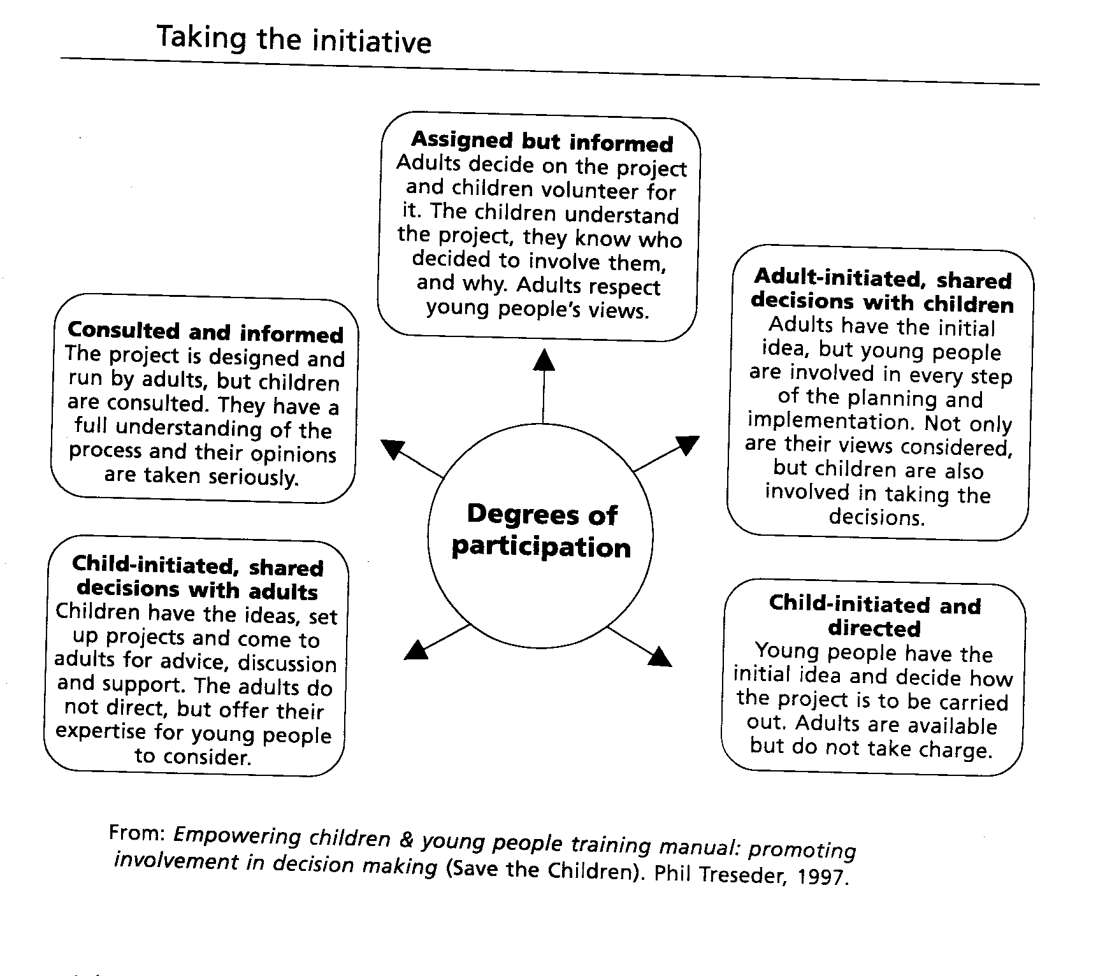

2.3 Consultation is part of participation.

2.4 Young people’s involvement in decision making should not be delayed until they attain ‘adulthood’ in the eyes of the Church.

2.5 Participation does not mean simply voting on Church politics. It is broader. “It includes many actions that capable people take to contribute responsibly to society. At the root of it is the desire and ability of young people to be part of the processes that determine what happens to one’s life and the lives of others in the community”.

2.6 If the Church is serious about developing with enhanced energy, initiatives to reach those who are completely outside any Christian community then there is a need to embrace a theology of young people. Young people need to be enabled to live as Christians, to witness to their peers and to participate as equals in the Church. “As groups of young people begin to speak of their encounter with God a theology which is indigenous to them will emerge and contact is likely to follow.” (Taking a Part, 2000: Church House Publishing) This approach however requires the Church to rethink and reshape its theology of youth work and the Youth Participation Strategy is an essential element of this.
- Strategy now proposed
3.1 The YPS will continue to be based on a modest number of full time paid staff supported by part time paid young people working for one year on a ‘living wage’ basis. The various roles and tasks are set out below.

3.2 The Youth Participation Strategy team will be part of the one 0-19’s team supporting The Methodist Church’s work with children and young people.

3.3 The YPS will be organised across the Connexion through the regional structure existing for the Methodist Regional Training Forums. There will be seven “Regional Participation Officers” across the connexion, of which one will be based in each of the five English Regional Forums (and covering the Channel Islands and Isle of Man within neighbouring forum areas), and two further posts will be available to cover the nations of Scotland and Wales. The precise structure for the latter posts will be agreed by consultation with the Districts concerned, but given the geography and Methodist membership in Scotland and Wales, it may be appropriate to work in collaboration with other forums, but using the additional resources indicated in this paragraph.

3.4 The Steering Group gave much time to examining the detail of the initial proposal and asking if it was the best fit for The Methodist Church. On the whole it was, but there were some significant additions and changes of focus. The recommended structure for the Strategy is laid out below –

Youth Participation Strategy Reference Group
(Reporting to Methodist Conference / Methodist Council)

Discipleship & Ministries Manager

Under 19’s Team Leader

Participation Development Officer

3 Under 19’s Development Officers

Equalities & Diversities Participation Worker

Children’s Participation Worker (Research)

Youth President

Regional Youth Participation Workers (7)

Regional management forums (7)
Linking with Methodist Regional Training Forums

Linking with Methodist Regional Training Forums

32 District Youth Enablers (Part-time)

Mission Possible
Working groups
District roles &
responsibilities
Youth Assembly
Planning group

Voluntary Young people
(From associated district networks)

(The ‘Mission Possible’ projects bring to the attention of the wider church the issues and concerns of young people within Britain, and enable young people to participate in working with the whole Church in developing appropriate responses – Ref: 3.5.)

Line management/ support function

Associated responsibility/ collaborative working

3.5 Part-time District Youth Enablers
The purpose of the post is to enable young people to take an active role in their local communities, Circuits, Districts and the Connexion. Recruitment would be via existing events and networks such as Breakout, and open accessible recruitment processes such as adverts in schools, colleges, and community venues.
- The model of Youth Enablers is intended to be as flexible as possible.
- Each District will receive a grant from the central fund for the employment of a young person aged 16-23 for 15 hours a week.
Between 9 - 12 hours a week will be given to work within the district.
The remaining 3 – 6 hours a week will be used for national initiatives. (These may be banked to provide a larger portion of time for attendance at full-day or weekend/ overnight meetings.)
Districts could pay to increase the hours of the designated Youth Enabler, or may wish to consider creating additional Youth Enabler roles.
  - Appointments are strictly for one year only (September to August), at which point another young person will assume the role. (Induction training and support networks will ensure a level of continuity without stifling the creative development of what each new District Youth Enabler brings to the role.)
  - Young people will apply for a role within the District they live in (if Districts are unable to recruit arrangements may be made for a suitable young person to move into the locality for the year).
  - Applications are considered from all those who are sympathetic to the aims of the Methodist Church.
  - An initial weekend training event will be held in September provided as part of their induction with a further four residential meetings throughout the connexional year to manage the ‘Mission Possible’ projects.
  - The District Youth Enablers are key staff in ensuring that each District sends at least two young people to Youth Assembly which takes place in November.
  - The year in post will be a time of vocational discernment allowing youth enablers to access a range of skills based training programmes, which will be provided locally and as part of the national training framework of the Youth Participation Strategy.
  - The programme will also seek to relate to the “Extending Discipleship Exploring Vocation” (EDEV) process being developed in the Methodist Church. Experience gained by District Youth Enablers would be considered as a placement and reflected upon theologically by the core EDEV group where the enabler wished to be a part of such a group.
  - A “Mission Possible” is simply a realistic suggestion for putting the gospel into action. This will enable the young people in the Districts of the region to undertake work of service, or challenges about Justice, Peace and the Integrity of Creation. While networks might develop around these projects that will outlast the year of the particular Mission Possible, each year a new Mission Possible will be taken on.
  - It is crucial that the Connexion takes its responsibility towards employing people of all ages seriously, this is ever more significant with young people. The DYEs will be supported locally by trained Youth work staff, either drawn from existing church or circuit appointments, or utilising other support networks which will be facilitated by the YPS staff themselves. There is no expectation that the DYEs will be mobile across the whole District if this is not appropriate.

3.6 Regional Participation Workers
There will be seven full time Methodist Council appointments operating within the geographical parameters of the Methodist Regional Training Forums. Their purposes include:
  - supporting Youth Enablers
  - delivering training at church, circuit, district and connexional level
  - project development and networking with external and ecumenical bodies and agencies
  - provide additional support to Training Officers and theological colleges for children’s and youth training and co-ordination
  - project development and networking with external and ecumenical bodies and agencies.

The Regional Participation Workers’ tasks will include supervision of the District Youth Enablers, but they will also be available to the Regional Training Forums to share in the delivery of training for children’s and youth work and safeguarding.

The Regional Participation Workers will bring together the District Youth Enablers and at times other young people from the Districts in their region for support, training and consultation. They will be responsible for ensuring that the resolutions of the Annual Youth Assembly are taken forward and acted upon.

At the regional gathering referred to above each region will agree annually a “Mission Possible” project, which will have been proposed by young people in the region.

3.7 Connexional Participation Staff

3.7.1 Participation Development Officer
This post holder will:
  - Manage the development and implementation of the strategy
  - Lead on the development of a theological framework in consultation with other bodies
- Coordinate funding applications and create relationships with other denominations
- Manage support programme for Youth Enablers – develop training, induction and exit process
  - Ensure integration with broader Church initiatives and project areas – Fresh Expressions, Chaplaincy, Under 19’s and others

3.7.2 Children’s Participation Development Worker
This post holder will:
- Research models for the participation of children in organisations
- Develop resources for use by children’s workers
- Integrate models of children’s participation into work of the under 19s

3.7.3 Equalities and Diversities Participation Development Worker
This post holder will:
- Work with the Association of Black Methodist Youth to ensure the voice and place of black and ethnic minority youth within the Connexional Participation Strategy
- Educate, train, develop and facilitate Circuits and Districts on the ethos and methodology of the Youth Participation Scheme with specific regard to equality and inclusion issues
- Participate in contributing towards the monitoring and evaluation of the Scheme with specific regard to equality and inclusion issues
- Encourage the attendance of black and minority ethnic young people at national youth events

3.7.4 Youth President

Each year the Youth Assembly will elect a Youth President Elect. He or she will then serve as Youth President for the year commencing at the opening of the next Youth Assembly.

During the year of office, the Youth President will:
- act as the representative embodiment of the Youth Assembly between Assemblies;
- be the normal spokesperson for young Methodists wherever one is needed inside or outside the Church;
- be a member of the Conferenceand the Connexional Leaders’ Forum and be one of the Youth Representatives on the Methodist Council;
- preside at the Youth Assembly (unless he or she chooses to delegate this function for particular items of business);
- chair meetings of the Youth Assembly planning group and the District Youth Enablers (unless he or she chooses to delegate this function for particular items of business); and
- travel around the Connexion encouraging and enabling young people.
During such travels he or she will also be given opportunity to challenge Methodists of all ages to welcome the participation of children and young people in all aspects of the Church’s work and life.

During the year as Youth President Elect he or she will consider with the Connexional Participation Officer, other members of the Under 19s Team and the District Youth Enablers:
- his or her particular emphases for the year of office;
- his or her training needs (for example, in representational and media work and in chairing meetings); and
- priorities for his or her year as Youth President.

In the light of such consultation he or she will draw up a plan of visits in consultation with District Chairs and with the Under 19s Team Leader. He or she will continue to work alongside the Connexional Participation Officer, other members of the Under 19s Team and the District Youth Enablers as appropriate. Where time permits, the Youth President may take on particular tasks, for example, in following up resolutions of the Youth Assembly or in representing young people on groups. Such tasks will be shared with the District Youth Enablers serving during that year part of whose time will be devoted to such Connexional responsibilities.

In recognition of his or her contribution to the life of the Connexion in his or her year of office the Youth President will receive:
- a bursary from Connexional funds;
- expenses from Connexional funds in respect of all duties as Youth President Elect and as Youth President; and
- agreed training funded by the Connexion.

- Systems and Structures
4.1 Effective working relationships with Districts will be essential throughout the pilot. Every District could have existing within its boundaries a number of Youth Forums or Networks. These Forums will grow organically depending on a number of factors within the District and may be based around existing Youth groups. These Forums will be convened by the Youth Enabler. What the Forum does will be decided by the people involved – activities may range from working on regional or national projects (such as the Mission Possible), work in a local community, contributing towards District initiatives, organising events for others, or whatever else is felt to be a priority by the young people.

As each District will have at least one Youth Forum there will be a locus for youth work and for youth opinion in the District. Each District should work with the Youth Enabler and the Regional Participation Worker to ensure that the Youth Forum and the young people who are part of it are offered opportunities to contribute in all aspects of the mission and ministry of the District.

4.2 The Youth Enabler will be linked to a Regional Participation Worker who will have the task of supervising and mentoring the Enabler. By having a number of Enablers in their Region the Worker will be able to share best practice across the Region and enable the Enabler to carry out their responsibilities.

4.3 All the Youth Enablers will meet together at specified times throughout the year. The first of these meetings will be a Training weekend run by the Participation Staff. The other meetings will be to do the groundwork on the Mission Possible projects, the Methodist Youth Assembly, and to work with the Youth President and those young people who wish to volunteer for a specific piece of work.

4.4 Every year there will be a Planning Group for the Methodist Youth Assembly and this will be convened by the Youth President and will involve volunteers from the District Groups. This Assembly will draw on all the young people involved in the Youth Forums, youth work connected with Methodist churches, Youth Clubs, Youth organisations and young people in the community. The Assembly will be the body that will communicate with the Methodist Conference as well as be the locus for the work of the Youth Forums and the Youth Enablers.

4.5 Every two years a large outreach event, currently known as Breakout, will take place. The event is shaped around the MAYC curriculum journey and the associated outcomes.

4.6 The monitoring and evaluation of the Strategy will be ongoing. The Youth Participation Strategy Reference Group with appropriate staff will determine annual indicators, processes for evaluation and action changes when required. “We often ‘know’ organically whether something is working or life-giving. The value of indicators as a way of reflecting what is good and what works leads us to consider what can be changed and how we might improve it”.

The full Framework for understanding anticipated OUTCOMES and possible impact of the Youth Participation Strategy is contained within the Steering Group Report.

5.0 The Steering Group was also charged by last year’s Conference to bring proposals ‘for a further Steering Group to oversee the Strategy’s implementation and subsequently to monitor and review the Strategy for the course of the five-year pilot scheme’. We propose that these tasks be undertaken by a Youth Participation Strategy Reference Group. This will report to the Conference through the Council. Initial recommendations for membership of this group include -
- 50% of the group to be young people who would eventually be made up of Youth President, one or more Youth Enablers, and one or more Voluntary Young people.

Others might include:
- A District Chair
- An External Youth work training specialist (perhaps YM College)
- An External Youth Participation specialist (perhaps NCH)
- A specialist with experience in Monitoring, evaluation and skills management
- The Participation Development Officer (ex officio)

The full terms of reference for this group would include ensuring that the Strategy:
- Is responsive to the vision set out at the beginning of this report
- Fulfils its core purpose
- Empowers young people
- Encourages more young people to share in the mission of the Church
- Is effective across the Connexion
- Makes the most of ecumenical opportunities

6.0 Budget

Youth Participation Strategy 2008 start up budget
Staffing costs  - Participation Development Officer  - Children’s Participation Worker  - Equalities & Diversities Worker  - Regional Participation Worker (2)  - District Youth Enablers (8) | £ 242,627
Recruitment | £ 11,000
Training | £ 15,000
Resources | £ 5,800
Office | £ 11,600
IT costs | £10,000
Travel | £31,900
Youth Assembly | £ 15,000
National meetings (4/ year) | £ 12,240
Staff residential (2/ year) | £1,200
Miscellaneous  - Reference group costs  - Theological group  - Membership fees | £30,000
TOTAL | £386,367

Annual budget |  | 2009 |  | 2010 |  | 2011 |  | 2012
National Participation Staff |  | £147,235 |  | £ 150,918 |  | £154,711 |  | £158,617
Regional Participation Workers |  | £305,050 |  | £311,951 |  | £319060 |  | £326,382
3 ILW Youth Enablers |  | £36,228 |  | £36,955 |  | £37,704 |  | £38,475
29 x District Youth Enablers |  | £274,820 |  | £280,545 |  | £286441 |  | £292,514
Youth President |  | £19,805 |  | £20,265 |  | £20,738 |  | £21225
National Meetings 4/ year |  | £20,700 |  | £20,700 |  | £20,700 |  | £20,700
Youth Assembly |  | £15,000 |  | £15,000 |  | £15,000 |  | £15,000
Participation Officers Meetings |  | £2,400 |  | £2,400 |  | £2,400 |  | £2,400
Publications |  | £10,000 |  | £10,000 |  | £10,000 |  | £10,000
Equipment (Not DYE’s) |  | £10,000 |  | £10,000 |  | £10,000 |  | £10,000
Contingency |  | £42,000 |  | £42,000 |  | £42,000 |  | £42,000
TOTAL |  | £883,238 |  | £900,734 |  | £918,754 |  | £937,313

This budget is a little higher than that envisaged last year. This reflects a number of changes of which the most significant are the addition of a net two Connexional participation staff and the replacement of 8 full time regional enablers with 32 part time District Youth Enablers and a full-time Youth President.

Although this budget is presented for the five years of the Connexional Strategy it will be a key function of the Development Officer to explore a wide range of partnership and funding opportunities to ensure the long-term viability of the Strategy beyond the five years.

6.1 Griff Fund
This is a fund established in memory of the Revd Douglas Griffiths. Monies are used for the development of local, regional and national youth initiatives as well as providing small grants to individuals.

It is intended that the money within the Griff fund approx £250,000 would be used to finance IT equipment for District Youth Enablers, support Breakout with a grant of £20,000/ event and prime start Mission Possible projects.

7.0 Implementation timetable
During the work of the Steering Group a number of concerns were raised and tackled. Many of these connected to the time frame of the Strategy as well as the opportunity to test out the various components prior to a national pilot.

With this in mind the Steering Group felt it necessary that due time was committed to ensuring that as much could be learned from an initial test.
The following timetable marks out how this might be done:

Timeline | Action
July 2008 | Steering group report to Methodist Conference.
July 2008 | Proposal for intergenerational project focusing on Youth Violence made to Methodist Conference. (Joint resolution from Methodist Youth Conference & Association of Black Methodist Youth).
July 2008 | Promotion of Youth Participation Strategy at Breakout 2008 through Radio broadcasts & Publications - hand books for young people and youth workers.
July 2008 | Youth Participation Strategy Reference Group initial meeting to:  - Agree 2008-2009 targets  - Framework for monitoring & evaluation  - Negotiate review processes
July 2008 | Agree initial recruitment processes
July 2008 | Visits to Districts expressing interest in appointing DYE in 2008
August 2008 | Promotion of Youth Participation Strategy at ABMY Conference.
August 2008 | Recruitment process for 8 District Youth Enablers to:  - Work on Youth Violence Mission Possible  - Develop/ manage recruitment processes for Regional participation Workers/ District Youth Enablers/ Youth President  - Plan Youth Assembly  - Evaluate and commence planning for Breakout 2008
September 2008 | Training weekend for 8 District Youth Enablers
October 2008 | Recruitment process for 2 Regional Workers & Equalities and Diversities Participation Worker
November 2008 | Final Youth Conference  Election of Youth President for 2009
January 2009 | Regional Workers/ E & D Participation Worker Induction and Training
Mar 2009 | Evaluate recruitment processes for District Youth Enablers & Regional Participation Workers
Mar 2009 | Visits to districts
May 2009 | Advertising for Youth Enablers
May 2008 | Recruitment process for remaining Regional Youth Participation Workers
June 2009 | Interviews and Appointments for Youth Enablers
August 2009 | Regional Workers Induction and Training
July/ August | Exit interviews/ review for 8 Initial District Youth Enablers
September 2009 | Training Weekend for Youth Enablers
November 2009 | First Methodist Youth Assembly

8.0 Methodist Youth Conference (MYC) 2007
A substantial amount of time was dedicated to looking at the Youth Participation Strategy at MYC. Members of the YPS steering group presented an explanation of the revised model and spent a lot of time ensuring that the strategy was understood and answering questions from delegates. The YPS steering group felt it was vital that MYC were kept informed of the progress of the strategy but also wished to keep delegates involved in decision-making. Many of the members of the steering group attended the debate surrounding the YPS at MYC in order to get a feel for the opinions of delegates. MYC was split into different workshops during the debate; one group explored and discussed the theology of participation whilst the three other groups looked at issues of recruitment, nomenclature, and ways in which the strategy can better outreach to those not currently attached with the Church.

The debate surrounding the YPS was very positive and the changes which are proposed by the steering group were well received. The delegates that had attended MYC 2006 overwhelmingly supported the changes and felt that they addressed many of the concerns raised by delegates in the original debate at MYC 2006.

MYC 2007 voted unanimously in favour of a resolution supporting the YPS, which read, “Youth Conference welcomes the decision taken by Methodist Conference 2007 and expresses its support for the Church in continuing along in this process, Youth Conference would also wish to express its thanks to those who have worked upon the strategy in the past year”.

***RESOLUTIONS
21/1. The Conference receives the Report.

21/2. The Conference endorses the Report’s recommendations for a five-year connexional pilot for a youth participation strategy, beginning with an initial roll-out in 2008-2009.

21/3. The Conference endorses the recommendation in paragraph 5.0 for the setting up of a Youth Participation Strategy Group and directs that Group to bring an annual report to the Conference on the Strategy, liaising with the Faith and Order Committee to develop appropriate theological resourcing for the Strategy, with a full evaluation report to be presented in 2011.

The Conference, by the required majority, suspended Standing Order 250 for the connexional year 2008-9 so far as necessary to give effect to this strategy.

Taking the initiative, Edited by Steve Mokwena, The Carnegie Youth Trust.
Taking a Part, 2000: 32, Church House Publishing.

