26. Unified Statement of Connexional Finances

Contact Name and Details | Email: Maureen Sebanakitta, Director of Financial Operations  sebanakittam@methodistchurch.org.uk

Summary of Content

Subject and Aims | Summary extracts of the full consolidated accounts of the Methodist Church in Great Britain for 2011/12 adopted by the Methodist Council and presented to the Conference as the unified statement of connexional finances required by Standing Order 360.
Main Points | These accounts consolidate figures for a wide variety of Methodist activities and entities; together they had income of £46m and expenditure of £37m.  At the end of the year, the Church recorded net incoming resources before transfers and revaluations of £7.8 million (2011: £1.4 million). Total incoming resources for the year were £46 million, up 4% on the previous year. Total resources expended fell by 10% to £37.8 million (£42.2 million in 2011).  One entity, Southlands Methodist Trust was incorporated into these consolidated accounts for the first time.
Background Context and Relevant Documents | When the Methodist Church in Great Britain was registered with the Charity Commission it was agreed that the accounts of the registered charity would be those of the Methodist Council. The full consolidated accounts were presented to the Council and adopted by the Council under SO 212 (1) on 22 January 2013. They are available for scrutiny on the Methodist Church website and in printed form from the contact named at the head of this Report.  Under SO 360 the Council has to present to the Conference a “unified statement of connexional finances.... so as to give an overall view of those moneys and other assets for which the council is responsible”.  This Report consists of extracts from the full consolidated accounts which provide a summary of them to meet that requirement. It is submitted to the Conference as the trustee body of the registered charity.

- Financial Review

The activities covered in these consolidated accounts are those under the oversight of the Methodist Council. The Methodist Church is the registered charity and the Charity Commission have agreed that these accounts can properly serve as the accounts of the charity.

At the end of the year, the Church recorded net incoming resources before transfers and revaluations of £7.8 million (2011: £1.4 million). Total incoming resources for the year were £46 million, up 4% on the previous year. Total resources expended fell by 10% to £37.8 million (£42.2 million in 2011).

Charitable income

The main sources of charitable income are donations (including legacies) and the district assessment. Together these accounted for 50% of all incoming resources.

The increase in income of 4% to £46 million (2011: £44 million) is mainly due to the impact of the first time consolidation of Southlands Methodist Trust (£4m). Sales of the hymn book, Singing the Faith account for the increase in fundraising trading of 38%. Investment income rose by 13%. Against this there was a fall in voluntary income of 9%. Current year income includes the “donation” of the net assets of Southlands Methodist Trust upon consolidation, (2011 included £4million worth of the net assets of Westminster College Oxford Trust). If these one-off charges are excluded, the net year-on-year reduction in voluntary income is 17%.

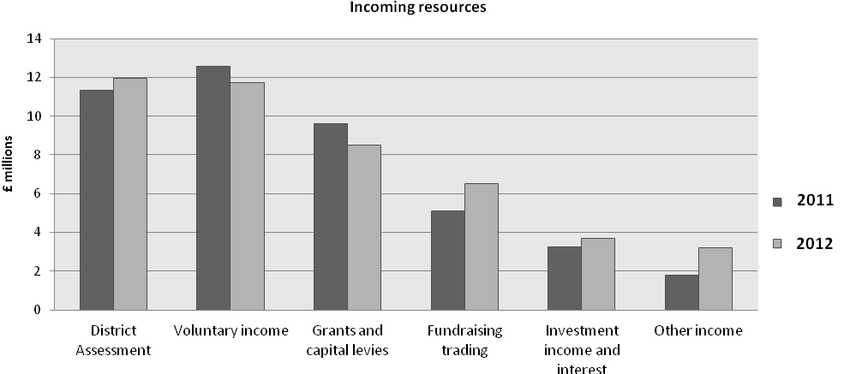

Charitable Expenditure

Overall expenditure fell by 10%. The biggest reduction has been in the area of grant giving, which fell by 33% to £13 million (2011: £19 million). Property grants saw the biggest fall (91%) reflecting one-off adjustments made in the previous year, whilst resourcing overseas mission grants fell by 22% and the other types of grants fell by 28%. This trend reflects an overall decline in the level of grant commitments, but in the case of overseas mission grants will be reversed in 2012/13 as some are now being committed on a three-yearly cycle rather than annually. The overseas mission grants include a grant commitment write back of £1.7 million due to a change in accounting convention. Non charitable expenditure increased by 32%, with the biggest increase attributed to fundraising trading, an area which has grown significantly in the past twelve months due to hymn book sales.

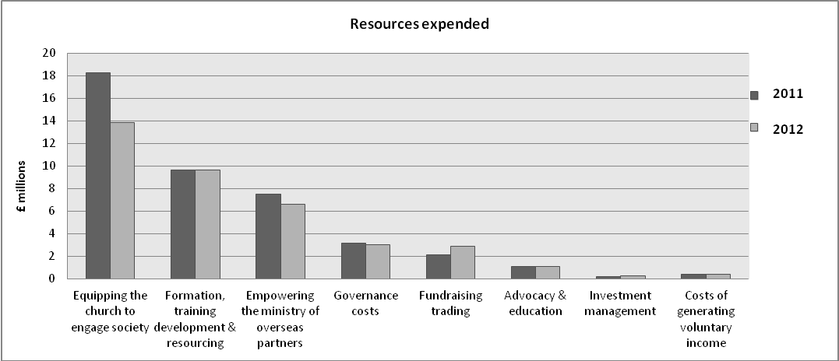

Strategic objectives, aims and purposes of the Methodist Church in Great Britain

The activities covered in these accounts falls within the work of the Methodist Church. The strategic objectives of The Methodist Church are directly linked to its aims. They are:
- Worship – to increase awareness of God’s presence and to celebrate God’s love;
- Learning and Caring – to help people to learn and grow as Christians, through mutual support and care;
- Service – supporting community development and action for justice, especially among the most deprived and poor - in Britain and worldwide; and
- Evangelism – developing confidence in evangelism and in the capacity to speak of God and faith in ways that make sense to all involved.

Public Benefit Requirement

The trustees of The Methodist Church had due regard to the public benefit guidance published by the Charity Commission in compliance with its duties under section 17 of the Charities Act 2011.

This guidance sets out two key principles:
- The organisation must have an identifiable benefit.
- The benefit must be to the public or a section of the public.

The Church exists, inter alia, to:
- increase awareness of God’s presence and to celebrate God’s love;
- help people to learn and grow as Christians, through mutual support and care;
- be a good neighbour to people in need and challenge injustice;
- make more followers of Jesus Christ.

The trustees consider that for these reasons the charity meets these public benefit requirements.
Consolidated Statement of Financial Activities for the year ended 31 August
 |  |  |  | Unrestricted Funds |  |  |  | Restricted Funds |  |  |  | Endowment Funds |  |  |  | Total |  |  | Total
 |  |  |  |  |  |  |  |  |  |  |  |  |  |  |  | 2012 |  |  | 2011
 |  |  |  | £000 |  |  |  | £000 |  |  |  | £000 |  |  |  | £000 |  |  | £000
Incoming resources:
Incoming resources from generated funds
District Assessment |  |  |  | 11,929 |  |  |  | - |  |  |  | - |  |  |  | 11,929 |  |  | 11,316
Voluntary income |  |  |  | 871 |  |  |  | 10,875 |  |  |  | - |  |  |  | 11,746 |  |  | 12,924
Investment income and interest |  |  |  | 1,186 |  |  |  | 2,484 |  |  |  | - |  |  |  | 3,670 |  |  | 3,260
Activities for generating funds
Fundraising trading |  |  |  | 1,718 |  |  |  | 4,817 |  |  |  | - |  |  |  | 6,535 |  |  | 4,726
Incoming resources from charitable activities
Grants and capital levies |  |  |  | 7,738 |  |  |  | 749 |  |  |  | - |  |  |  | 8,487 |  |  | 9,628
Other income |  |  |  | 1,044 |  |  |  | 699 |  |  |  | - |  |  |  | 1,743 |  |  | 1,874
Other income resources
Net gain on disposal of tangible fixed assets |  |  |  | 934 |  |  |  | 541 |  |  |  | - |  |  |  | 1,475 |  |  | (92)
Total incoming resources |  |  |  | 25,420 |  |  |  | 20,165 |  |  |  | - |  |  |  | 45,585 |  |  | 43,636
Resources expended
Cost of generating funds
Costs of generating voluntary income |  |  |  | 380 |  |  |  | - |  |  |  | - |  |  |  | 380 |  |  | 365
Fundraising trading |  |  |  | 742 |  |  |  | 2,155 |  |  |  | - |  |  |  | 2,897 |  |  | 2,124
Investment Management |  |  |  | 107 |  |  |  | 120 |  |  |  | - |  |  |  | 227 |  |  | 169
Charitable activities
Equipping the church to engage society |  |  |  | 7,153 |  |  |  | 6,718 |  |  |  | - |  |  |  | 13,871 |  |  | 18,224
Formation, Training Development & Resourcing |  |  |  | 7,342 |  |  |  | 2,321 |  |  |  | - |  |  |  | 9,663 |  |  | 9,656
Empowering the Ministry of Overseas Partners |  |  |  | 1,513 |  |  |  | 5,105 |  |  |  | - |  |  |  | 6,618 |  |  | 7,514
Advocacy & Education |  |  |  | 1,117 |  |  |  | - |  |  |  | - |  |  |  | 1,117 |  |  | 1,058
Governance costs |  |  |  | 3,031 |  |  |  | - |  |  |  | - |  |  |  | 3,031 |  |  | 3,126
Total resources expended |  |  |  | 21,385 |  |  |  | 16,419 |  |  |  | - |  |  |  | 37,804 |  |  | 42,236
Net incoming/(outgoing) resources before transfers |  |  |  | 4,035 |  |  |  | 3,746 |  |  |  | - |  |  |  | 7,781 |  |  | 1,400
Gross transfers between funds |  |  |  | (2,725) |  |  |  | 1,427 |  |  |  | 1,298 |  |  |  | - |  |  | -
Net incoming/(outgoing) resources after transfers and before other recognised gains |  |  |  | 1,310 |  |  |  | 5,173 |  |  |  | 1,298 |  |  |  | 7,781 |  |  | 1,400
(Losses)/Gains on revaluations and disposal of investment assets |  |  |  | 2,009 |  |  |  | 5,034 |  |  |  | 94 |  |  |  | 7,137 |  |  | 1,612
Net movement in funds |  |  |  | 3,319 |  |  |  | 10,207 |  |  |  | 1,392 |  |  |  | 14,918 |  |  | 3,012
Total funds brought forward
Total funds brought forward at 1 September |  |  |  | 40,786 |  |  |  | 85,680 |  |  |  | 12,632 |  |  |  | 139,098 |  |  | 136,086
Total funds carried forward at 31 August |  |  |  | 44,105 |  |  |  | 95,887 |  |  |  | 14,024 |  |  |  | 154,016 |  |  | 139,098

Consolidated balance sheets as at 31 August
 |  | 2012 |  | 2011
 |  | £000 |  | £000
Fixed Assets
Tangible assets |  | 25,031 |  | 22,871
Investments |  | 130,402 |  | 116,266
 |  | 155,433 |  | 139,137
Current Assets
Stock |  | 165 |  | 167
Asset held for sale |  | 700 |  | -
Debtors |  | 5,813 |  | 8,366
Short term deposits |  | 8,607 |  | 12,426
Cash at bank and in hand |  | 3,609 |  | 1,787
 |  | 18,894 |  | 22,746
Creditors
Amounts falling due within 1 year |  | (10,942) |  | (13,093)
Net current assets |  | 7,952 |  | 9,653
Total Assets less current liabilities |  | 163,385 |  | 148,790
Creditors
Amounts falling due after more than 1 year |  | (9,369) |  | (9,692)
Net Assets |  | 154,016 |  | 139,098
The funds of the Methodist Church in Great Britain
Endowment funds |  | 14,024 |  | 12,632
Restricted income funds |  | 95,888 |  | 85,680
Unrestricted income funds |  | 44,104 |  | 40,786
Total funds |  | 154,016 |  | 139,098

The Methodist Church
Notes to the consolidated Financial Statements for the year ended 31 August 2012

1. Accounting policies

- Basis of accounting
The consolidated accounts of The Methodist Church have been prepared under the historical cost convention, except for investments which are stated at market value and hotel properties are held at valuation, and are in accordance with the Statement of Recommended Practice: Accounting and Reporting by Charities (SORP 2005), UK Accounting Standards and the Charities Act 2011.

b) Basis of preparation
The entities included in these accounts have been consolidated based on the view of the Council of the degree of control which it exercises over the entities concerned, which is constantly under review.

- Basis of consolidation
The consolidation principles applied are based on Financial Reporting Standard (FRS) 2 and SORP 2005 which require consolidation of subsidiary undertakings as identified by the measure of control exercised. Control can be determined in the context of voting rights and/or the exercise of dominant influence over the Board or activities of the subsidiary undertaking.

All of the entities listed below are consolidated on the grounds that the Methodist Conference has the right to exercise dominant influence, and this influence is demonstrated in a number of ways, but mainly through the selection of the trustees on the boards of these entities.

All the entities which are separately registered as charities, together with their wholly owned trading subsidiaries, have been consolidated as subsidiaries on a line by line basis in accordance with FRS2 and SORP 2005.

Activities managed or administered by the Connexional Team (hereafter referred to as the Connexional Funds)
Cliff College | (a separately registered charity)
Cliff College Outreach Limited | (a separately registered company)
Cliff (Methodist) Developments Limited | (a separately registered company)
Methodist International Centre Limited | (a separately registered company)
Methodist Relief and Development Fund | (a separately registered charity)
Southlands Methodist Trust | (a separately registered charity)
T Beckett (Saddler) Limited | (a separately registered company)
Westminster College Oxford Trust | (a separately registered charity)

For the purposes of these accounts these entities are referred to as The Methodist Church in Great Britain. During the year Trinity Hall Trust was dissolved as a separately registered charity and transferred into the Connexional Funds, where it continues to be administered by the Connexional Allowances Committee.

- Accounting Policies (continued)

- The accounting / reporting structure
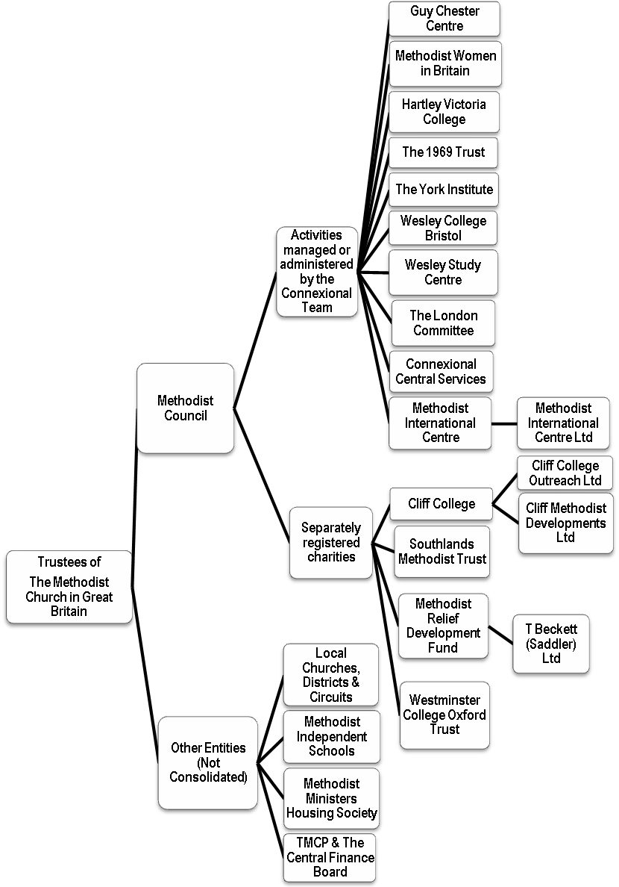
1. Accounting Policies (continued)
- Excluded entities - grounds for exclusion under paragraph 384 of SORP 2005
A number of entities have been excluded from the consolidation. These are:
Local Churches, Circuits and Districts
Methodist Independent Schools
Trustees for the Methodist Church Purposes (TMCP)
The Central Finance Board (CFB)
Methodist Ministers Housing Society

Whilst these entities might form part of the overall picture of the Methodist Church, the Methodist Council does not control their activities.

- Incoming resources

District assessment
The District Assessment is accounted for on a receivable basis.

Voluntary income
Donations, contributions and legacies are accounted for when entitlement has been confirmed, the amount can be measured accurately and receipt is certain. In accordance with this policy, legacies are included when advice has been received from the personal representative of an estate that payment will be made or property transferred and the amount involved can be quantified with reasonable certainty.

Capital levies
Capital levies are due on the disposal of property by churches, circuits and districts under Standing Order 970 of the Constitutional Practice and Discipline of the Methodist Church and are accounted for on a receipts basis.

Grants receivable
Grants receivable are included when the relevant conditions for the grant have been met.

Rental income
Rental income is accounted for on a receivable basis. Rental income is included within fundraising trading within the Statement of Financial Activities

All other incoming resources
All other incoming resources are accounted for on an accruals basis.

g) Resources expended
All resources expended are accounted for on an accruals basis. Any ensuing liabilities are recognised as soon as a legal or constructive obligation arises.

Costs of generating funds
Costs of generating funds include the direct costs of fundraising trading, investment management, custody fees and a proportion of shared and indirect support costs.

Charitable activities
Charitable activities: These include the direct costs of the activities. Where such costs relate to more than one functional cost category, they have been apportioned based on the relative size of the direct costs of the relevant service units.

Support costs: Support costs include the central functions and have been allocated to fundraising, charitable activities and governance in proportion to the directly attributable staff costs of these activities.

Governance costs: These are the costs associated with constitutional and statutory requirements and include external audit, legal advice on governance issues, district chairs, trustees’ expenses and a proportion of shared and indirect support costs.

Grants payable: Grants payable have been accounted for in full to the extent that past events have created a legal and constructive expectation in other parties that the Church will honour commitments, both legal and implied and any attaching conditions are outside the Church’s control. All grants are denominated in sterling.

h) Funds
Unrestricted funds are funds which are available for use at the discretion of the trustees in furtherance of the general objectives of the Charity.

Designated funds comprise unrestricted funds that have been set aside by the trustees for particular purposes. The aim and use of each designated fund is set out in the notes to the financial statements.

Restricted funds are funds which are to be used in accordance with specific restrictions imposed by donors or which have been raised by the trustees’ particular purposes. The cost of raising and administering such funds are charged against the specific fund. The aim and use of the major restricted funds is set out in the notes to the financial statements.

Endowment funds represent monies received from donors where there is some restriction on the use of the initial capital.

Investment income is allocated to the appropriate fund in the case of restricted funds and in accordance with the terms of the endowment in the case of endowment funds

i) Gains/(losses) on investments
Realised and unrealised gains and losses on investments are dealt with in the Statement of Financial Activities in the year in which they arise.

j) Pension costs
The Church’s defined benefit pension schemes are treated for accounting purposes as though they are defined contribution schemes on the grounds that both are multi-employer schemes and that the Church is unable to identify its share of the underlying assets and liabilities in the schemes on a consistent and reasonable basis. For defined contribution schemes the amount charged to the Statement of Financial Activities in respect of pension costs and other post retirement benefits is the contributions payable in the year.

k) Tangible fixed assets
Properties are stated at cost. The Trustees consider that the age of the properties are such and their residual values so high based on prices prevailing at the time of acquisition) that the annual depreciation charge and accumulated depreciation is not material. Accordingly, no depreciation is provided on freehold properties used for charitable activities. An annual impairment review is undertaken for assets which are not depreciated. Any material impairment in the value of such properties, following an annual review, would be chargeable to the Statement of Financial Activities. Hotel properties are held at valuation.

In line with SORP 276 requirements, the managing trustees of the various entities have reassessed the market value of their existing land and buildings and are of the opinion that it significantly exceeds the book value of the assets.

Assets having an initial cost of £1,000 or less are written off on acquisition. Furniture & fittings, computer equipment, computer software and motor vehicles having an initial cost greater than £1,000 are stated at cost less depreciation which is charged on a straight line basis. Computer equipment and software are depreciated at the rate of 33 1/3% per annum.

Furniture & fittings and motor vehicles are depreciated at the rate of 20% per annum.

l) Heritage assets
Heritage assets are defined as assets which have historical, artistic, scientific, technological, geographical or environmental qualities that are held and maintained principally for their contribution to knowledge and culture.

Where the Church has information on the cost or value of a heritage asset then it will account for it at that cost or valuation. Where this information is not available and the historical cost information cannot be obtained the assets have been excluded from the balance sheet.

There are four Methodist Heritage sites under a certain amount of jurisdiction of the Conference which fit into this definition. These are: The Old Rectory, Epworth, Lincolnshire; The New Room (John Wesley's Chapel), Bristol; Wesley's Chapel, House and The Museum of Methodism, London, and Englesea Brook Chapel & Museum of Primitive Methodism, near Crewe.

m) Investments
Investment properties are revalued by firms of professional valuers triennially, and in between by the trustees.

The market value of quoted securities is based on the middle market quotation on the relevant Stock Exchange. Investments, which are held in units in the Central Finance Board, are stated at the Board’s published valuations. Investments in William Leech (Investments) Ltd are stated at the underlying value of the net assets based on the company’s audited Balance Sheet at 31 March 2012, updated by the value of any share acquisitions (at cost) up to 31 August 2012.

Assets held for sale where the proceeds will not be reinvested in investments are included in current asset investments.

n) Stocks
Stocks are valued at the lower of cost and net realisable value after making due allowance for obsolete or slow moving items.

o) Operating Leases
Annual rentals are charged to the Statement of Financial Activities on a straight line basis over the lease term.
p) Foreign Currencies
Monetary assets and liabilities denominated in foreign currencies are translated at the rate of exchange ruling at the balance sheet date. Transactions in foreign currencies are recorded at the rate ruling at the date of the transaction. All differences are taken to the Statement of Financial Activities.

q) Irrecoverable VAT
Irrecoverable VAT has been charged to the expenditure to which it relates to within the Statement of Financial Activities.

***RESOLUTION

26/1. The Conference receives the Report as the Unified Statement of Connexional Finances required by SO 360.
Independent Auditor’s Report to the Trustees of The Methodist Church in Great Britain

We have audited the financial statements of The Methodist Church in Great Britain for the year ended 31 August 2012. The financial reporting framework that has been applied in their preparation is applicable law and United Kingdom Accounting Standards (United Kingdom Generally Accepted Accounting Practice).

This report is made solely to the charity’s trustees as a body, in accordance with the Charities Act 2011. Our audit work has been undertaken so that we might state to the charity’s trustees those matters we are required to state to them in an auditor’s report and for no other purpose. To the fullest extent permitted by law, we do not accept or assume responsibility to anyone other than the charity and the charity’s trustees as a body, for our audit work, for this report, or for the opinions we have formed.

Respective responsibilities of trustees and auditor

The trustees are responsible for the preparation of the financial statements and for being satisfied that they give a true and fair view.

We have been appointed as auditors under section 151 of the Charities Act 2011 and report in accordance with regulations made under section 154 of that Act. Our responsibility is to audit and express an opinion on the financial statements in accordance with applicable law and International Standards on Auditing (UK and Ireland). Those standards require us to comply with the Auditing Practices Board’s (APB’s) Ethical Standards for Auditors.

Scope of the audit of the financial statements

A description of the scope of an audit of financial statements is provided on the APB’s website at www.frc.org.uk/apb/scope/private.cfm

Opinion on financial statements
In our opinion the financial statements:
- give a true and fair view of the state of the group’s and charity’s affairs as at 31 August 2012 and of their incoming resources and application of resources for the year then ended;
- have been properly prepared in accordance with United Kingdom Generally Accepted Accounting Practice; and
- have been prepared in accordance with the requirements of the Charities Act 2011.

Matters on which we are required to report by exception
We have nothing to report in respect of the following matters where the Charities Act 2011 requires us to report to you if, in our opinion:
- the information given in the Trustees’ Report is inconsistent in any material respect with the financial statements; or
- the parent charity has not kept sufficient accounting records; or
- the parent charity financial statements are not in agreement with the accounting records and returns; or
- we have not received all the information and explanations we require for our audit.

BAKER TILLY UK AUDIT LLP
Statutory Auditor
Hartwell House, 55 – 61 Victoria Street
Bristol, BS1 6AD

Date: 13 March 2013

