54. Stationing Committee Report
A REVIEW OF STATIONING ROUND FOR 2005
1. The Stationing Matching Group was faced with the familiar problems of the last few years in trying to meet the requirements of the Circuits. On the publication of the profiles it was clear that there were about 50 more Circuits wanting a minister than the number of ministers who were expecting to move. Also, the Group had to reconcile an imbalance of ministers’ geographical wishes with the spread of vacancies on offer. Equally, the Group did its utmost to pay particular attention to ministers who had pressing needs such as care and support of very elderly parents. That the task was achieved at all reflects considerable credit to all involved in the stationing process, and it is noticeably assisted where thorough preparation has been undertaken at all stages of the process.

2. The matching process is based on an enormous input of local knowledge as well as wider understanding of connexional needs, so it is gratifying to note that an acceptable level of matches was achieved in each phase of the 2005 stationing round. The respective outcomes were 80% in the 1st phase, 77% in the 2nd phase and 88% in the final phase. A simple assessment of mobility showed that 30 ministers moved within their existing District, 38 moved within the same stationing region and 73 moved beyond their stationing region. It would be unwise to draw firm conclusions from this crude analysis, as some moves beyond a current District may have involved just a limited change of location.

3. Nevertheless, the inescapable fact was that, at the conclusion of its work in February, the Stationing Matching Group had not been able to fill about ten posts that Circuits were desperate to fill. The Stationing Action Group had the unenviable task of attempting to “make bricks without straw”, and several Circuits, at the time of writing this report, will have to find alternative means of coping with the gap in the next connexional year. In some instances the challenge this presents leads to a heartening reappraisal of ministry and brings about innovative change.

B. MEETING THE PRIORITIES OF THE CONNEXION
4. During the year, the Stationing Committee has responded to concerns from various quarters that its current procedures lack the flexibility to reward innovation and to encourage change that leads to a renewed emphasis on mission and ministry. Discussions have centred around establishing new criteria for assessing the comparative worth of Circuit appointments, looking again at the need for establishment figures (which the Committee has decided to retain until it can come forward with a workable alternative), working out ways in which the single fixed date in September for moves can cope with the increasing desire to advertise posts (such as mission enablers) when lay people and ministers/deacons may be equally considered, and finally looking at the best approaches to the varying denominational systems of stationing.

5. Deliberations will continue, but it is already clear that many issues require closer linkage with the Ministerial Committee and the Connexional Allowances Committee. This is especially so in the light of the single list of ministers which encompasses a wide variety of circumstance. The Stationing Committee is
engaged in teasing out (with the committees already mentioned) how our stationing procedures can cope with the increasing number of ministers operating on a less than full-time basis; with the consequences of ministers having being appointed locally and consequently having very limited mobility in stationing terms; and with a very limited number of ministers who, already living in homes which they own, find themselves confined within tighter geographical limits. (Questions may also focus on the tax implications for ministers if living in own homes becomes more widespread.) The nature of these developments lead some to opine that itinerancy is dead. The Committee is not therefore going to rush to adopt quick fixes when the ramifications for the Church are likely to be profound. The Committee will continue to wrestle with these issues and report progress next year.

6. In considering these inter-connected issues, the Stationing Committee has recommended to the Methodist Council that a Working Group be established to review the plethora of Standing Orders, CPD guidance and good practice guidance on the stationing system with a view to a radical overhaul and hopefully reduction of the guidance and rules relating to stationing of ministers and deacons. The Committee notes that, somewhat surprisingly, even with all these instructions, there is no formal recognition of the constitution and purpose of the Regional Stationing Groups, although they are now more valuable as a sounding board in sorting out important and often difficult stationing issues.

C. STATIONING MATCHING GROUP PROCEDURES
7. The Committee has examined various suggestions for change to the Stationing Matching Group procedures but has not felt it sensible to alter arrangements when policy issues as outlined above are receiving attention. The Committee therefore decided that phase 1 should continue to be reserved for superintendencies even though there were calls for some relaxation where other significant appointments will have to wait their turn in phase 2. Attention was also paid to how best to handle the special needs of some ministers, and it was agreed that the early identification of such instances at the start of each phase was working well, enabling a fair and just treatment of all ministers in the whole stationing round.

8. The timetable for the 2006 round is as follows:
Circuit Meeting 20 September 2005
Probationer applications 27 September 2005
Profiles to Methodist Church House 7 October 2005
Profiles delivered late October 2005
First Matching Meeting 7-8 November 2005
Results reported to Methodist Church House 22 November 2005
Second Matching Meeting 28-30 November 2005
Results reported to Methodist Church House 13 December 2005
Probationers Stationing 5 January 2006
Third Matching Meeting 9 January 2006
Results reported to Methodist Church House 24 January 2006
D. PROJECTIONS OF THE AVAILABILITY OF METHODIST PRESBYTERS
9. In the Report to the 2004 Conference, the Committee included, for the first time, an attempt to give the Connexion some appreciation of the number of Methodist presbyters likely to be available over the next ten years or so. The same data, heavily qualified by the assumptions referred to on pages 455-456 of that Report, has been up-dated in Appendix 1. Forecasting the number of new probationers coming into the stations is a complex matter because of the variety of paths taken by those in training. It has therefore been decided to stay with the straight-line projection of 60 as used last year. On any scenario, the conclusion must be of a continuing shortfall of available Methodist presbyters, which is likely to go on worsening.

10. As a further aid to understanding the deployment of Methodist ministers and deacons, a further appendix has been added (Appendix 2). It also provides a glimpse as to the gender distribution of presbyters and deacons.

E. PERSONAL GOINGS IN AND OUT
11. This Report would not be complete without a brief tribute to the work of The Revd Ian T White as the chair of the Stationing Matching Group. He has held this position since the inception of the current stationing system and his wisdom and counsel have contributed hugely to the smooth working of the Group.

12. After due process the role will be taken on by a lay person, and the Committee has appointed Dr Malcolm Stevenson to be the chair from September 2005.

13. Finally, the Committee has decided that District Lay Stationing representatives who are members of the Stationing Committee will be welcome to attend as an observer at one of the two Stationing Matching Group meetings in November to enhance their understanding of and participation in the work of the Stationing Committee.

***RESOLUTION
54/1. The Conference adopts the Report.

Appendix 1: Forecast of Active Methodist Ministers
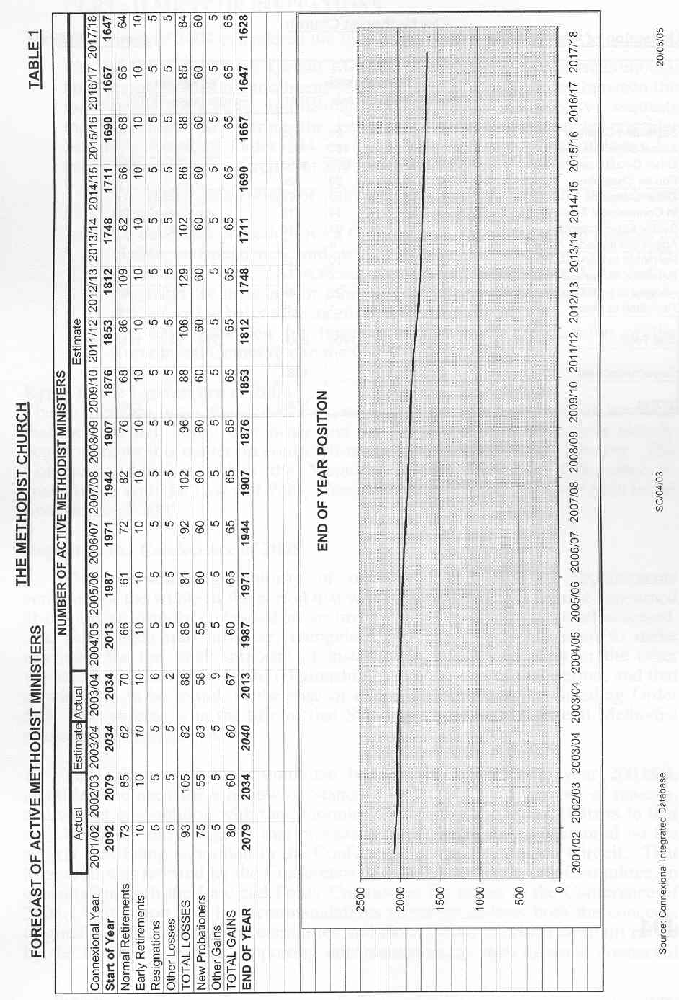
Appendix 2: Utilisation of Presbyters and Deacons
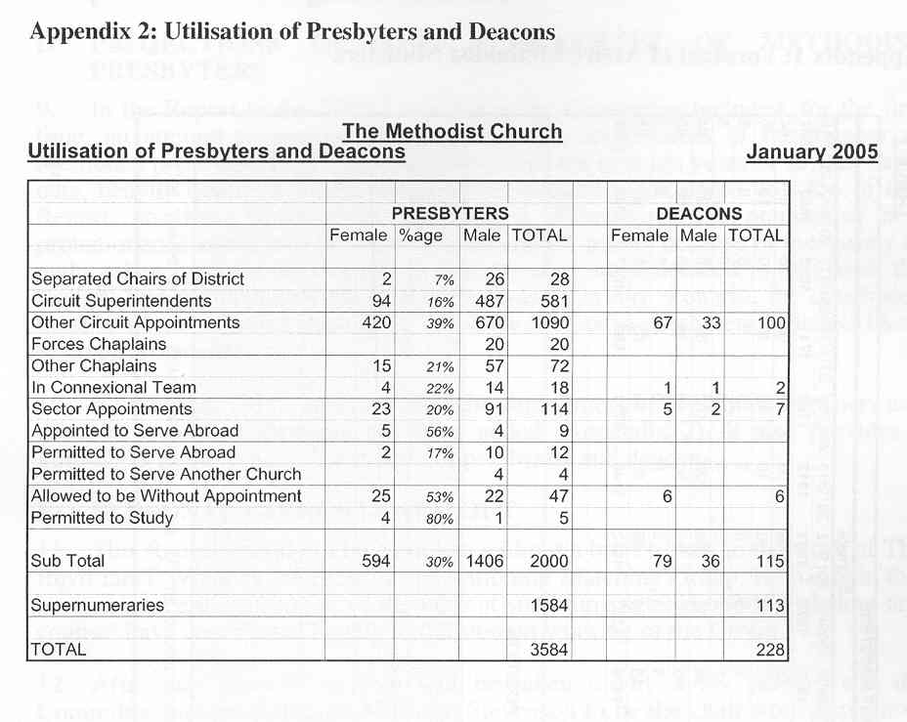

F. A REPORT FROM THE STATIONING COMMITTEE AND THE LAW AND POLITY COMMITTEE IN RESPONSE TO M52 (2004) ON CURTAILMENT OF INVITATIONS
The Conference of 2004 considered the following Memorial 52:
The Bridlington (29/10) Circuit Meeting (Present: 45. Vote: unanimous), having experienced a curtailment which was without agreement between the minister and the Circuit, and having found the procedure defective, requests the Conference to instruct the Law and Polity Committee to consider redrafting Standing Order 544 or to provide accompanying guidance for submission to the Conference of 2005, as follows:
i) To make provision for Circuit Stewards to consult the Circuit membership;
ii) To develop a procedure for a Curtailment Committee which ensures its visible independence and which allows for exchange of written information with a described format for such material, including provision for inclusion or otherwise of information from other people at a set period before the meeting of the Committee;
iii) To make provision for formal notification of the decision of the Curtailment Committee to the Circuit membership.

Reply to the Conference of 2004
The Conference notes the concern expressed in this Memorial and understands that the Law and Polity Committee and the Stationing Committee have already begun work on this matter, in consultation with the District Chairs’ Meeting. The Conference therefore refers the Memorial to the Stationing Committee in consultation with the Law and Polity Committee and directs it to report back to the Conference of 2005.

Report to the Conference of 2005
1. The overwhelming majority of ministerial and diaconal appointments continue for the whole of the period that was contemplated by everyone concerned at the outset, usually embodied in an invitation given or renewed and accepted. The Conference has, however, recognised for many years the need to make provision for the small minority of instances in which one party or the other wishes to be released from the relationship before the end of that period, and that provision is to be found, in the case of circuit appointments, in Standing Order 544. The process is in the title of that Standing Order and in general Methodist usage called “curtailment”.

2. The Law and Polity Committee had, in the connexional year 2003/04, identified the need for a review of Standing Order 544 for a number of reasons, and was in consultation with the Stationing Committee and district Chairs to that end, but at an early stage in that process became aware that a Memorial on the subject was being submitted to the Conference by the Bridlington Circuit. That Memorial was referred by the Conference of 2004 to the Stationing Committee, in consultation with the Law and Polity Committee, for report to the Conference of 2005. This report and its recommendations therefore address both the concerns originally in the mind of the committee and those (some of which overlap) raised by the Memorial and its supporting documentation, as well as some connected matters subsequently coming to the attention of the committee. They are treated below in that order.

3. This report and its recommendations are presented by the Stationing Committee and the Law and Polity Committee jointly, but have been drafted by members of the latter. In the interests of brevity it is often referred to in the singular as “the committee”.

General concerns
4. The most fundamental question is whether we need special provision for such cases. It is as well to make it clear that the committee has not simply assumed that the mere fact that there is at present a Standing Order means that it must remain. However, after consultation with the district Chairs, it has no doubt that continuing provision in Standing Orders for curtailment is necessary.

5. Although not immediately obvious, it emerged at a very early stage that there was an issue as to the scope of Standing Order 544; what situations should it cover? As at present expressed it appears to apply equally and universally to all situations in which “it appears desirable” to either side that the appointment should be curtailed. When the initiative comes from the circuit that seems straightforward, and causes no difficulty in practice, but in the converse situation there are several categories of case in which it does not seem practicable, and has indeed not been the practice, to operate the machinery of this Standing Order. The committee considers that the wording should recognise that fact and that provision should where appropriate be made elsewhere for comparable consultations. That is dealt with in the proposed new clause (3) and by an addition to Standing Order 323. The position of probationers is also clarified in clause (1)(c) and Standing Order 723.

6. Next there is a question about what happens when curtailment is agreed. Strictly speaking the first sentence of 544(1) or (1A) at present applies; that is clearly implicit in the opening words of the second sentence, but everything else in the Standing Order operates only in the case of failure to agree, so the situation in which there is agreement is left in the air. That is now dealt with by the new clause (2); in case of agreement at any stage the Standing Order will not apply or will cease to do so.

7. At present curtailment issues are referred to an ad hoc committee appointed by the district Chair. That has two distinct disadvantages. The first is that, given the infrequency of curtailment cases, the persons appointed are almost certain to have had no experience or training. The second is that the Chair will invariably have been involved in the developing situation which has led to the invocation of Standing Order 544, so that a committee of his or her appointees is in danger of not being seen by one or both of the parties as independent, a danger enhanced by the absence of any requirements ensuring the impartiality of the appointees or the fairness of their proceedings. It is proposed to address these deficiencies, without the remoteness and expense of a centralised system, by having regional groupings of Districts, which will provide panels of persons suitable for appointment to curtailment committees and enable appointments to be made by a neutral Chair (clauses (4) to (6)), and by making express provision in clause (8) for the impartiality of appointees and in clause (10) for the fairness of their procedure.
8. The committee considered whether there should be provision for an appeal. In practice the possibility already exists, in the sense that after the committee has reported the matter still has to go through the Stationing Committee to the Conference, and representations can be made at those stages. To add another layer would, the committee considered, be excessive, and would moreover make it more difficult to meet the often pressing need to arrive at a measure of finality without undue delay. The right to make representations to the Stationing Committee is, however, made explicit in clause (9).

The Memorial
9. The Bridlington Circuit was concerned about lack of consultation with "the churches of which the minister [is] in pastoral charge" or with "the circuit membership". Although treated as if the same these are two rather different concepts. The committee considers that there is everything to be said for involving the church stewards of the relevant churches, if they are not already on the circuit Invitation Committee (which acts for the Circuit in curtailment cases), but that to bring in the entire membership, whether of those churches or the entire circuit, would effectively make the debate public, which would often be distressing and unwelcome to those personally involved. Clause (1)(i) of the proposed new Standing Order therefore requires the Invitation Committee to consult the church stewards of the churches in which the person concerned exercises pastoral responsibility.

10. The Memorial’s next concern was of failure to ensure the "visible independence" of the curtailment committee. As appears above, this was a concern already felt by the committee, and it has been dealt with in paragraph 7 above.

11. The Circuit also desired a requirement for the "exchange of written information" in a "described format". The committee agrees that in a fair procedure each side should have the right to know what the other is saying to the committee and have an opportunity of commenting upon it, and that also is dealt with in paragraph 7 above. It does not see the need to prescribe a format, and indeed it is important that this principle be applied whatever the form of the communication, whether written or oral and whether spontaneous or in response to enquiries by the committee.

12. The Circuit felt a “lack of clarity”, because the "decision" of the committee was "subject to confirmation by Conference". It is true that the use of the word “judgment” in the present text could mislead, and the proposed clause (9) is intended to make the position clear.

13. The Memorial finally calls for provision for "formal notification of the decision ... to the circuit membership". The proposed clause (11) makes it the responsibility of the Invitation Committee to ensure that the nature and effect of the curtailment committee’s recommendation are adequately known and understood by the members of the Circuit.

Other matters
14. The present Standing Order deals separately, and at length, with ministers and deacons. There are some slight differences, but the committee has found it possible to deal with them in clauses (1)(b), (5), (6) and (11) without wholesale repetition.

15. Standing Order 544 covers only circuit appointments. There is parallel provision for appointments to the connexional Team in Standing Order 316. The committee was not asked, and sees no need, to overhaul that Standing Order generally, but considers that the requirements of impartiality and fair procedure should apply equally in that situation and proposes an amendment to that effect.

16. Standing Order 544 is applied by Standing Orders 343(4) and 344(7) to chaplaincies in residential schools and in Southlands and Westminster colleges respectively, with adaptations which include quite differently constituted curtailment committees. It has been reported to the committee that these provisions have given rise in practice to difficulties which would be met by bringing these situations more closely into accord with circuit appointments, and in particular by ending any distinction in the composition of the curtailment committees. Amendments to that effect to Standing Orders 343(4) and 344(7) are therefore proposed.

17. Some consequential amendments to the Guidance on the Stationing of Ministers and Deacons in CPD are required and included.

Amendments to Standing Orders and Guidance
A Standing Order 544
(1) Text of existing Standing Order
544 Curtailment. (1) If for any reason it appears desirable to a minister or the circuit Invitation Committee that the current period of invitation (whether the initial period or an extension) be curtailed or when a team convened from a district Complaints Panel under Standing Order 022B considers that the question whether that period should be curtailed should be examined the Chair of the District shall be informed. If the minister and the circuit committee are unable to agree or when the Chair is so informed by such a team, the Chair shall submit the case to a district committee which he or she shall appoint consisting of six persons, including at least two ministers and at least two lay persons of whom one shall be the district Lay Stationing Representative. In the case of a minister of another conference or of an overseas church whose appointment has been negotiated with that conference or church, the committee shall also include a member of the connexional Team responsible for such appointments. The Chair of the District shall report the judgment of the committee to the minister concerned, the Circuit Meeting and the Stationing Committee.
(1A) If for any reason it appears desirable to a deacon or the circuit Invitation Committee that the current period of appointment (whether initial or extended) be curtailed or when a team convened from a district Complaints Panel under Standing Order 022B considers that the question whether that period should be curtailed should be examined the Chair of the District and the Warden of the Methodist Diaconal Order shall be informed. If the deacon and the circuit committee are unable to agree or when the Chair is informed by such a team, the Chair shall submit the case to a district committee which he or she shall appoint consisting of two ministers, two deacons and two lay persons of whom one shall be the district Lay Stationing Representative. The deacons appointed need not necessarily be persons eligible to be members of district committees in that District under Standing Order 402(6). In the case of a deacon of another conference or of an overseas church whose appointment has been negotiated with that conference or church, the committee shall also include a member of the connexional Team responsible for such appointments. The Chair of the District shall report the judgment of the committee to the deacon concerned, the Circuit Meeting, the Warden and the Stationing Committee.
(2) A committee convened under this Standing Order may in addition refer the case to a district Consultative Committee under Standing Order 040.

(2) Proposed new text of Standing Order
544 Curtailment (1)(a) Subject to sub-clauses (b) and (c) of this clause and to clause (2) below this Standing Order applies when:
(i) the circuit Invitation Committee, after consulting the church stewards of the Local Churches in which the person concerned exercises pastoral responsibility, wishes the current period of invitation or deemed invitation to the Circuit (whether the initial period or an extension) of a minister, deacon or probationer to be curtailed; or
(ii) subject to clause (3) below, a minister, deacon or probationer wishes his or her current period of invitation or deemed invitation to the Circuit (whether the initial period or an extension) to be curtailed; or
(iii) a team convened from a district Complaints Panel under Standing Order 022B considers that the question whether such a period shall be curtailed should be examined.
(b) References in this Standing Order to periods of invitation or deemed invitation apply also, in the case of deacons and diaconal probationers, to their initial period or deemed period of appointment.
(c) References in this Standing Order to probationers apply only to curtailments which would take effect after the end of their period of probation.
(2) If the circuit Invitation Committee and the minister, deacon or probationer concerned agree, whether before or after the procedure prescribed by clauses (6) to (11) below has begun, that such a period shall be curtailed by one or more years then their agreement shall have effect and this Standing Order shall not apply, or shall cease to apply, as the case may be.
(3) This Standing Order does not apply by virtue of clause (1)(ii) above if the possibility of curtailment arises because the person concerned is being considered for an appointment in the connexional Team, or for some other appointment by the Conference for which the Methodist Council is required to submit a nomination, or as a district Chair, or has been requested by the Stationing Committee or any sub-committee or group acting on its behalf to accept a change of station, or has applied to the Stationing Advisory Committee under Standing Order 323(2)(iv), or is being encouraged by that committee to apply under Standing Order 323(2)(i).
(4) In each group of Districts designated by the General Secretary for this purpose there shall be established and maintained a panel of ministers, deacons and lay members fit to serve on committees acting under clauses (6) to (11) below. Appointments to such panels shall be made by the Synods of the constituent Districts.
(5) When this Standing Order applies the person or persons raising the matter under clause (1) above shall so inform the Chair of the District and, if a deacon or diaconal probationer is involved, the Warden of the Methodist Diaconal Order. The Chair, or the Chair and the Warden jointly, as the case may be, shall then request the Chair of another District in the same group to appoint a committee to consider the case unless, in a case arising under clause (1)(i) or (ii) above, they are able without undue delay to achieve agreement between the parties.
(6) The Chair so requested shall appoint a committee consisting, subject to clause (7) below, of a chair and six other persons. The chair shall be the appointor or another Chair or lay stationing representative of one of the Districts in the group, not being the Chair of the District containing the relevant Circuit. The other appointees shall be chosen from the members of the relevant panel constituted under clause (4) above and shall consist of three lay members and (if the case concerns a minister or ministerial probationer) two ministers and one deacon or, (if it concerns a deacon or diaconal probationer) two deacons and one minister.
(7) In the case of a minister, deacon or probationer of another conference or of an overseas church whose appointment has been negotiated with that conference or church, the committee shall also include a member of the connexional Team, being if possible the person responsible for such appointments.
(8)(a) Notwithstanding anything contained elsewhere in this Standing Order no person shall act as the appointing Chair under clause (6) above or as a member of the committee constituted in accordance with clauses (6) and (7) above who:
(i) is a member, or stationed, in the Circuit in question; or
(ii) in a case arising under clause (1)(iii) above is or has at any material time been the convenor of the relevant district Complaints Panel or a member of the relevant team; or
(iii) has any personal interest in the outcome; or
(iv) has received in confidence information relevant to the issues; or
(v) by reason of close friendship or relationship with a person involved in any of the above ways, or for any other reason, might or might reasonably be supposed to be open to partiality or embarrassment in carrying out his or her responsibilities under this Standing Order.
(b) The appointing Chair shall promptly inform the persons concerned of the names of the persons appointed to the committee, so that they may inform him or her of any objection under sub-clause (a) above.
(9) The committee shall investigate the question whether the relevant invitation should be curtailed and make a recommendation to the Stationing Committee. The circuit Invitation Committee or the minister, deacon or probationer involved, if dissatisfied with the recommendation, may make representations to the Stationing Committee, but there shall be no other appeal against the committee’s conclusions. The committee may in addition refer the case to a district Consultative Committee under Standing Order 040.
(10)(a) In its investigation the committee shall give the circuit Invitation Committee and the minister, deacon or probationer involved the opportunity of making representations and of knowing the substance of, and dealing with, any representations or other material before the committee adverse to their case. The committee shall not, in the course of its deliberations, take into account any point which the party affected has not had an opportunity of meeting.
(b) Subject to sub-clause (a) above the committee shall determine its own procedure.
(11) The chair of the committee shall forthwith inform the Chair of the District containing the relevant Circuit and, if the person concerned is a deacon or a diaconal probationer, the Warden of the Methodist Diaconal Order, of its recommendation. The Chair or Warden, as appropriate, shall inform the minister, deacon or probationer involved, and the Chair shall inform the circuit Invitation Committee, which shall be responsible for ensuring that the nature and effect of the recommendation are adequately known and understood by the members of the Circuit.

B Other amendments to Standing Orders
Part 3 The Connexional Team. Standing Order 316 Curtailment of Appointment.
Insert a new clause (1A), as follows:
(1A) Clause (8) of Standing Order 544 shall apply to the constitution of the curtailment committee appointed under clause (1) above, and clause (10) of that Standing Order to its procedure, in each case with any necessary adaptations.

323 Stationing Advisory Committee. Add a new clause (3), as follows:
(3) If any application or potential application under clause (2)(i) or (iv) above involves the possibility of the curtailment of a current period of invitation or appointment or deemed invitation or appointment of a person in a circuit appointment the committee shall consult the circuit Invitation Committee and take its views into account.

343 Residential Schools. In clause (4) amend sub-clause (ii) as follows;
(4) In recommending to the Conference the appointment of ministers as chaplains to such schools the Stationing Committee shall take into consideration any invitations duly given and accepted. For that purpose Standing Orders 543 to 545 shall apply with the substitution of references to the school for those to the Circuit and with the following further adaptations:
(i) The functions of the Circuit Meeting and its invitation committee shall be exercised by the head teacher or by the Governing Body or Board of Management, as may be appropriate, having regard in particular to responsibility for making appointments to the teaching staff. Any doubt as to the appropriate person or body shall be resolved by the Co-ordinating Secretary responsible for secondary education affairs. Whoever of the above exercises such functions shall at each stage inform and consult the other and the Co-ordinating Secretary.
(ii) The committee to be appointed by the Chairman of the District under Standing Order 544 shall consist of the Co-ordinating Secretary referred to under sub-clause (i) above, the secretary of the Board of Management and two members of that board or two governors, as may be appropriate. in clause (1)(a)(i) of Standing Order 544 delete “after consulting the church stewards of the Local Churches in which the person concerned exercises pastoral responsibility”.
(iii) For clause (1) of Standing Order 545 substitute “(1) No minister shall be appointed chaplain to the same school for more than five successive years except upon an invitation given in accordance with clause (2) or (3) of this Standing Order.”.

344 Institutions in the Higher Education Sector. In clause (7) amend sub-clauses (i) and (ii) as follows;
(7) Standing Order 544 shall apply to appointments made under clause (2) above, with the following adaptations:
(i) for references to the circuit Invitation Committee and Circuit Meeting substitute
as to Southlands College: the Principal of the College;
as to the Westminster Institute of Education: the Head of the Institute;
(ii) the committee to be appointed by the Chairman of the District shall consist of the Co-ordinating Secretary responsible for higher education affairs and
as to Southlands College: three Governors of the College;
as to the Westminster Institute of Education: a Director of Westminster College Oxford Trust Ltd and two others. in clause (1)(a)(i) of Standing Order 544 delete “after consulting the church stewards of the Local Churches in which the person concerned exercises pastoral responsibility”.

723 Probationers’ Appointments. Insert a new sub-clause (2)(d), as follows:
(d) If Standing Order 544, as to curtailment, would apply in the case of a probationer but for the limitation in sub-clause (1)(c) of that Standing Order, the question of possible curtailment shall be dealt with by the relevant Candidates and Probationers Oversight Committee, which shall make a recommendation to the Stationing Committee.

C Guidance
Amend paragraph I of the Guidance on the Stationing of Ministers and Deacons in Section 1 of Part 2 of Book VI of the Constitutional Practice and Discipline of the Methodist Church as follows:
I CURTAILMENT
If circumstances arise whereby either a minister, deacon or probationer or the Circuit should seek to be released from an invitation, the parties should first consult the Chairman of the District and, in the case of a deacon or diaconal probationer, Chairman should consult the Warden of the Order. , and then follow the normal procedure (see S.O. 544(1A)). In the case of a minister the normal procedure (see S.O. 544(1)) should be followed. Unless without undue delay agreement between the parties can then be achieved the provisions of Standing Order 544 or 723(2)(d) will apply.

D Consequential amendments
1. In Standing Order 040(3) and (4) for “544(2)” substitute “544(9)”.
2. In Standing Order 040(4), in “district curtailment committee”, delete “district”.
3. In Standing Order 402(6), for “,451 and 544(1A)” substitute “and 451”.
***RESOLUTIONS
54/2. The Conference adopts the Report.

54/3. The Conference resolves that the section of the above Report entitled The Memorial be its reply to Memorial 52 of 2004.

54/4. The Conference amends Standing Orders and the Guidance on the Stationing of Ministers and Deacons in Section 1 of Part 2 of Book VI of the Constitutional Practice and Discipline of the Methodist Church as set out in “Amendments to Standing Orders and Guidance”, A to D, above.

