49. Methodist Church Statistics
This report presents some general analysis of the Triennial Membership returns and Statistics for Mission. Summary tables indicating the changes between 2002 and 2004 in membership and church attendance figures accompany it. Further details of attendance, membership, community roll figures, church-sponsored youth groups and other data can be obtained from the Methodist Church website www.methodist.org.uk (Site Ref: IN120505 [n.b. this is case sensitive]) and Methodist Church House.

Introduction
1. The Triennial statistics for Church Membership, Attendance at Worship and Local Influence are now available. Thanks are due to everyone who helped ensure that this point was reached significantly earlier than in previous years, particularly District Membership Secretaries who do a tremendous amount of work, striving to collect the returns within reasonable sight of the deadlines. This year an overall return rate of 96% has been achieved and 100% in most Districts.

Statistics of Membership and Statistics for Mission
- In the attached Summary and Comparison of some Key Figures for Membership and the summary of Membership in the Districts there is an artificially high reduction in the total Methodist membership for 2004. This is because following the introduction with ecumenical partners of a Joint Return we now have a better range of data for most Local Ecumenical Partnerships (LEPs), and these more detailed returns confirm that in previous years the Methodist Church has in many cases been counting all the members of an LEP as Methodist. For example, one LEP that has been counted within Methodist membership figures in the past as having over 300 members has in fact only two Methodist members, and the other 298 “joint” members should have been shared among four denominations. Each LEP has some “traditional” members who belonged to a particular denomination before it became a LEP or who have transferred to it from another church of that denomination, and some “joint” members who have been made members or confirmed since the LEP began and who in a sense belong to all of the participating denominations. But it cannot be right for each denomination to claim all the joint members as part of its own denomination. The Joint Return has therefore been used to calculate a more realistic figure for the Methodist membership. This only includes a proportion of joint members and excludes members of other denominations. In some Districts this adjustment has created an artificial increase in the numbers of members, but the overall effect has been to create an apparent reduction in the total membership of the Methodist Church, which is artificially high.

- The introduction of the Joint Return, therefore, has meant that in some cases it has been necessary to make adjustments to the figures inherited from previous years. Further adjustments have also been required to the base-line figures in the connexional database because, in addition to the situation affecting LEPs mentioned above, there have been a few churches who have reported that their membership at the start of the year was not as had
previously been indicated. It has also become apparent that, where a church closes, its members are often not shown as “Transfers Out” of that church and do not seem to be “Transfers In” at another church. All of these factors have been taken into account in the “Other adjustments” line on the Summary.

- The detailed figures for each church in a Circuit have been sent for information and for checking to the superintendent of that Circuit, along with the figures for Attendance at Worship and those for Local Influence. An example of just one facet of the latter is shown in the attached summary Church-Sponsored Youth Groups report.

5. The Methodist Council agreed that all the data (which amounts to many pages) should be made available on the Methodist Church website and in hard copy to anyone who requests it, but that only the summaries be printed in the Conference Agenda together with the fruits of the detailed analysis mentioned below.

6. The Research and Statistics Department of the Archbishops’ Council of the Church of England was commissioned to provide detailed analysis of some of the trends in the figures, including some of the growth points within them. We are grateful for the expertise and help that the members of that Department have provided, and the following paragraphs of this report are essentially their work.

Summary Analysis
7. The year 2004 was the third year of the collection of new Statistics for Mission direct from local churches. The process has improved and individual reports have again been provided to local Circuits. This report provides a comparison of the figures collected over the three-year period.

- There are encouraging signs of growth in attendance levels at church services. Although the national totals do not yet directly reflect this trend, approaching half (fifteen) of the Districts in the Connexion saw an increase from 2002 to 2004 in the levels of church attendance each week among adults. Over the two years, eleven Districts saw an increase in the number of young people (aged 13 to 19 years) attending church services over a typical month and seven saw an increase in the number of children (under 13 years of age) attending.

- Adult attendance is growing in churches situated in “suburban neighbourhood” and “village rural” areas. In these areas there has been 5% growth in monthly church attendance levels, but weekly church attendance levels have grown only in suburban neighbourhood areas. This may reflect the less frequent provision of church services in many rural Circuits. In contrast, the most significant losses among children and young people attending church worship are in “inner city”, “city centre” and “council estate” locations.

- These attendance growths are supported by significant rises in the making of new members. Over the three-year period to 2004 several Districts saw increases in making new church members, although transfers of churches from one District to another and some of the adjustments made in the light of the Joint Returns may have had a slight effect on some of the individual figures. Nevertheless, between 2002 and 2004 the national total showed a slight increase. 13,000 new members were added to the Connexion, and the annual figures show signs of growth.

- The number of churches decreased in most Districts, with the exception of the Bolton and Rochdale District where the number of churches increased by four because of a transfer of churches between Districts. In ten Districts, ten or more churches were closed and across the Connexion the number of churches dropped by 4% over 2002 to 2004. Generally, however, there is evidence that opening new churches or starting new opportunities for worship during a week promotes church growth. Several Districts which show an increase in attendance at worship show a greater increase in attendance measured across the whole week than in that on Sunday alone.

- In Local Ecumenical Partnerships involving Methodist participation, 46% of members are Methodist and 36% have joint membership with the other participating denominations.

Particular Results
- Church attendance
- The average number of adults attending church services each week during October 2004 was 243,000, 9% more than on Sundays. This figure has changed negligibly since 2002. Adult attendance levels at church services have remained static since 2002. For every ten attending on a normal Sunday, another attends midweek and two more over a whole month.
- Approaching half of the Districts across the Connexion, fifteen in fact, saw an increase in the number of adults attending church services each week, the highest increase in England being 9% in the District of East Anglia. Fourteen of these Districts also saw their adult attendance levels on Sundays increase and ten saw their adult attendance levels over the whole month increase.
- Overall, the average number of people attending church services over the whole week (Sunday to Saturday) decreased from 2002 to 2004 by 4%. On average 317,000 adults, children and young people attended church worship each week during 2004 compared to 331,000 in 2002. The number attending on Sundays only also decreased but for every ten people attending church on an average Sunday another two attend midweek. Even allowing for a measure of people attending more than one act of worship, offering church services between Monday and Saturday adds another 21% on average to church attendance levels.
- More than 367,000 adults, children and young people attend church over a complete month which in turn adds another 17% on average to church attendance levels. For every ten people attending church services on an average Sunday four more attend over the whole month, two on Sundays and two midweek. Over 2002 to 2004, churches have found that the number of less-frequent church attenders has declined by 4% in line with the decrease in regular church attenders.
- Over the four weeks of October 2004 weekly attendance levels at church services fluctuated from their highest level to their lowest by 38%. In 2002 and 2003 similar figures fluctuated by 42% and 35%. Churches clearly provide different services week by week that attract different levels of church attendance. The most obvious example here is perhaps the monthly family services that often have a higher all-age attendance than other services held during the month.

- Children and young people at church
- The number of children and young people attending church services between 2002 and 2004 fell by 12% among those under 13 years of age and by 9% among those aged between 13 and 19 years. Over October 2004 more than 75,000 children and 22,000 young people were in contact with local churches through their church services. Figures reported show that many churches cannot provide regularly for children and young people each week in their church services. Attendance levels among children and young people increased by 42% and 44% respectively when average Sunday figures were compared with attendance figures over the whole month.
- There are encouraging signs of growth in some Districts among children and young people attending church services. Seven Districts saw child attendance levels increase between 2002 and 2004 for the month of October while eleven Districts saw the number of young people increase over the same period.

- Geographic variations
- Information is collected for churches according to their geographical location utilising the following categories:
city centre suburban neighbourhood
council estate small town
inner city village rural
- In suburban neighbourhood churches weekly adult attendance over 2002 to 2004 grew by 3% whilst in both suburban neighbourhood and village rural churches monthly adult attendance grew by 5%.
- In city centre and inner city churches, church attendance among children declined very significantly by approximately 1 in 4 (25%). In council estate churches attendance among young people decreased by 1 in 10 (10%) while, in contrast, increases were seen in city centre churches of 1 in 8 (12%) particularly on Sundays.

- Church activities
- It must be remembered that the figures above relate only to attendance at church-based worship and do not include social groups, home groups, mother and toddler groups, youth groups etc. These all add to the life of the church but only those who identify with the worshipping life of the church have been counted in the attendance figures above.
- In 2004, 134,000 children under 13 years of age were in contact with church-sponsored youth groups. Girls dominated by 3:2 but these groups bring the churches into contact with more than 60,000 children in addition to the 75,000 involved regularly in church services. Toddler groups with children under 5 years of age account for 7% of these contacts that bring the churches into contact with parents to a greater extent than other child age groups.
- In 2004, approximately 35,000 young people aged 13 to 19 years and 4,000 young adults aged 20 to 25 years were involved in church-sponsored youth groups. These groups add at least 13,000 young people to the 22,000 involved regularly in church services.
- The number of adults, children and young people on local church community rolls in 2004 was 807,000 compared to 883,000 in 2002, a decrease of 8% over two years. This is 2 ¾ times larger than church membership levels and 2 ¼ times larger than all- age church attendance levels in 2004.

- Membership
- Since 2001 church membership has declined in round figures by 9.7% from 325,000 to 294,000. However, more new members are being added to the Connexion each year (other than by transfer from other Churches), and several Districts are showing significant increases in the rate of doing this. Thirteen Districts have increased the number of new members that they have made in each of the last two years. A further eighteen have increased the number of new members in one of those two years. 13,000 new members were added across all Districts in 2002 to 2004 and the annual figures are showing signs of growth. However, these increases do not sufficiently counter the increased losses seen particularly in 2003.
- The number of deaths among members continues at a steady but high level of 8,500 a year while transfers in and out of membership offset each other (at 20,000 each year over the three years). In total the membership gains over 2002 to 2004 of 36,262 were more than countered by losses of 67,731.
- In 2004 a breakdown was obtained in Local Ecumenical Partnership membership. In LEPs involving Methodist participation, 16,500 members (46%) were Methodist, 6,650 members (18%) were of other denominations and 13,200 (36%) were joint members.

- Baptisms
- The number of baptisms each year has decreased by 7% between 2002 and 2004 from 15,400 to 14,300. The pattern across different age groups remained constant. 70% (7 in 10) baptisms were of infants under 1 year of age, 25% (1 in 4) were of children between 1 and 12 years of age leaving just 5% among young people and adults aged 13 years of age and over.
- The decrease in baptisms was primarily among infants and children 12 years of age and under. Among young people and adults 13 years of age and over, baptisms increased since the previous triennium by 22% (approaching 1 in 4) across the Connexion from an average of 615 a year to an average of 740 a year.
- Experiences regarding baptism rates continue to vary significantly across the Connexion. In 2004, the Sheffield District conducted over 900 baptisms while Lincoln and Grimsby conducted approximately 240. The total number of thanksgivings for the birth of a child taken across the Connexion grew in 2004 to 630.

- Marriages
- Overall, 7,000 marriages and blessings of marriage are conducted in churches across the Connexion each year. This represented 13% (1 in 8) of the total number of services connected with rites of passage (i.e. baptisms, marriages and funerals).
- Blessings of marriage accounted for only 1 in 10 of all ceremonies of marriage and blessings of marriage. By far the majority, 9 in 10, of ceremonies involving marriages or blessing of marriage fall into the former category, this pattern being evident across all the Districts.

- Funerals
- 33,400 funerals are taken on behalf of churches across the Connexion each year. This is approximately 54 funerals in each Circuit each year, one each week, which confirms also the significant impact of deaths on membership levels (see Results section 5 above).
- The graph below indicates that by far the majority of church-based occasional offices and rites of passage (approximately 6 in 10) are funerals taken in church or at local crematoria (each in comparable numbers).

For every marriage/blessing of marriage, local churches have pastoral contact with two baptisms/thanksgivings and four funerals.

***RESOLUTION
49/1. The Conference receives the Report
c&p
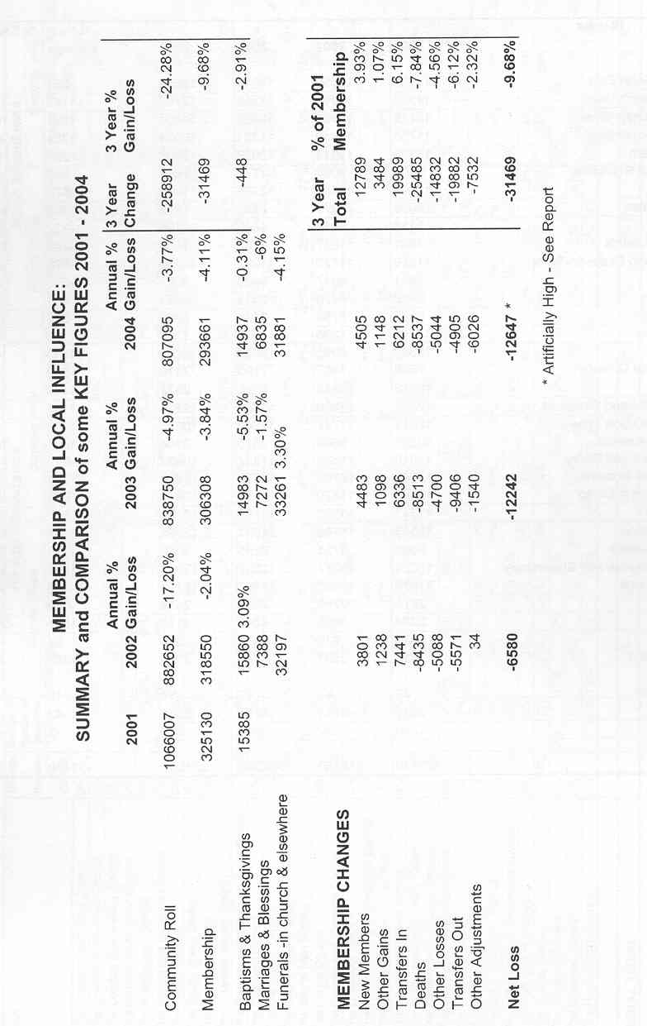
c&p
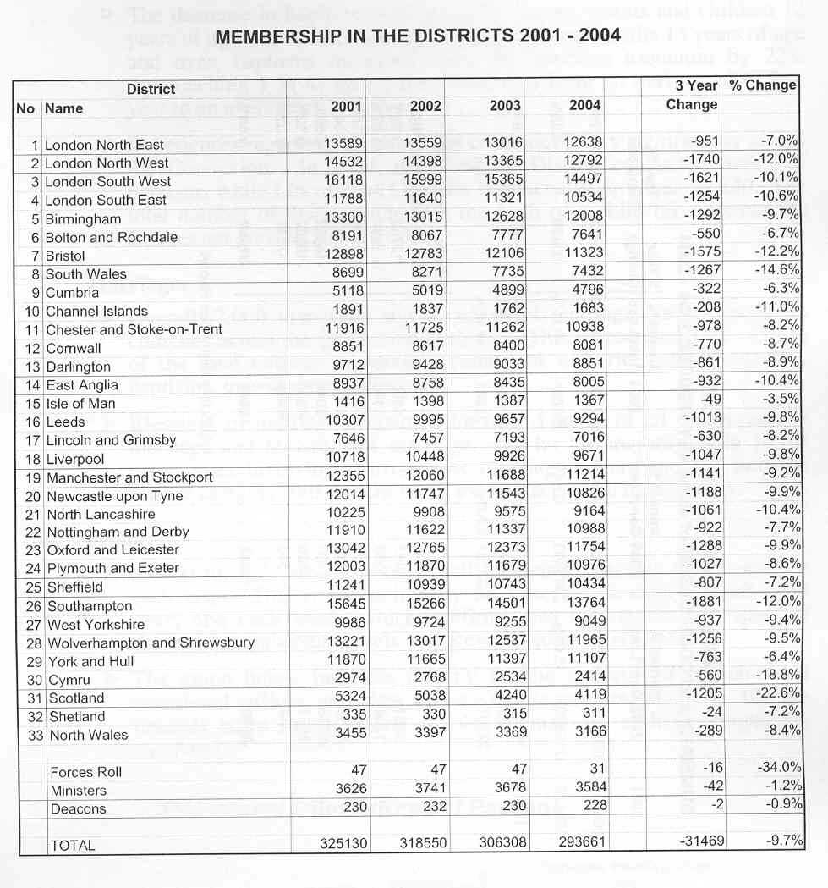
c&p
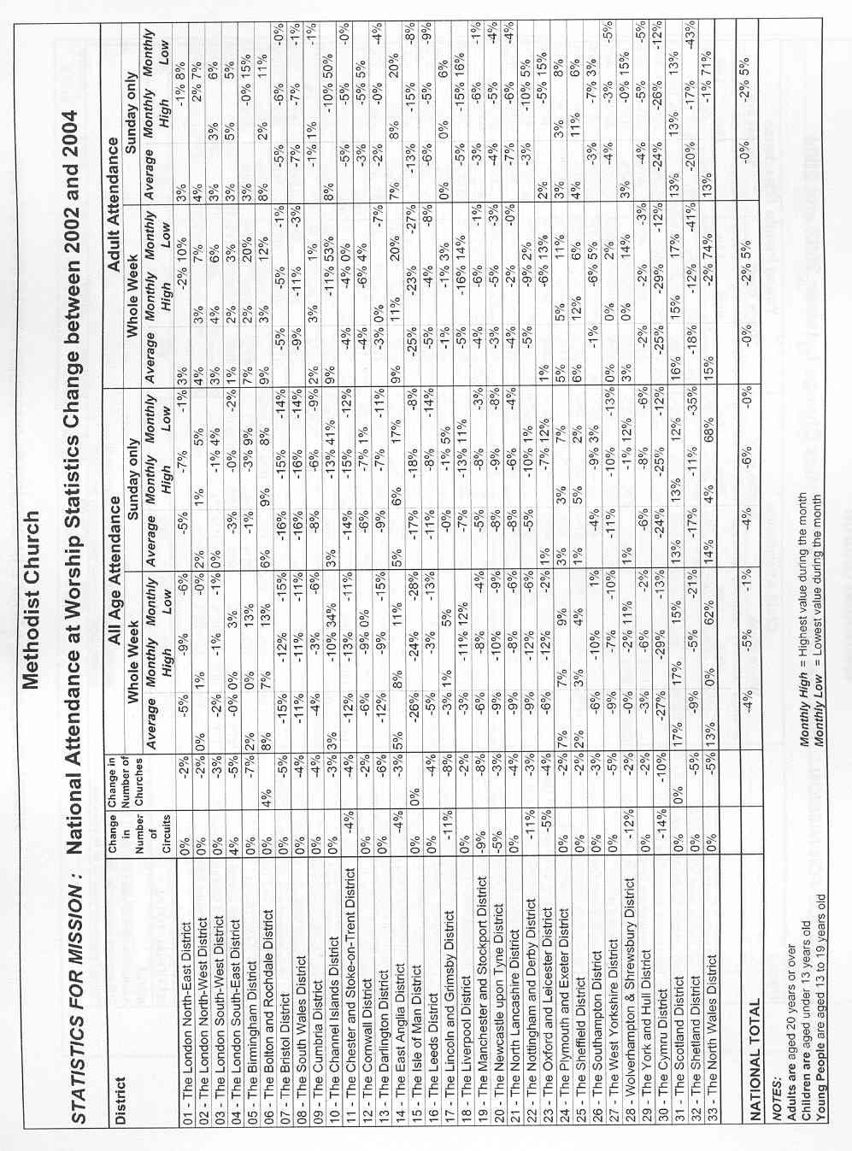
c&p
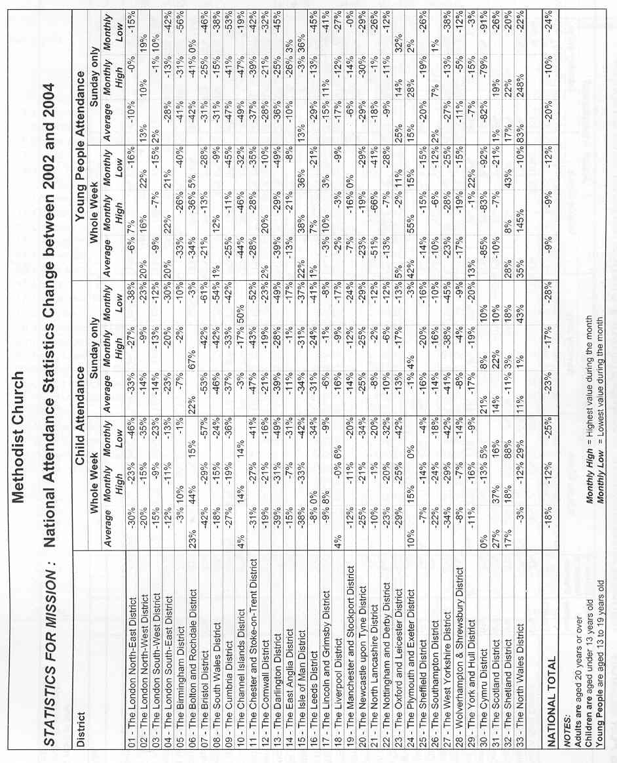
c&p
