39. Trustees for Methodist Church Purposes
1. General Report
2. Report and Financial Statements for the Year ended 31st August 2004

1. GENERAL REPORT
The Report of the Board for the year ending the 31st August 2004 is contained within Section 2 as part of the Accounts of the Board’s Administration Fund. This Report deals with activities from September 2004.
During the current connexional year the Board has met three times: on the 14th October 2004, the 10th February 2005 and the 18th May 2005 and its Executive has met three times: on the 30th November 2004, the 5th April 2005 and the 26th July 2005. The Audit Committee continues to function separately and its Chair reports direct to the Board.
Since September 2004 the Board has:
i) Explored its relationship with the Methodist Council through a meeting with the General Secretary and others.
ii) Indicated a willingness to share in a review of Part 9 of CPD.
iii) Considered a new scheme of emailing Annual Statements which is to be tried out next year on a group of Superintendent Ministers, who have agreed to become ‘guinea pigs’ to see if it is something which they would welcome. There are a number of advantages:
- Speed of receipt
- Ability to copy to the Treasurer, which would save many calls for duplicates and complaints that the statements have not been forwarded to them.
- A saving in time, mailing and stationery costs in the office.
Responses are invited as to whether it is a good idea or not.
N.B. TMCP can also now email statements on request.
More information about the work of TMCP can be found in the Annual Report leaflet, which is available on request from the office.

***RESOLUTION
39/1. The Conference adopts the General Report.

2. REPORT AND FINANCIAL STATEMENTS FOR THE YEAR ENDED
31ST AUGUST 2004
Members of the Board as at 31stAugust 2004
The Revd James Booth | Mr Duncan Booth
The Revd David G Deeks | Mr K Peter Bounds
The Revd Doreen Hare | Mr David Bradshaw
The Revd Christine A Hawke | Mr J Robert Gillingwater
The Revd Ian D Johnson | Mrs Susan Howdle
The Revd G Michael Sparrow | Mr Malcolm Pearson
The Revd Kenneth E Street (Secretary) | Mr G Alan Pimlott
The Revd David F Willie (Chairman) | Mrs Eunice Shepherd

TMCP Staff Members as at 31st August 2004
Mr Brian Couch | Mrs Margaret Pryde
Mrs Amanda Flynn | Miss Linda Richards
Mrs Caroline Hickling (General Manager) | Mrs Kathrin Rosenfeld
Mr Neville Johnson | Mr Simon Speechley
Mrs Kathleen Mason | Mrs Janet Street
Mr David Phillips

Office and Advisers
Office: Central Buildings
Oldham Street, Manchester M1 1JQ
Auditors: Beever & Struthers
St Georges House, 215-219 Chester Road,
Manchester M15 4JE
Bankers: HSBC
22 Victoria Street, Westminster, London SW1H 0NJ
Fund Managers: Central Finance Board of the Methodist Church
4th Floor, Friendly House, 52-58 Tabernacle Street
London EC2A 4PL
Solicitors: Pothecary & Barratt
Talbot House, Talbot Court, Gracechurch Street
London EC3V 0BS
Stockbrokers: Gerrard
1 St James’s Square, Manchester M2 6DN

Financial Statements For the Year Ended 31st August 2004

Contents Page
Report of the Board 1 - 3
Independent Auditors’ Report to the Board 4 - 5
Statement of Financial Activities 6
Balance Sheet 7
Notes to the Accounts 8 – 14
accounts
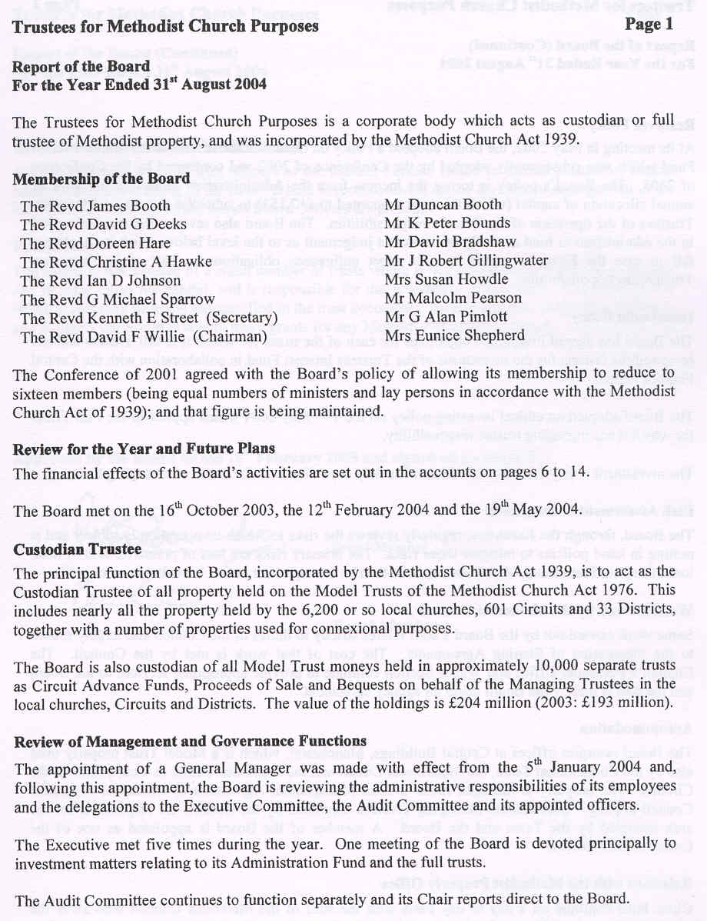
accounts
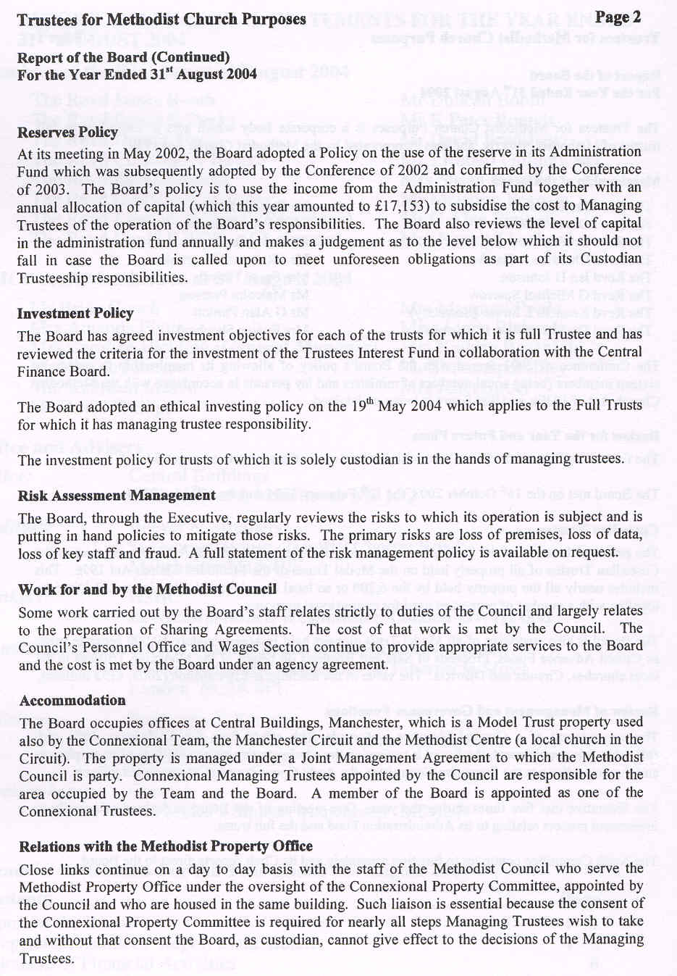
accounts
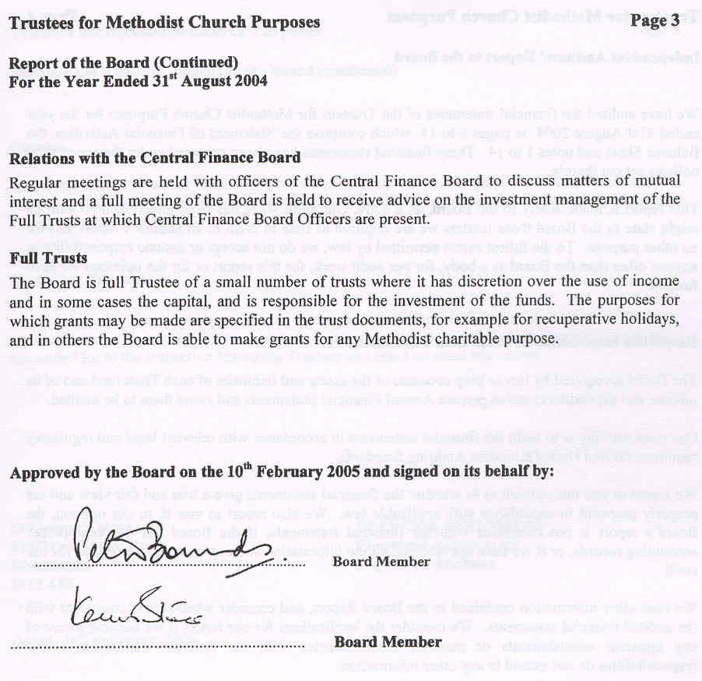
accounts
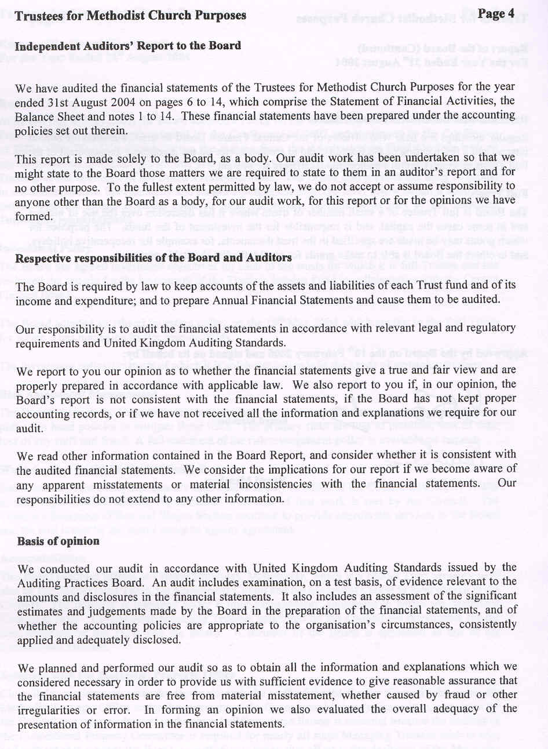
accounts
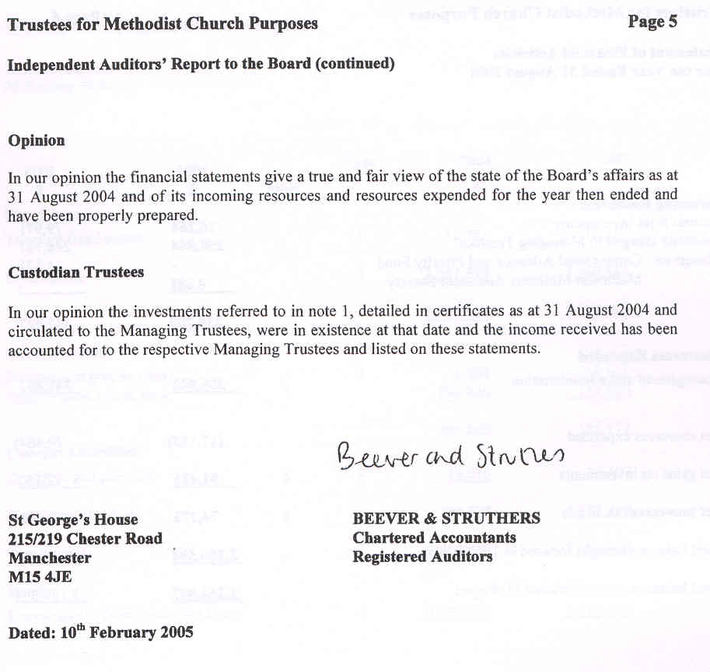
accounts
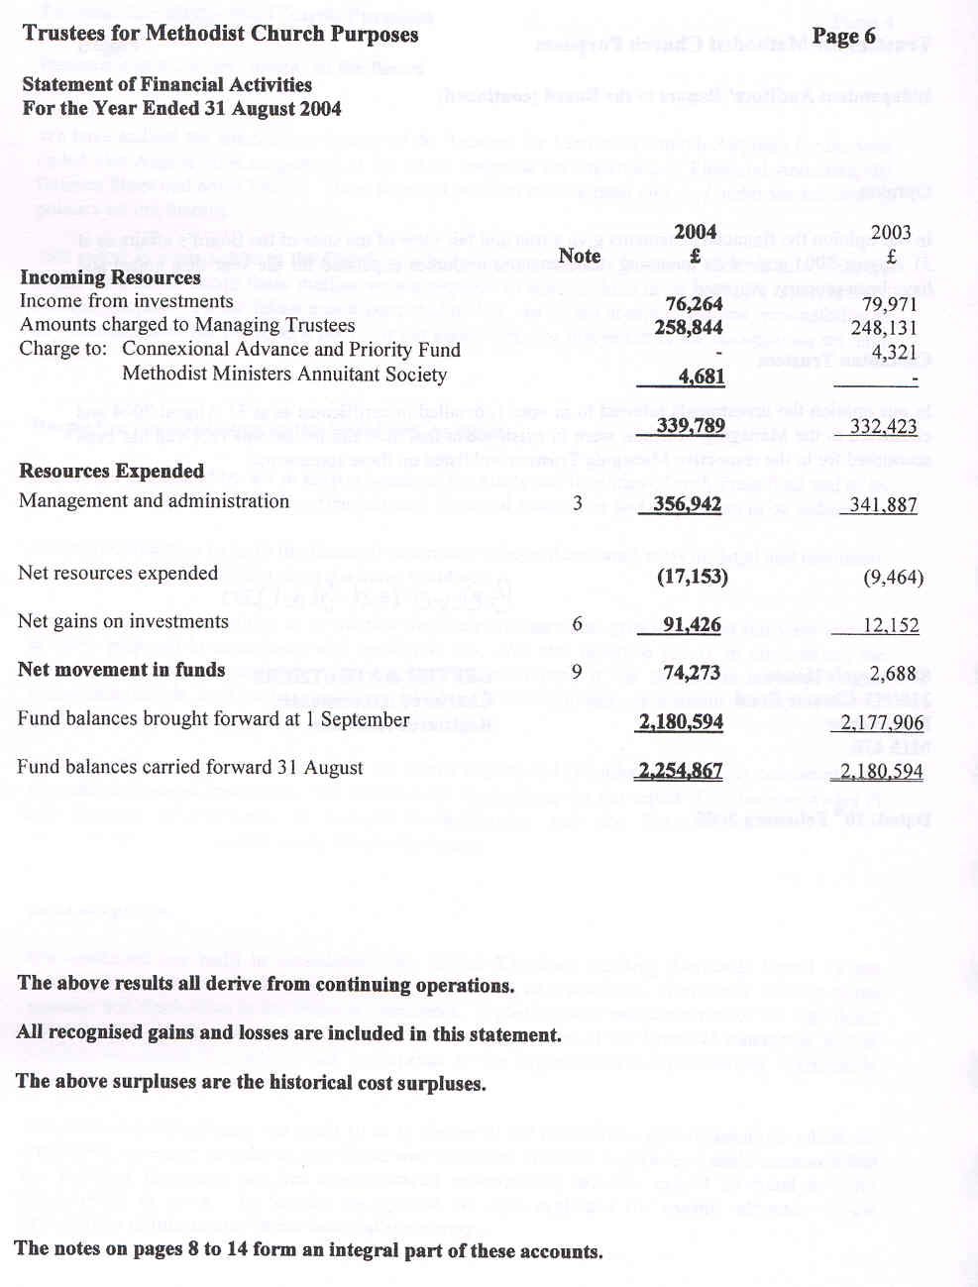
accounts
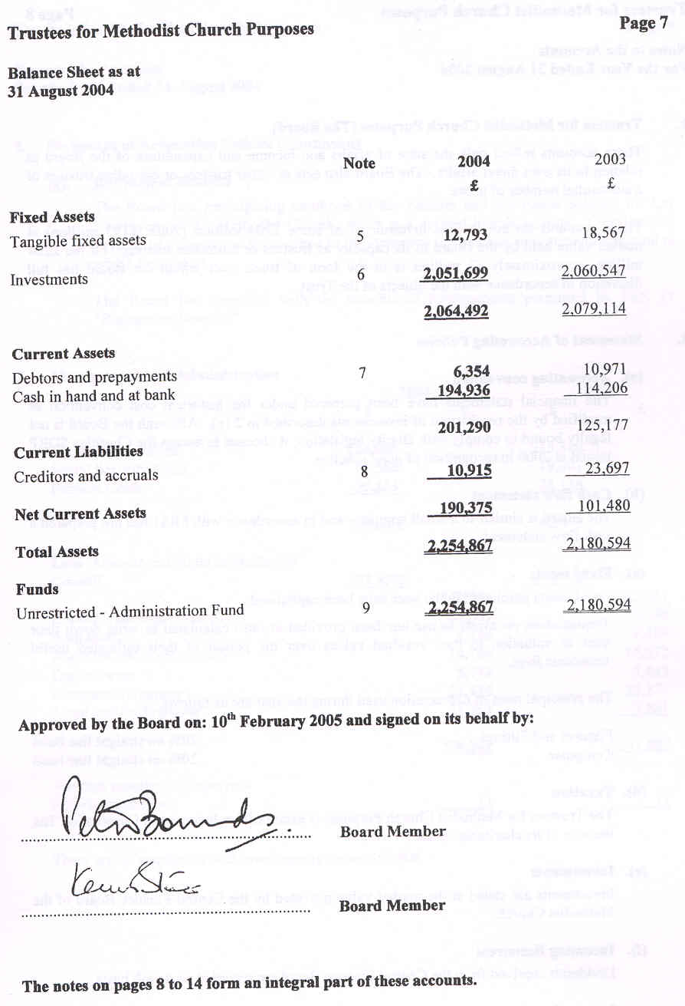
accounts
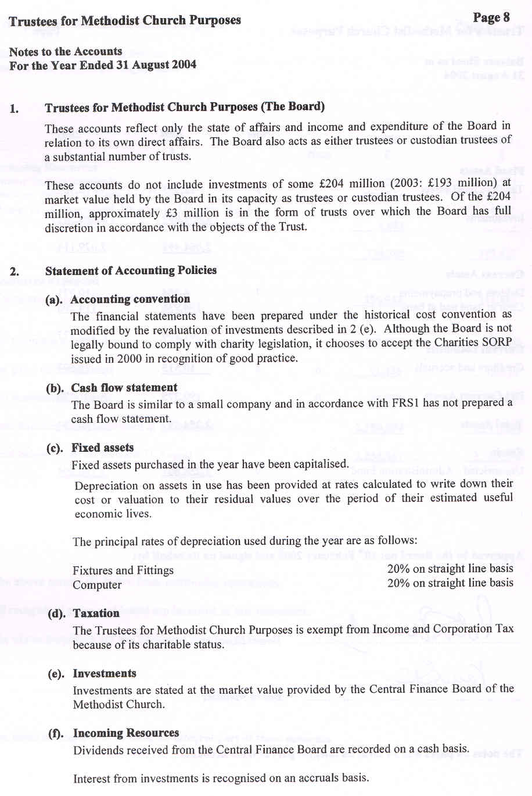
accounts
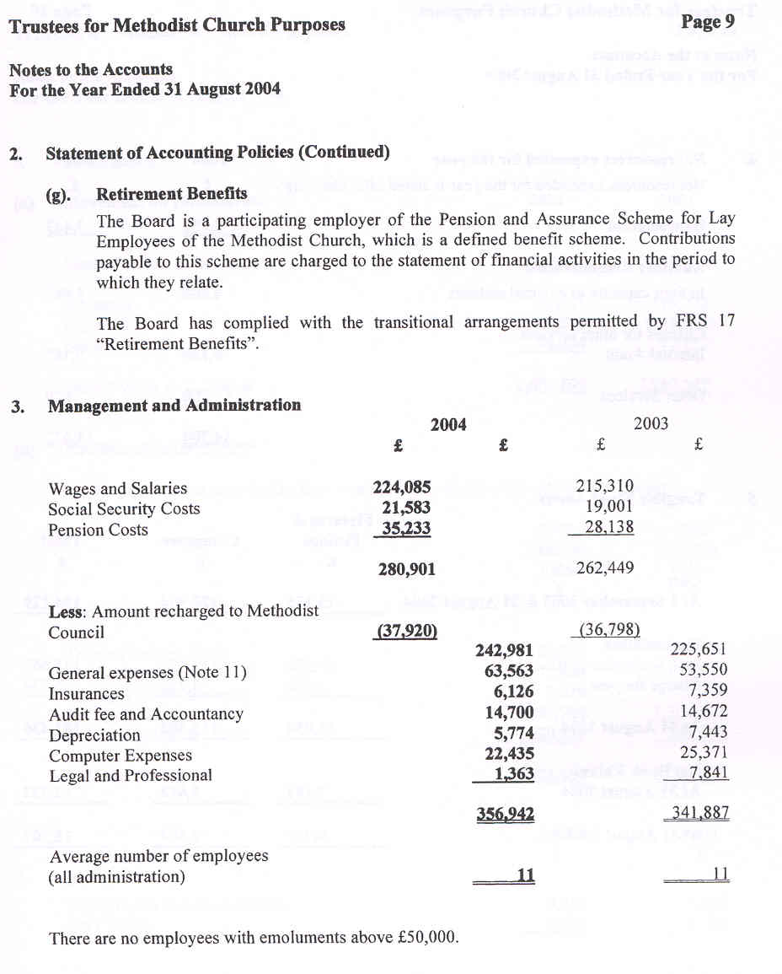
accounts
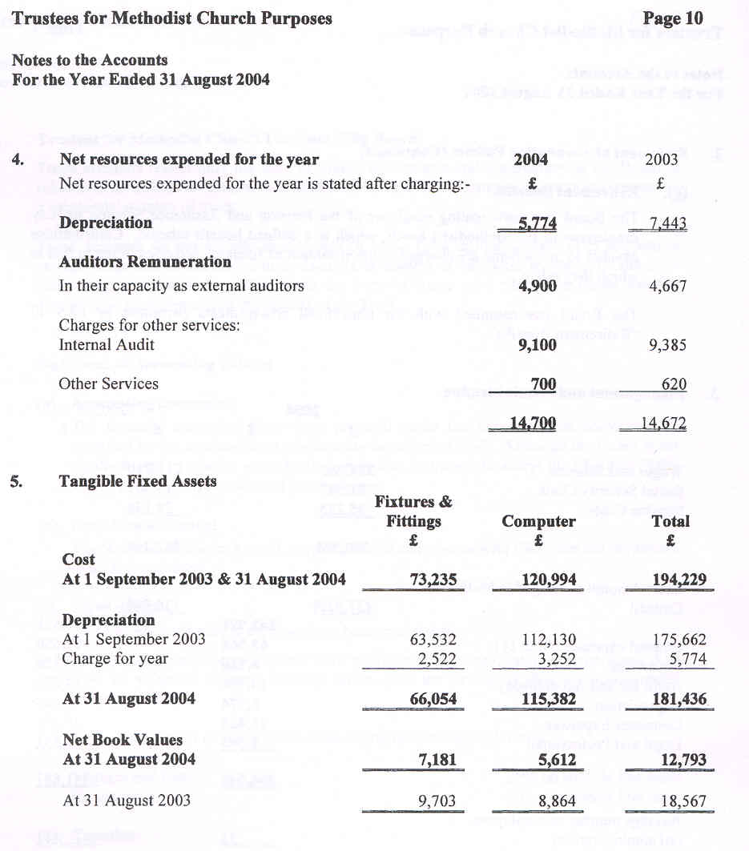
accounts
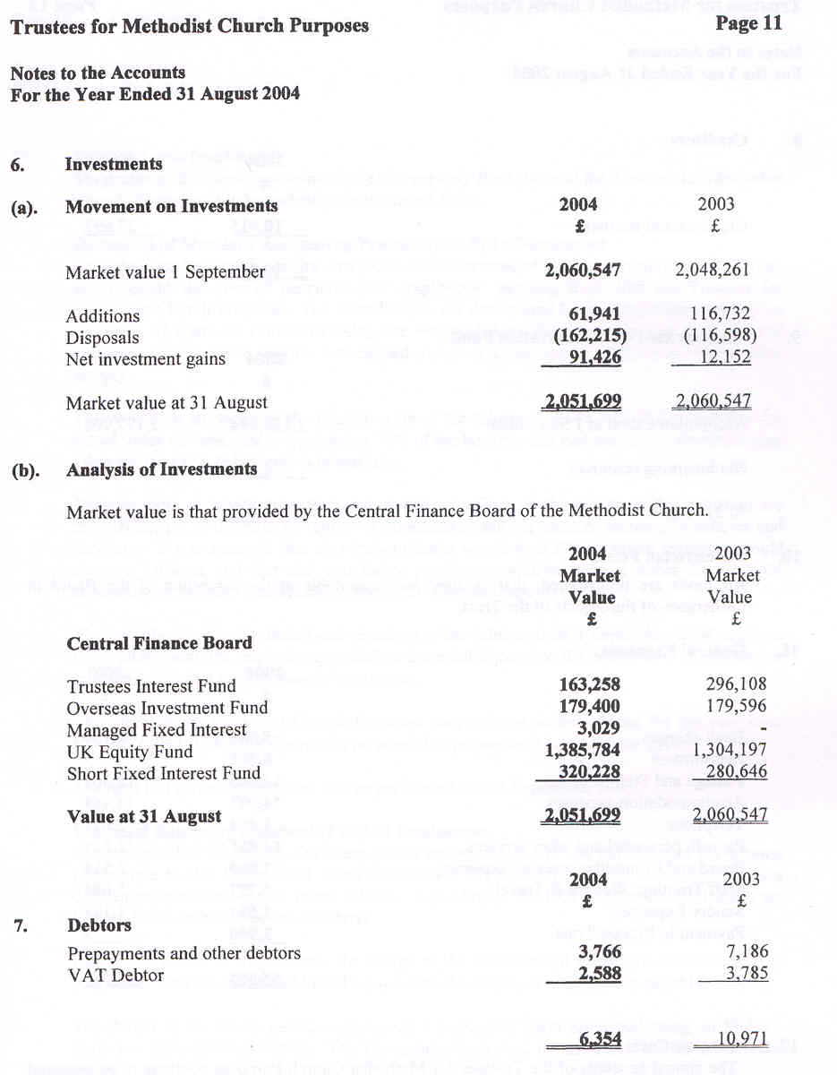
accounts
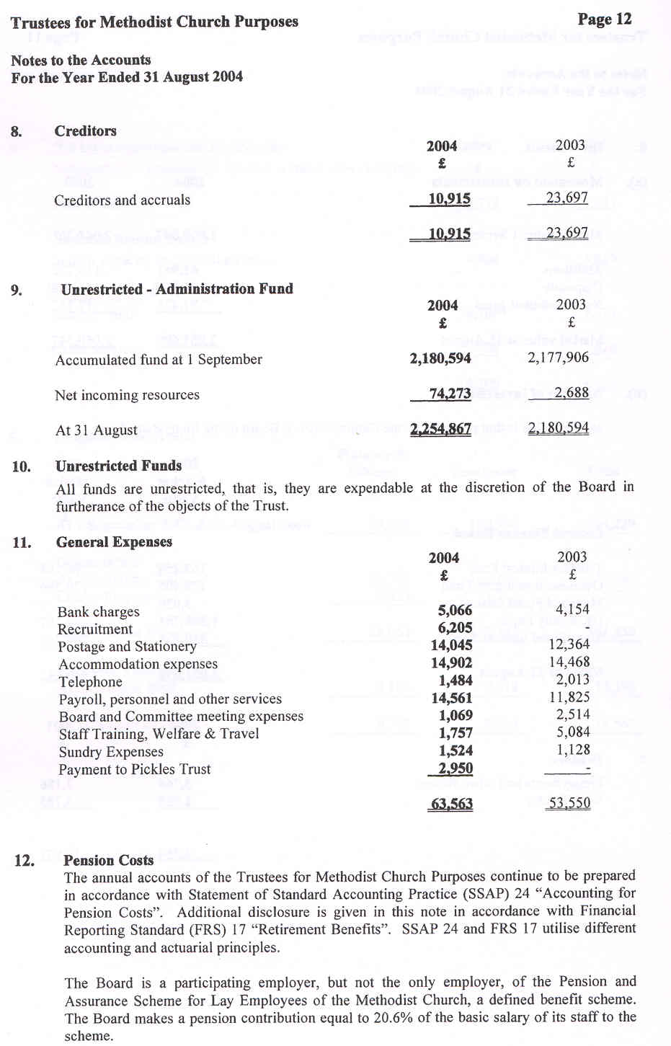
accounts
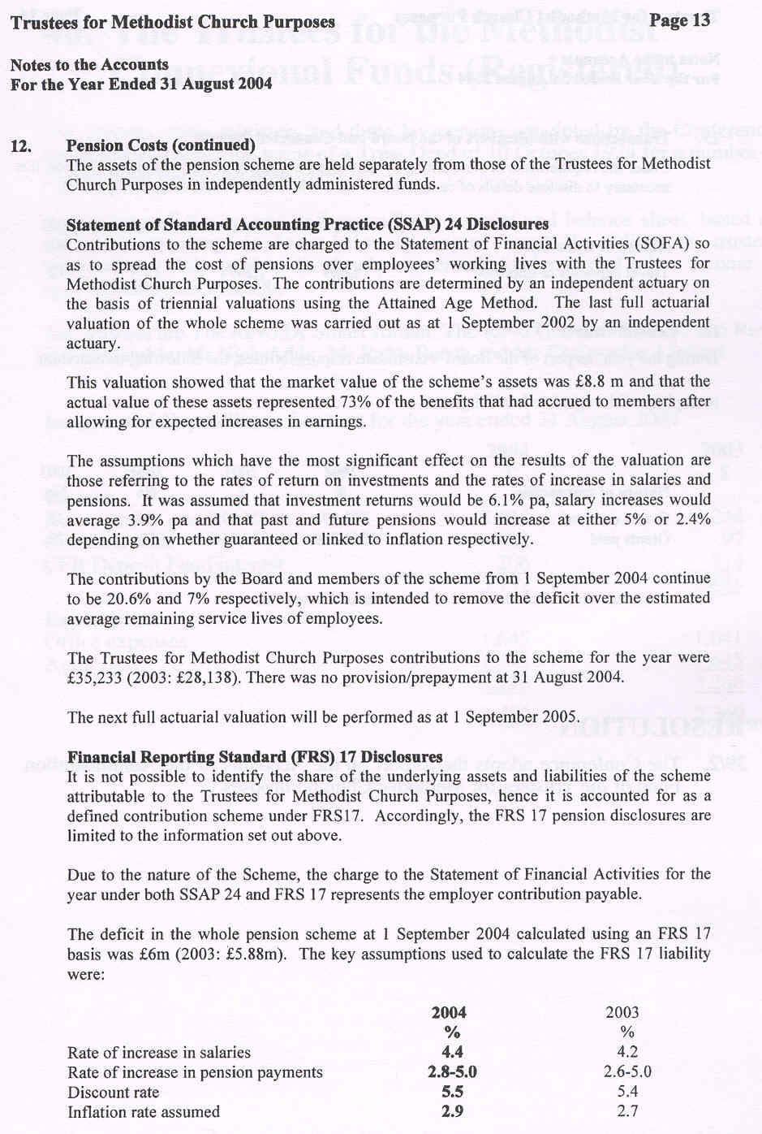
accounts
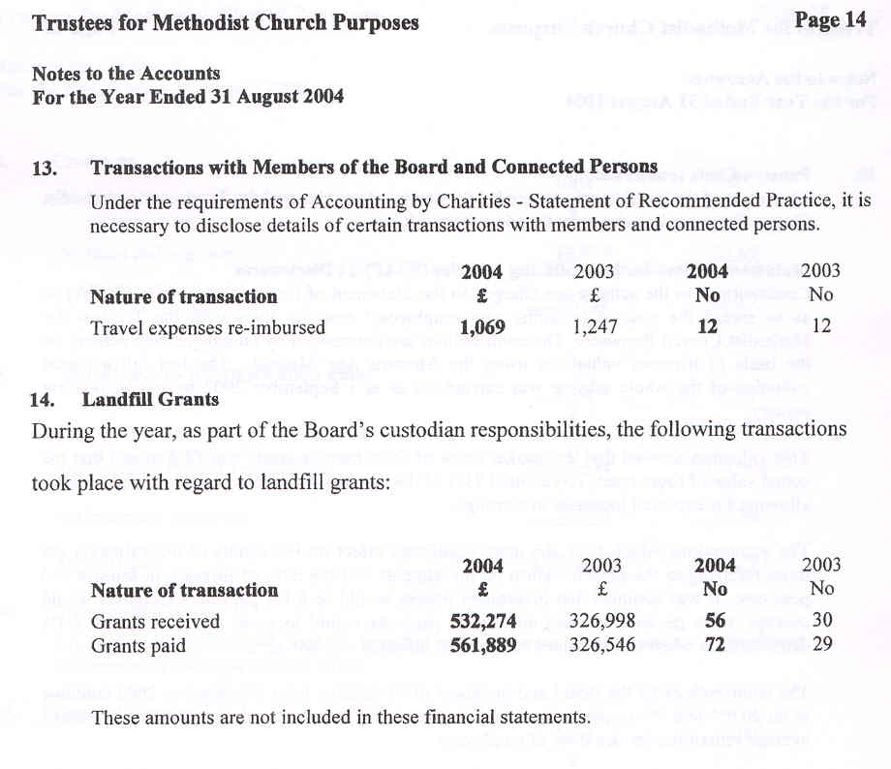

***RESOLUTION
39/2. The Conference adopts the Report on the Accounts of the Administration Fund of the Trustees for Methodist Church Purposes.

