33. Relief and Extension Fund for Scotland
The One Hundred and Twenty-fifth Annual Report and Financial Statement, 31st December 2004.
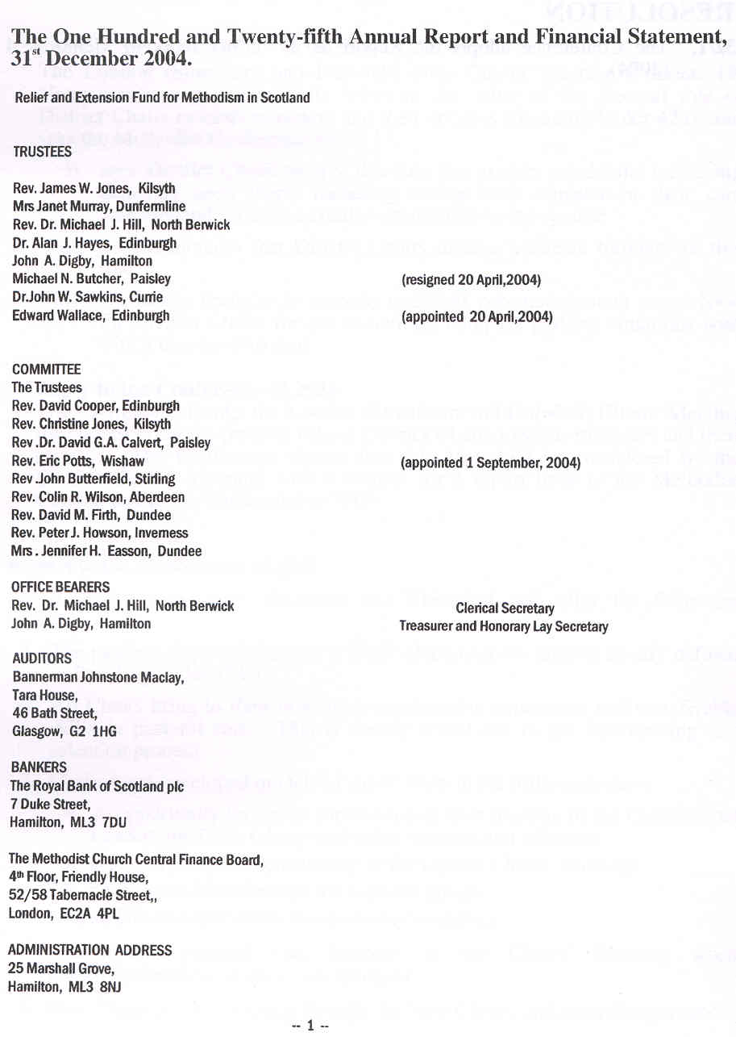

accounts
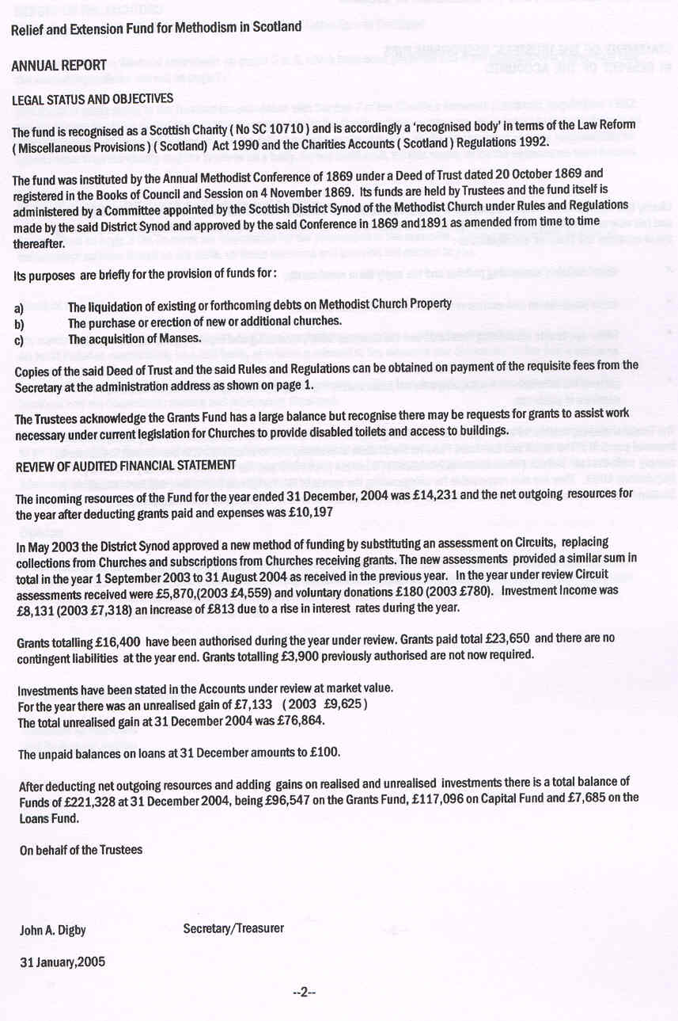
accounts
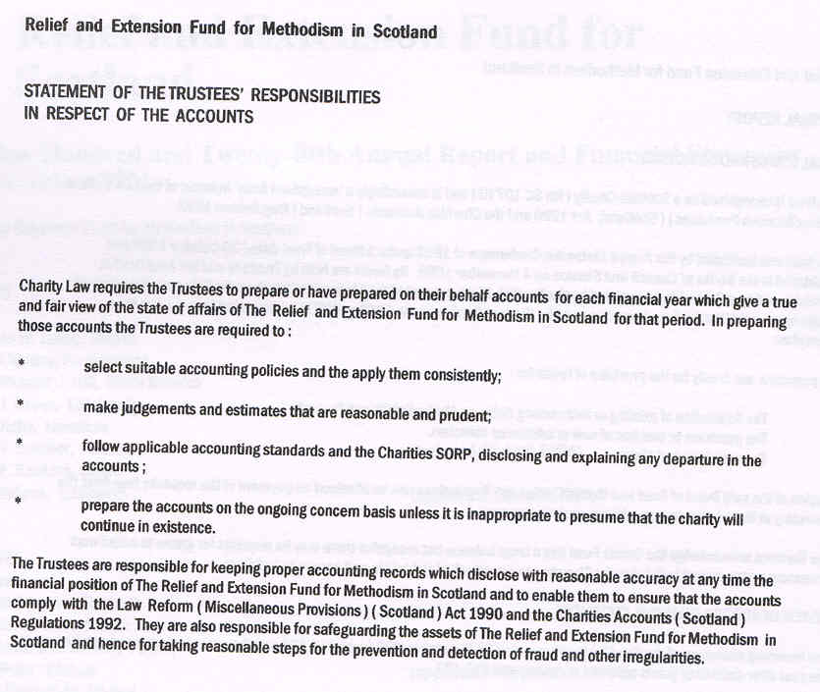
accounts
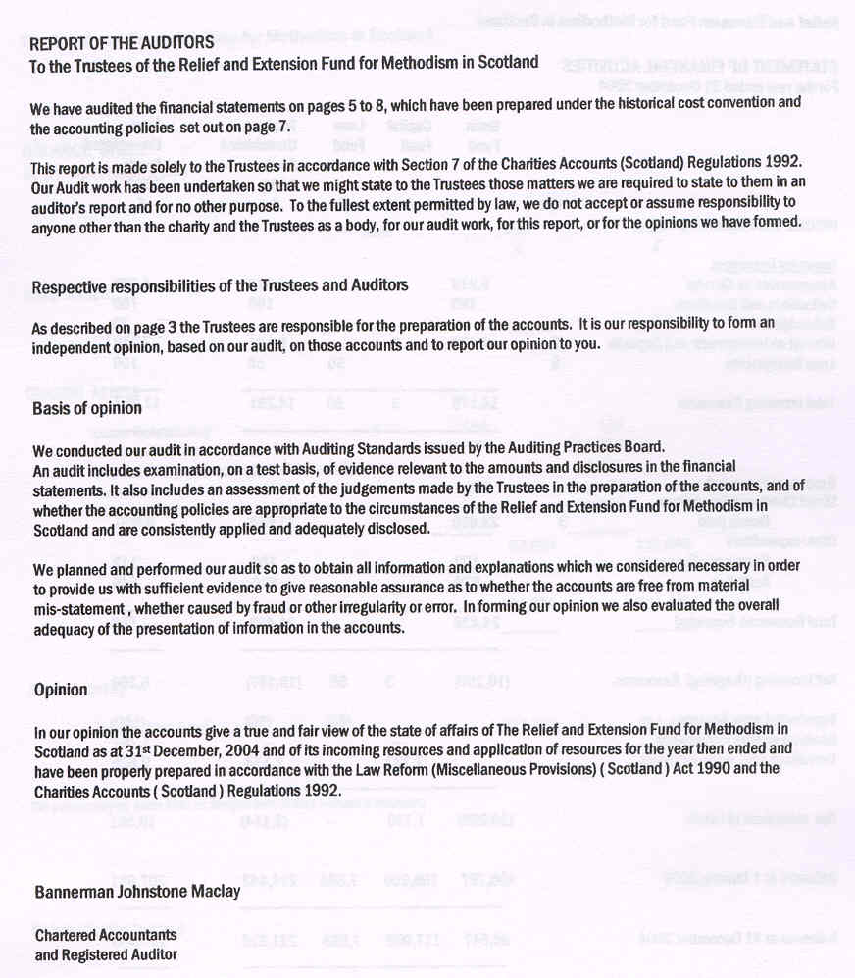
accounts
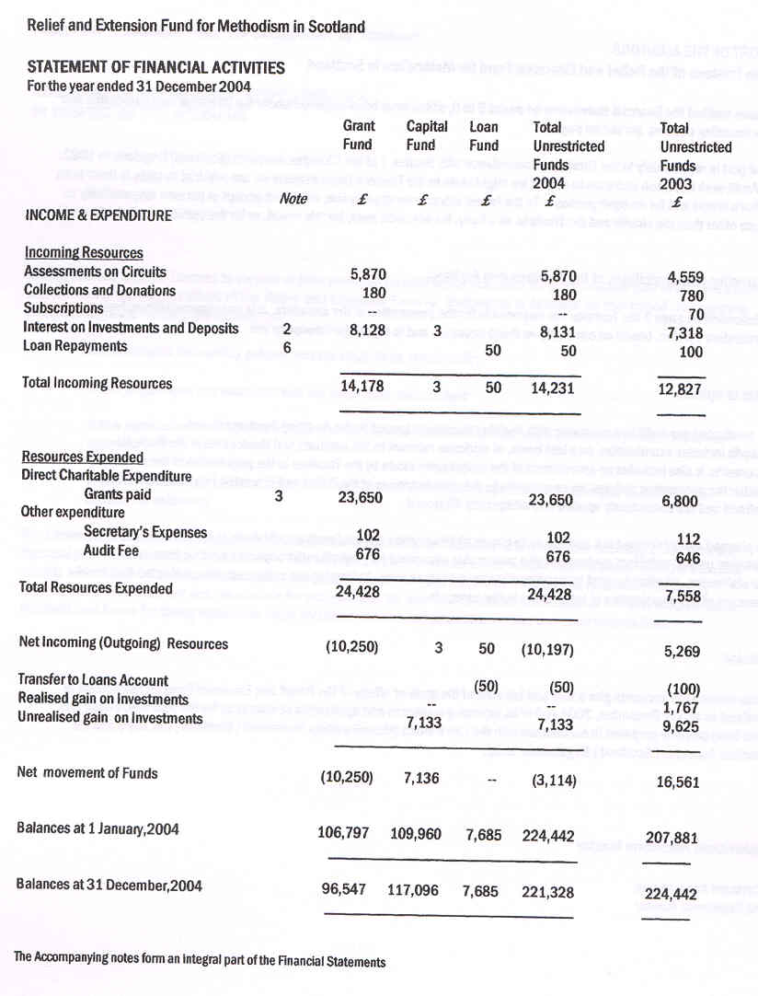
accounts
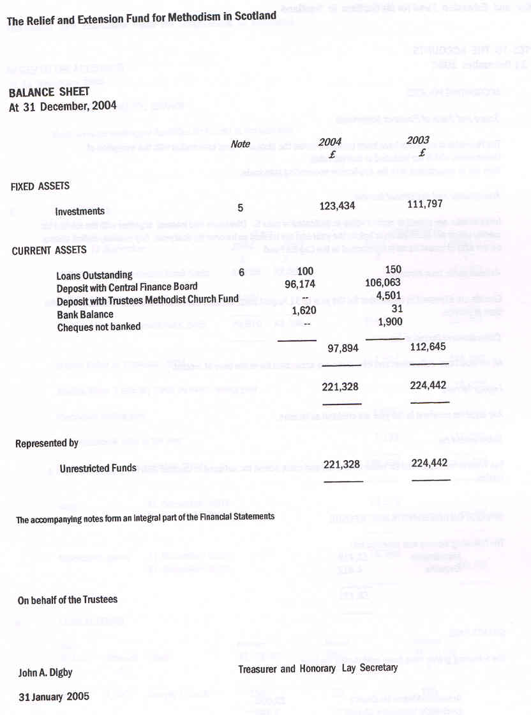
accounts
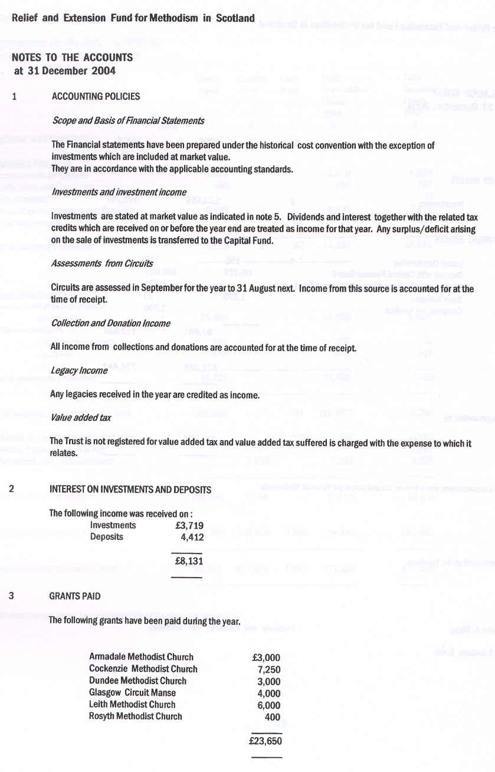
accounts
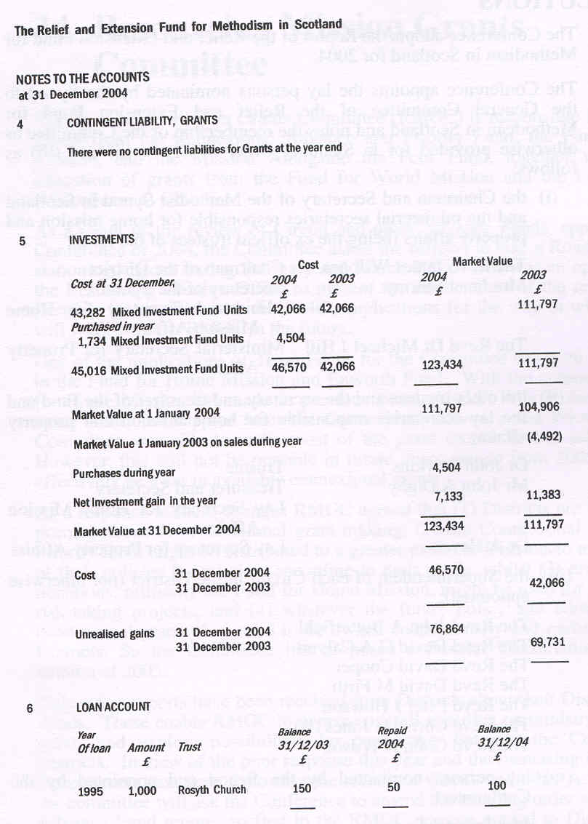
***RESOLUTIONS
33/1. The Conference adopts the Report of the Relief and Extension Fund for Methodism in Scotland for 2004.

33/2. The Conference appoints the lay persons nominated by the Synod to the General Committee of the Relief and Extension Fund for Methodism in Scotland and notes the membership of the Committee as otherwise provided for in Standing Order 476(1)(i), (ii) and (iii) as follows:
(i) the Chairman and Secretary of the Methodist Synod in Scotland and the ministerial secretaries responsible for home mission and property affairs (being the ex officio trustees of the fund);
The Revd James W Jones Chairman of the District
Mrs Janet Murray Secretary of the Synod
Ministerial Secretary for Home Mission Affairs
The Revd Dr Michael J Hill Ministerial Secretary for Property Affairs
(ii) the other trustees and the secretary and treasurer of the fund and the lay secretaries responsible for home mission and property affairs;
Dr John Sawkins Trustee
Mr John A Digby Treasurer and Secretary
Lay Secretary for Home Mission Affairs
Dr A Hayes Lay Secretary for Property Affairs
(iii) the Superintendent of each Circuit in the District (not otherwise appointed);
The Revd John A Butterfield
The Revd David G A Calvert
The Revd David Cooper
The Revd David M Firth
The Revd Peter J Howson
The Revd Christine Jones (B)
The Revd Colin R Wilson
(iv) lay persons nominated by the Synod and appointed by the Conference;
Mrs Jennifer Easson
Vacancy

