28. Local Preachers Mutual Aid Association
MISSION ACCOMPLISHED
The Lord spake unto Joshua, the son of Nun, Moses’ minister, saying, ‘Moses my servant is dead; now therefore arise, go over this Jordan…unto the land which I do give……to the children of Israel (Joshua 1.2).
The Methodist Local Preachers Mutual Aid Association has pleasure in presenting this, its final annual report, to the Methodist Conference meeting in Torquay from 23-30 June 2005.
LPMA General Committee member John Witt, of Leeds, based his memorial address to the Aggregate of 2004 on the text set out above. It is a fitting text at this point in the life of LPMA. Just as Moses had been an influential figure in the history of Israel up to the time of his death, so the Association, with its values of mutuality, has made a significant contribution to the people called Methodist and especially to the well-being of Local Preachers in the Methodist and Wesleyan Reform Union churches for 156 years. Now in a changing world order, it is time, first to honour the past achievements of preachers in mutual aid; then to move on, with a modernised organisation and new leadership, to give support over a wider range of need than has hitherto been permitted, to all who exercise the ministries of preaching the gospel of Christ and leading the worship of the faithful in the divided Church. Such a vision might enable the Leaders of Worship and Preachers Trust to become an influential force for the establishment of a sense of unity of purpose amongst the people of God, however long it takes to establish unity of structure.

ANNUAL AGGREGATE MEETING 2004
The 156th Annual Aggregate Meeting was held at the Brighouse Central Methodist Church, West Yorkshire from 12-14 June 2004. Mr Noel Clarkson, of Sale, Cheshire, was installed as President. The principal notice of motion before the meeting was intended to give approval and effect to the process of transformation set out in detail in last year’s Report, as follows,
‘This Aggregate Meeting authorises the General Committee (subject to appropriate legal advice):
- to form a new company limited by guarantee to be called ‘The Leaders of Worship and Preachers Trust’ (LWPT)
- to register such company as a charity,
- at a date to be determined to sign an appropriate agreement and all ancillary agreements to effect the transfer of the assets of LPMA to LWPT, with a restriction that existing LPMA funds must be used subject to the oversight of the Charity Commission only to fulfil the objects of LPMA and
- consequently to bring to the following Aggregate Meeting a resolution that LPMA should be dissolved.’

This motion was approved with 142 votes in favour, six against and six abstentions, a result far in excess of the 75% required. Within a month of the meeting, the proposal had also been endorsed by the Methodist Conference meeting at Loughborough, and the Conference of the Wesleyan Reform Union of Churches meeting at The Hayes, Swanwick, Derbyshire.
The remaining work of the General Committee was therefore to set up the new company and to have it registered as a charity. Both these tasks have been accomplished. A notice of motion has been submitted by the General Committee to what is expected to be the final Aggregate Meeting in June 2005 to transfer all the assets and liabilities of LPMA to LWPT on 31 August 2005 and thereafter to dissolve the Association. The mission of the Committee in the recent past, and of the Association in the 156 years of its history, can then be said to be accomplished, successfully and honourably, but the future well-being of beneficiaries and the community of preachers and worship leaders will be in safe hands.
The Committee is pleased to note that the trustees of the Leaders of Worship and Preachers Trust (LWPT) have commenced operations and fund-raising and that they have appointed bankers and most of their professional advisers, in many cases retaining the services of those who have served LPMA in recent years. It is particularly pleasing to note that the trustees have decided to retain Head Office of LPMA at 89 High St, Rickmansworth, as its Registered Office and National Headquarters, and to retain the services of the employees at that site. Some desirable modernisation of equipment and facilities has been provided for (see below), but beneficiaries of the Trust will benefit from the collective experience and care of the staff for which they have been so widely commended for many years.

FINANCE
In the year ending 31 August 2004, income from members, churches and donations, including the Annual Appeal, amounted to £318,999, little changed from the previous year’s total of £319,302. Given the uncertainty inevitably generated by a process of change, this was very gratifying. Income from members’ subscriptions was lower at £73,409 compared with £81,647 in the previous year, but grants and collections from churches at £188,594 (£178,309 in 2003) represent a continuing generous recognition of the debt of Methodist and WRU congregations to Local Preachers for their ministry, in difficult times for churches’ finances. The Association wishes to place on record its sincere appreciation of the high level of continuing financial support from its members and the congregations they serve.
The increase in expenditure outlined above entailed the use of some of the income from legacies during the year for current expenditure. Legacy income for the year amounted to £235,363, an above average figure but, disregarding legacy income, the excess of ordinary expenditure over ordinary income was £45,168. Nevertheless, grants of £121,067 were made to Mutual Aid Homes for capital expenditure. The value of the reserves was maintained by a net gain of £17,019 in the value of invested assets. The reserves are thus in a very healthy state and this, together with the strong influx of legacies in the first half of the year 2004-05, has encouraged the General Committee to agree to fund a significant number of improvements in LPMA Homes and, as suggested in the previous paragraph, some essential renewals to equipment and systems at Head Office. Although LWPT plans to continue financial support to LPMA Homes for capital expenditure, no major projects should be necessary within the current property portfolio in the next few years.
The most significant development planned to benefit from this funding in the summer of 2005 is the conversion of disused former staff accommodation on the ground floor at Westerley, Minehead for use by residents. This finalises the process already completed at the other homes of maximising the availability of rooms in our buildings for residents’ use, recognising that the need to provide residential accommodation for employees is no longer as pressing as it was in earlier years.
Investment values continued to show steady improvement in the year ending 31 August 2004 and the gain in the first six months of the current year, to February 2005, has been yet more marked. The world economic environment continues to be stable, despite the political uncertainties that remain arising from tensions between the Islamic World and the West. Energy prices have reached record high levels during the winter of 2004-05 but the major economies have been resilient to the potential impact on business and the cost of living.

PERSONALITIES
On the nomination of the Aggregate Meeting, the Methodist Conference meeting in Loughborough in June 2004 confirmed the election of Mrs Lois Morton as President-Elect. It also appointed Mrs Rosalind Peedle as Senior Honorary Secretary, a role in which she had been acting since the premature retirement of Mr Clarkson from this role in January 2004. Messrs Keith Angilley (Plymouth) and Peter Relf (Mansfield) were appointed as Honorary Secretaries, following a change in the rules to permit an additional Honorary Secretary to be appointed. Mrs Doreen Shuttleworth retired as Honorary Secretary (Homes) after holding the post for four years, and Mr Brian Young (Bolton) was elected to take her place. Mr Keith Rothery (Chasetown) was re-elected as Honorary Treasurer.
The Association has been pleased to welcome Mr Ronald Kirk (Great Ayton) to membership of the General Committee. He was nominated by the Methodist Council, in place of Mr Peter Relf, who as Honorary Secretary is now an ex-officio member of the committee.
Mr Godfrey Talford, General Secretary, was on sick leave from June to August 2004. During that time, Messrs Frank Pickles, Keith Rothery and Mesdames Ros Peedle and Doreen Shuttleworth formed a special task force to manage the Association on a day-to-day basis. The committee was grateful to them all for their contributions of time and effort far in excess of normal expectations for voluntary workers. As ever, they were ably supported by the staff at Head Office to whom the committee would like to express its gratitude for their support throughout the year, not least for their exceptional contribution during that difficult period.

MARKETING AND PUBLICITY
The Association continues to promote its activities through the periodical ‘Ichthus’, the website, press advertising, promotional merchandise and through the various leaflets which are produced from time to time. The Association has been grateful to all who have taken part in these aspects of its work. However, it has been heavily dependent on members and Branch and District Officers to promote the work of LPMA by word and activity.
Preachers planned to conduct worship on Local Preachers’ Sundays are asked to thank congregations for their support and to inform them briefly about the work of the preachers’ charity. Preachers are also asked to invite members of their congregations to remember its work in their wills and, most of all, to pray for all those who seek to support preachers and their dependants in times of need. LPMA has some support material for those conducting worship on Local Preachers’ Sunday. This has recently been revised and is obtainable direct from Head Office and from the website (www.lpma.co.uk).

MUTUAL AID HOMES
Since the 1960s, Mutual Aid Homes has been an Industrial and Provident Society and as such it has enjoyed ‘exempt charity’ status. Membership of the Society has been defined by reference to the offices held by its members in LPMA. The Annual General Meeting of members of Mutual Aid Homes, held at Brighouse on 11 June 2004, approved in principle the conversion of the Society to a Company Limited by Guarantee and a Registered Charity. It also approved the proposal that it should become a wholly owned subsidiary of the Leaders of Worship and Preachers Trust after LPMA is dissolved. With assistance from the Society’s solicitors, the Executive Committee prepared a draft constitution for the converted organisation which will be named the Leaders of Worship and Preachers Homes. The process of conversion was approved in principle by a special general meeting of members at Willerby, East Yorkshire, on 20 November 2004 and two further members’ meetings, on 17 February and 17 March 2005, have approved the draft memorandum and articles of association of the converted organisation. Application has now been made to the Financial Services Authority to effect the change, with the hope that the change will be effective at about the time of the formal launch of LWPT. Official stationery and publicity material has to be redesigned in parallel with the conversion process.
The hopes that the Society might achieve a balance between normal income and normal operating expenses still remained unfulfilled in the year under review. The Society reports an operating deficit of £92,999 from income (excluding interest and investment income) of £1,638,713. However this income includes legacies totalling £17,759 and gains in the value of investments. On ordinary activities the Society reports a loss of £110,758.
Average occupancy at 82.56 residents over the year compares with a target of 85.75, but the overall percentage continues to be acceptable and in line with norms in the industry. Although management accepts responsibility for waste in some areas, it believes its has no significant cost savings to extract from the business without compromising the quality of life and care for its residents. Unit labour costs continue to rise sharply, not least as a result of substantial increases in the National Minimum Wage. There have also been significant increases in energy costs and the share of the costs of regulation borne by Care Home operators, which ultimately have to be borne by the users of the services they provide. The Society continues to maintain that these cost increases have not been fully recognised by public sector contractors. National Minimum Standards do not allow for economies in manning levels, nor indeed would such economies be possible without compromising the safety and security of residents.
The National Care Standards Commission, set up in 2002, had been replaced after only two years by the Commission for Social Care Inspection. The new commission has begun to consult care providers about changes in the approach to regulation, but in his March 2005 budget statement, in the interests of cost-saving, the Chancellor of the Exchequer proposed further streamlining of regulators across a wide spectrum of services, including education, health and social care. It is proposed that the Commission for Social Care Inspection should be combined with the Health Care Commission by 2008, but responsibility for regulating children’s services should be transferred to Ofsted. Stability in the regulatory process seems to be an elusive goal; society must hope and pray that the security and safety of its vulnerable members are not compromised.
Improvements continue to be made to the fabric of the Homes. Essential renewals have been completed to the heating and hot water supply system at Westcliff and with the completion of the conversion of former staff accommodation at Minehead for residents’ use, the Leaders of Worship and Preachers Homes will have increased capacity there.
Finally the Society wishes to record its appreciation of the services of its staff. Without their competence and dedication, the Homes would not be able to maintain the reputation for quality of accommodation and care which they have justly earned.

CONCLUSION – MISSION ACCOMPLISHED
LPMA has a history of which it can be proud and throughout its history it has endeavoured to serve the interests of Local Preachers faithfully and diligently. It is now time to hand over the work to the Leaders of Worship and Preachers Trust. The Trust will no doubt value the continuing support of church members, just as members and honorary members of LPMA have supported the Association, with sacrificial giving of money, time, talents and prayer. For the Word of God and the Means of Grace, and for those who proclaim the Word and mediate the Grace, past, present and future, thanks be to God.

accounts
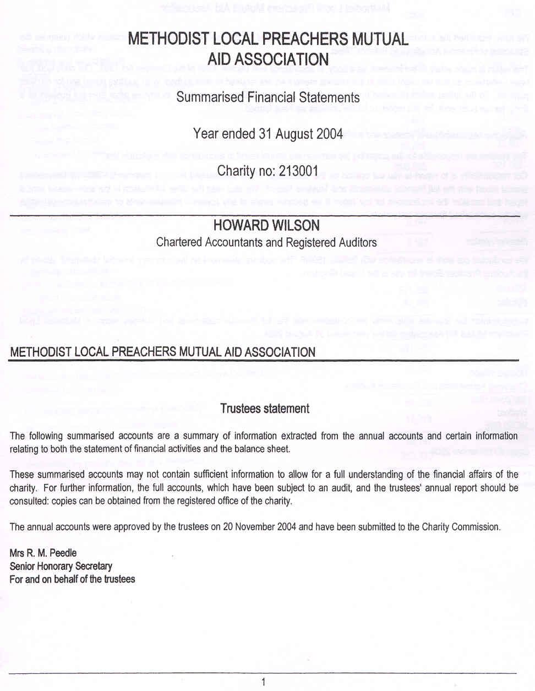
accounts
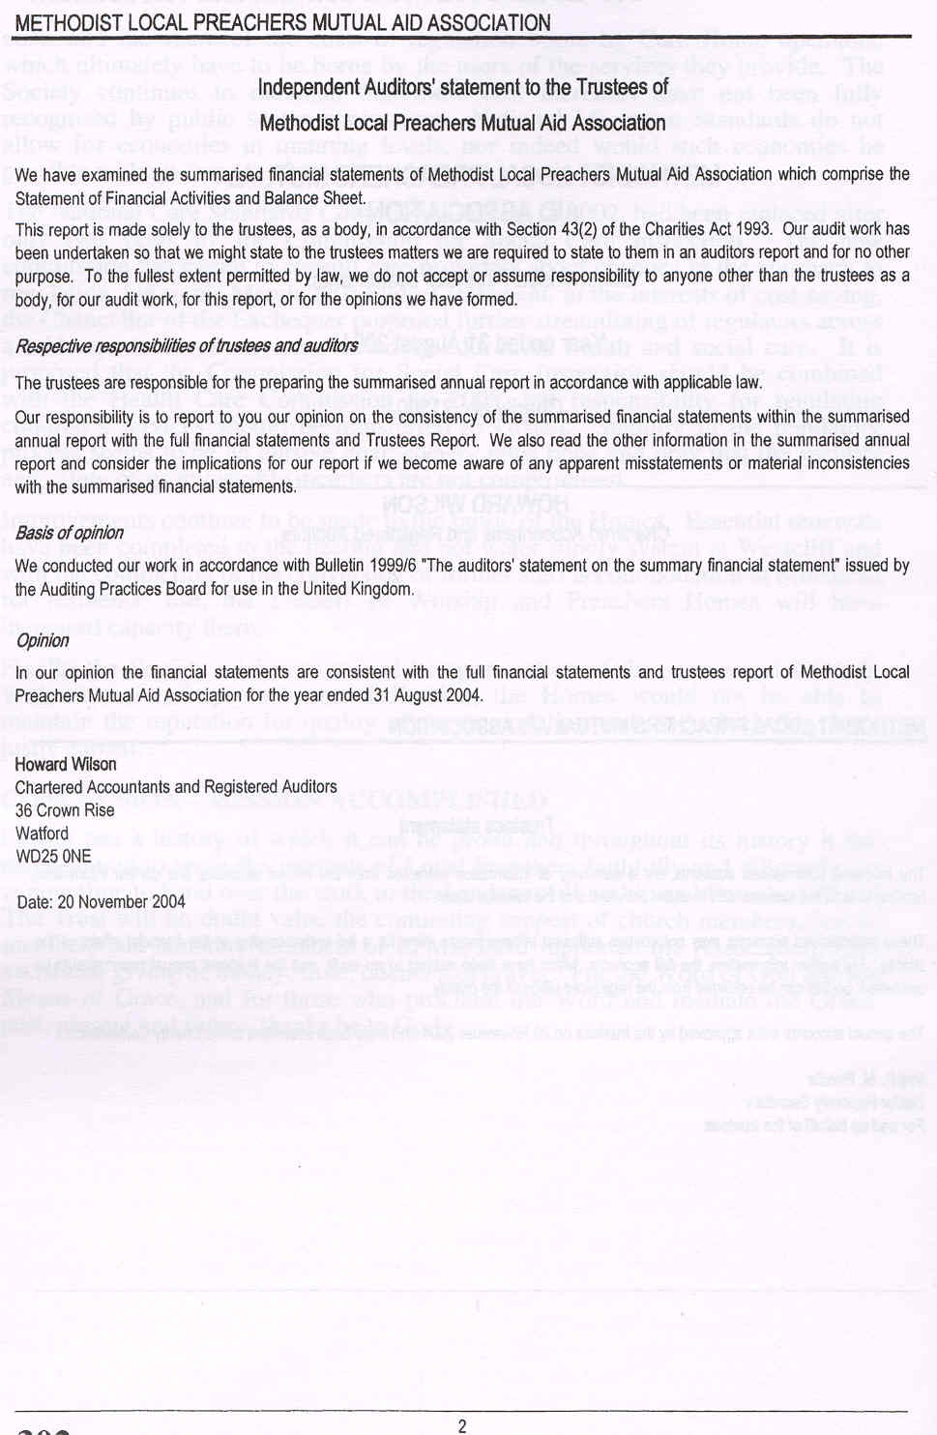
accounts
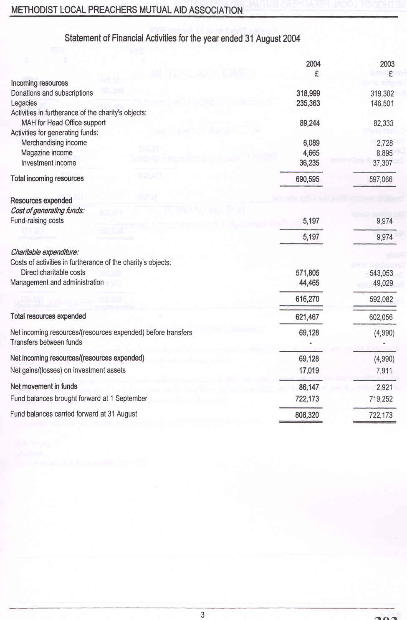
accounts
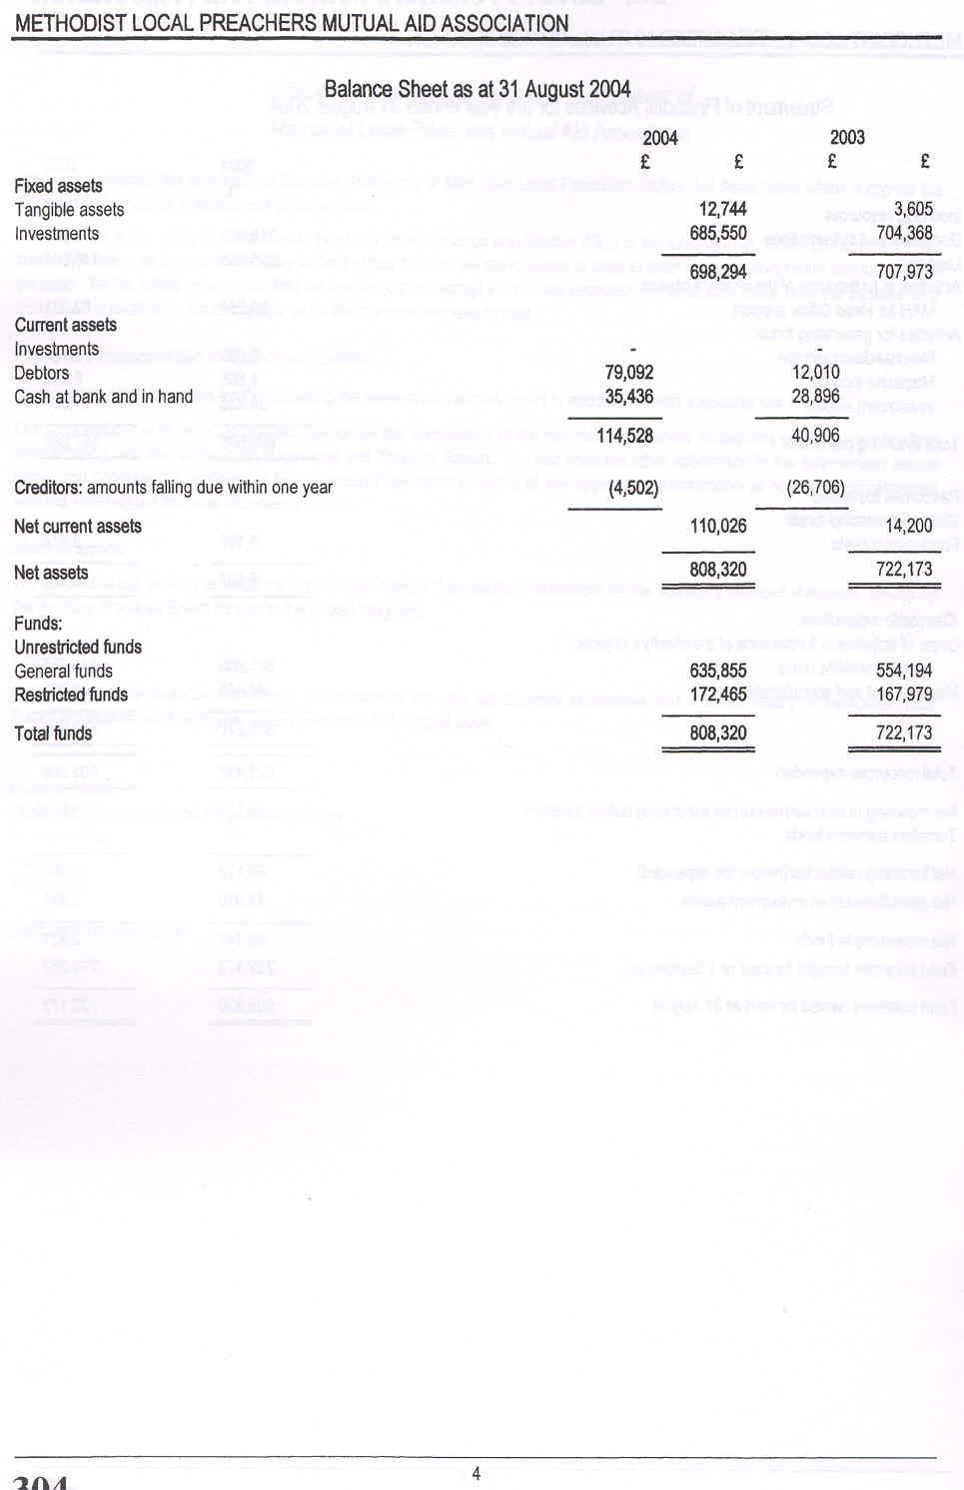
accounts

accounts
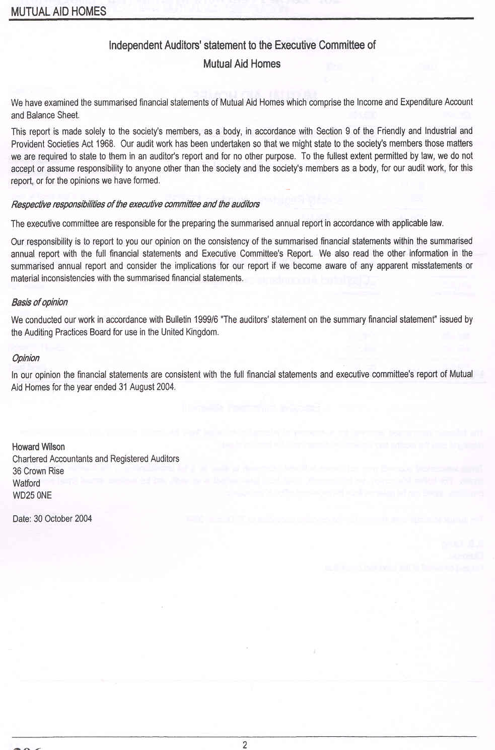
accounts
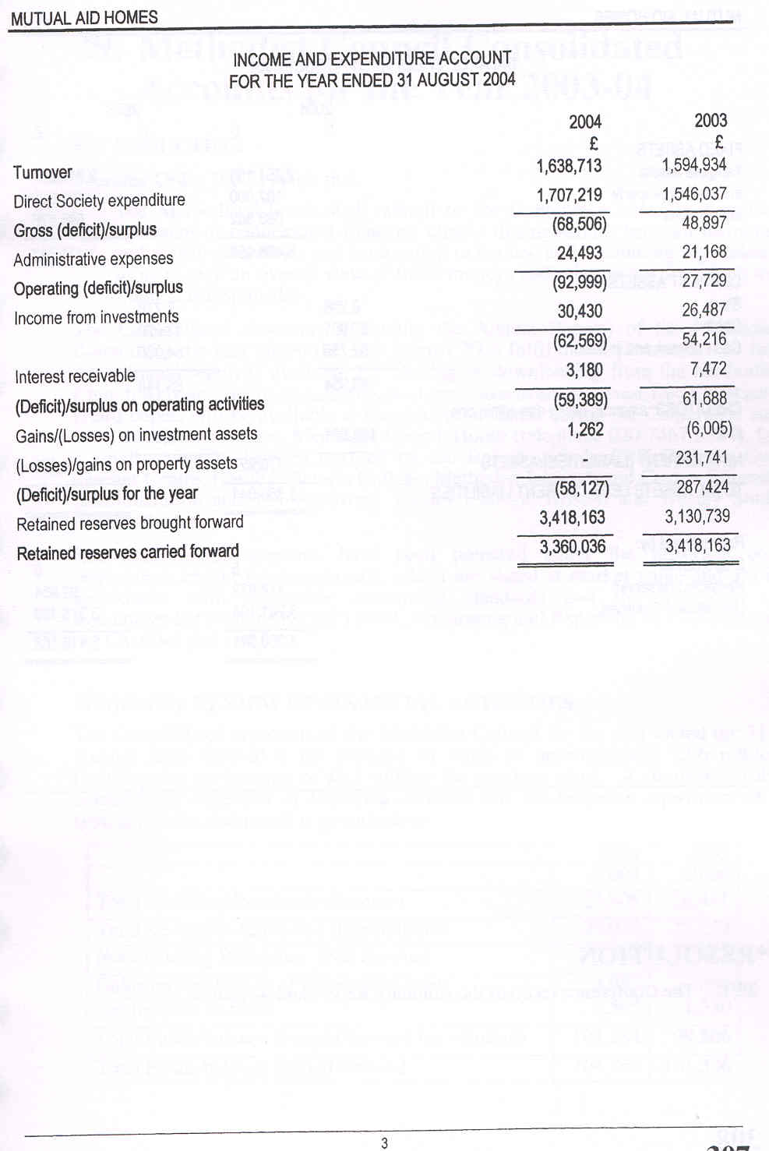
accounts
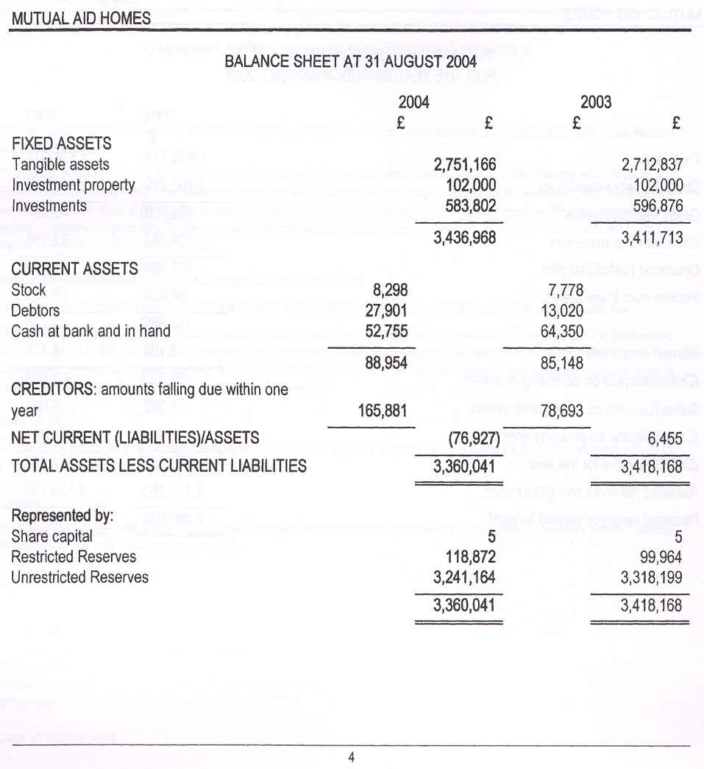

***RESOLUTION
28/1. The Conference receives the summary Report and Accounts.

