23. District Allocations: 2005-06
The District Treasurers at their meeting on Saturday the 21st August 2004 agreed that the total connexional assessment should only increase by the rate of inflation, 2.7% at the time. They also agreed that the formula to be applied for splitting this across the Districts should be that which was set up four years previously, taking into account the number of ministers/deacons/lay workers as well as the regional indices of disposable income. It was also agreed that the maximum increase that any District would face would be 5% and the minimum assessment payable would be not less than the figure assessed for the year 2004-05.

Taking these principles into account, the attached schedule shows the proposed allocations arrived at with increases in District allocations ranging between 0.5% and 5%. The District Treasurers’ meeting recommended these allocations to the Methodist Council, which agreed them.

The other contributions to the Connexion agreed to be included in the overall total due from the Districts, e.g. sabbatical levy, President/Vice President’s expenses, and Continuous Development in Ministry training travel expenses, are also shown in the schedule. It was also agreed for the cost incurred in obtaining safeguarding clearance for supernumeraries to be collected at the same time so that the Districts know at a glance the total amount payable to the Connexion for the year.

The attached schedule takes all these into account.

***RESOLUTION
23/1. The Conference adopts the allocation to the Districts of the Methodist Church Fund assessments.

accounts
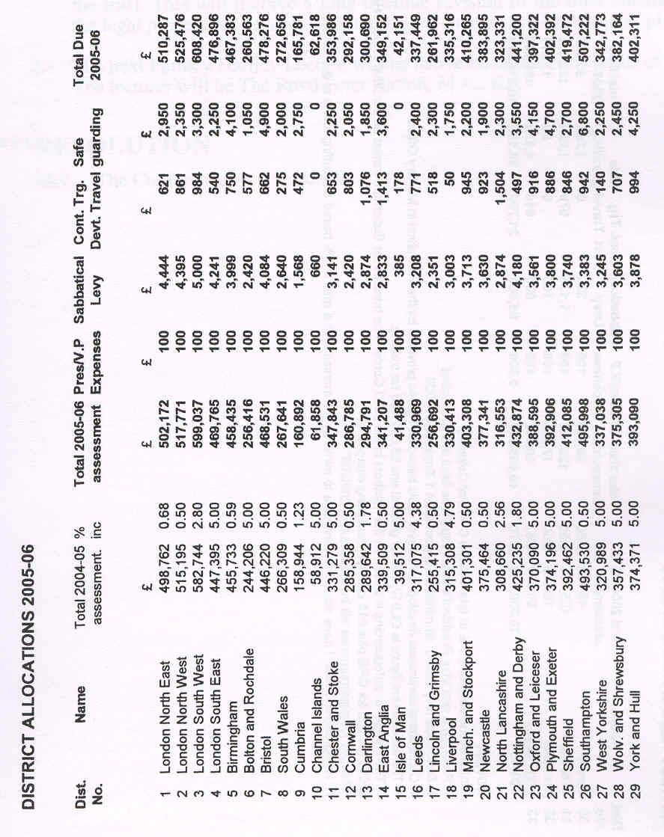
accounts
