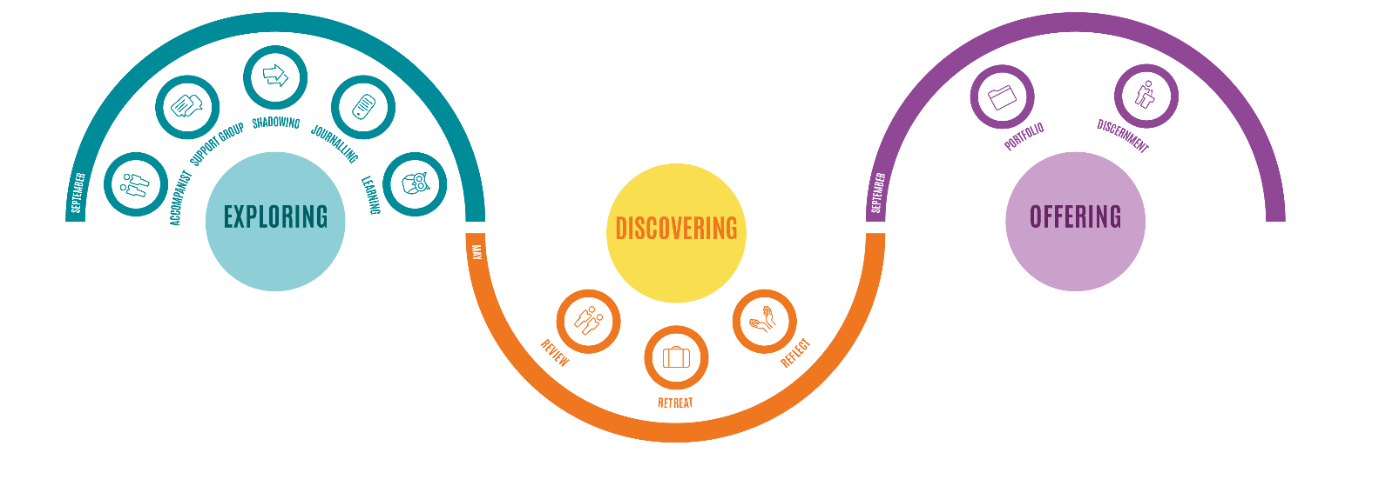
DISCERNING ORDAINED VOCATION COMMITTEE MEMBERS

The roles
- Being a member of the DOV2 Connexional discernment committee.

- Working as part of a panel to discern with candidates and make recommendations to the Conference regarding their acceptance for training.

- Working as part of a panel to discern with ministers applying to transfer to serve in the British Methodist church.

- Being a chaplain to the DOV2 Committee, candidates and applicants.

The time commitment
- The core commitment:
  - Two days for DOV2 Committee training in November each year.

  - Between 3 and 6 days in early February (Friday-Sunday and Monday-Wednesday) for the candidates’ panels. The second cycle (Monday –Wednesday) is only used if there are high numbers of candidates.

  - Preparation individually – engaging with application paperwork and material in other media, seeking and noting evidence in advance of the panels.

  - Panel preparation meetings

- The additional opportunities :
  - Up to four days (Tuesday-Friday) in November each year for transfer panels.

What is good about it?
- Playing a major role in the discernment of ordained vocation

- Working with a large team of varied, committed and positive people.

- Being part of the future of the Church.

How to apply
- Please complete the application form which you can find here: Become a member of the Discerning Ordained Vocation (DOV) Connexional Committee - Methodist Church
- Applications are particularly encouraged between September and November each year.
- Lay people are particularly encouraged to apply.

